Rainier, Oregon, USA
A quiet Columbia River mill town that punches above its size — dock steps from Riverfront Park and use it as a launchpad for Mount St. Helens or wander historic A Street at your own pace.
⚓ Docked (river pier) · 🕒 Typical call: 5–8 hrs · 💵 USD · 🗣️ English · 🌲 River & volcano country
✍️ MY DAY IN PORT (FILL IN)
Ship / Date
In port | arrive ______ · all aboard ______
Booked excursion
Notes / meeting point
GETTING ASHORE
- Docking: River dock at Rainier Marina / Riverfront Park — no tender
- Walk to town: Under 2 min — ship ties up next to Riverfront Park; A Street is 1 block
- Best For: Columbia River scenery, small-town Pacific NW charm, Mount St. Helens day trip
- Don't Miss: Lewis and Clark Bridge views from the park; watching cargo ships pass close-up
GETTING AROUND
- 📱 Rideshare: ✅ Uber
TOP THINGS TO DO
- Mount St. Helens National Volcanic Monument — The standout excursion from Rainier.
- Lewis and Clark Bridge & Longview, WA — Cross the towering 1930 bridge to Longview, Washington for a visit to Lake Sacajawea Park — often called one of the most…
- Dibblee Beach River Walk — A long sandy Columbia River beach about a mile west of the dock.
- Historic A Street Stroll — A Street's brick storefronts date to Rainier's logging heyday.
BEST WALKS
- Riverfront Park to A Street Loop: 0.5 mi · 15–20 min · Flat — From the pier, explore Riverfront Park's riverside path and historical markers, then cut one block…
- Dibblee Beach Walk: ~1 mi one-way · 20–25 min walk or 5 min taxi · Flat — Head west along the riverbank from the park to Dibblee Beach.
WEATHER · DAYLIGHT · MONEY
Month | High °F | Low °F | Rainy days
May | 66 | 47 | 9
Jul | 79 | 55 | 3
Sep | 71 | 52 | 9
Daylight: May 5:35AM–8:39PM · Jul 5:32AM–9:00PM · Sep 6:49AM–7:21PM
cruiseports.org/rainier-or · Confirm terminal & all-aboard time with your ship

Rainier, Oregon, USA — Port Map
Red = walkable sights · Amber = excursions farther out · P = cruise terminal
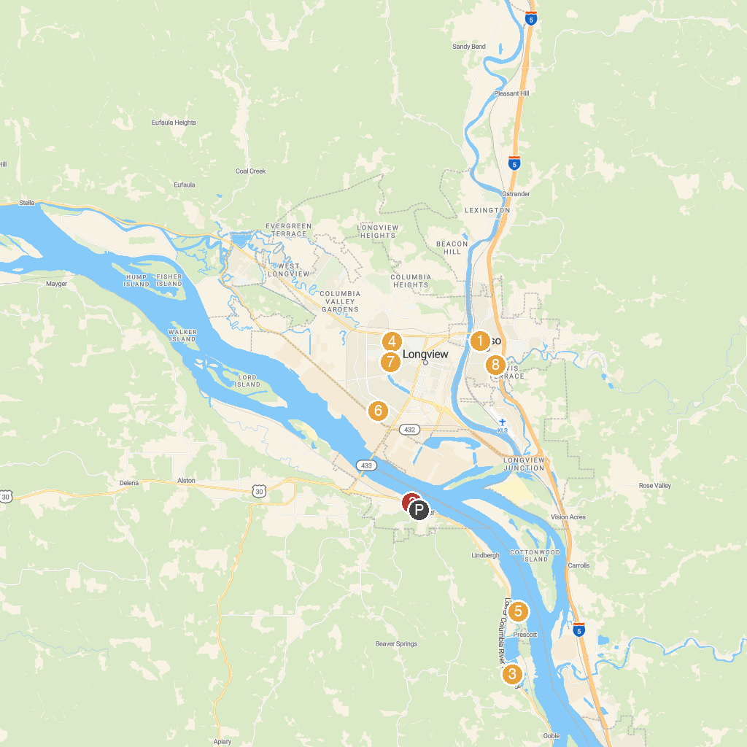
MAP KEY
1. Cowlitz County Historical Museum | 5. Prescott Beach Park
2. Rainier City Park | 6. Archie Anderson Park
3. Trojan Park | 7. Lake Sacajawea Park
4. Lake Sacajawea Park Japanese Gardens | 8. Cinema of Horrors Haunted House
P. Cruise port / terminal
Map © MapTiler © OpenStreetMap contributors · cruiseports.org

