Rabaul, East New Britain, Papua New Guinea
A port unlike any other: moored inside a flooded volcanic caldera, with a smoking cone on the horizon and buried streets from the catastrophic 1994 eruption. Rabaul is equal parts ghost town, WWII time capsule, and raw Pacific drama.
⚓ Pier — Rabaul Main Wharf · 🕒 Typical call: 7-9 hrs · 💵 PNG Kina (PGK) — USD/AUD accepted by some operators · 🗣️ Tok Pisin & English · 🌋 Active volcano in harbour
✍️ MY DAY IN PORT (FILL IN)
Ship / Date
In port | arrive ______ · all aboard ______
Booked excursion
Notes / meeting point
GETTING ASHORE
- Docking: Deep-water pier at Rabaul Main Wharf, Simpson Harbour; occasional tender for large ships
- Walk to centre: 15–20 min to old Rabaul (very limited); Kokopo (most attractions) is 40 min by taxi
- Best For: WWII history, volcano experiences, remote South Pacific culture
- Don't Miss: Mt. Tavurvur & hot springs, Japanese barge tunnels, Yamamoto's Bunker
GETTING AROUND
- 🚕 Taxi: Negotiate on arrival — Formal taxis are scarce. Some local minivans (PMVs) meet cruise ships and can be hired for point-to-point trips or hourl
- 📱 Rideshare: ❌ not available
TOP THINGS TO DO
- Mt. Tavurvur Volcano & Hot Springs — Boat to the foot of Rabaul's smoking cone, watch volcanic gases vent, and dip into geothermal hot springs where locals harvest…
- Japanese WWII Tunnels & Yamamoto's Bunker — Explore the vast network of hand-dug tunnels the Japanese built to hide barges, ammunition, and hospitals.
- Kokopo War Museum & Bitapaka Cemetery — The Kokopo Museum holds Japanese planes, tanks, and occupation-era relics; the Bitapaka War Cemetery (about 45 min out) is a…
- Baining Fire Dance — The Baining people dance barefoot through roaring bonfires wearing towering bark-cloth spirit masks.
- WWII Wreck Diving & Snorkelling — Simpson Harbour is a watery graveyard of WWII Japanese ships and planes that have become thriving artificial reefs.
BEST WALKS
- Wharf to Rabaul Market & Ghost Town: 1.5 km · ~20 min · Easy (dusty/ash underfoot) — Walk from the Rabaul Main Wharf along Mango Avenue toward the Rabaul Market.
WEATHER · DAYLIGHT · MONEY
Month | High °F | Low °F | Rainy days
May | 84 | 77 | 26
Jul | 84 | 77 | 20
Sep | 84 | 77 | 19
Daylight: May 5:50AM–5:45PM · Jul 6:00AM–5:54PM · Sep 5:44AM–5:48PM
cruiseports.org/rabaul · Confirm terminal & all-aboard time with your ship

Rabaul, East New Britain, Papua New Guinea — Port Map
Red = walkable sights · Amber = excursions farther out · P = cruise terminal
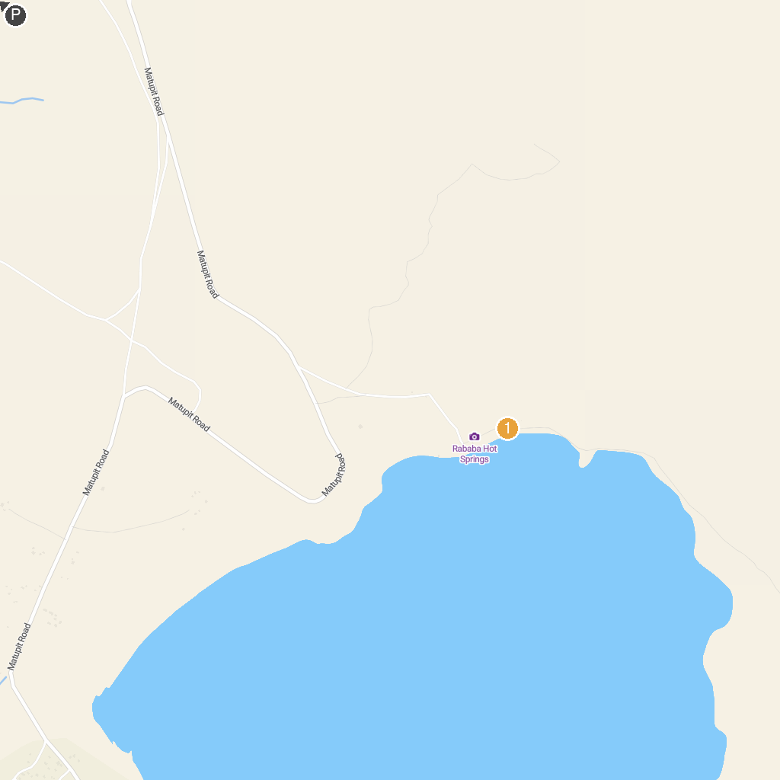
MAP KEY
1. Kokopo War Museum | 2. Rababa Hot Springs
P. Cruise port / terminal
Map © MapTiler © OpenStreetMap contributors · cruiseports.org

