Rabac, Istria, Croatia
A sheltered Istrian cove famed for turquoise waters, Blue Flag pebble beaches, and the hilltop medieval gem of Labin just above — one of Croatia's most underrated cruise stops.
⚓ Tender port (most ships) · 🕒 Typical call: 6–8 hrs · 💶 Currency: Euro (€) · 🗣️ Croatian (English & Italian widely spoken)
✍️ MY DAY IN PORT (FILL IN)
Ship / Date
In port | arrive ______ · all aboard ______
Booked excursion
Notes / meeting point
GETTING ASHORE
- Docking: Tender for most cruise ships; small vessels may dock at harbor pier
- Walk to center: 0 min — tender pier lands in the heart of Rabac
- Best For: Swimming, pebble beaches, Labin old town, Istrian food
- Don't Miss: Labin's coal-mine museum and anti-fascist Labin Republic history
GETTING AROUND
- 🚕 Taxi: €6–10 within Rabac; ~€20 to Labin — Taxis wait near the harbor. The scenic hilltop town of Labin is about 5 km away and makes an excellent half-day excursio
TOP THINGS TO DO
- Rabac Beach Promenade & Blue Flag Beaches — The flat Lungomare promenade stretches miles in both directions from the pier, linking Girandella, Lanterna, Maslinica, and St…
- Labin Old Town & Coal Mine Museum — Ride a taxi or bus up to the medieval hilltop town of Labin — Venetian-era architecture, artists' studios, and a unique 150-m…
- Sentona's Trail: Rabac to Labin Hike — A shaded forest trail with wooden bridges, streams, and waterfalls connecting the resort beach to the hilltop town.
- Istrian Food & Wine Tasting — Istria is one of Europe's great food regions: Kvarner scampi, hand-rolled pasta with black truffles, pršut ham, Malvazija white…
- Fortica Viewpoint, Labin — The highest point of Labin offers panoramic views over Rabac's cove, the Kvarner Gulf, and the Učka mountain range — one of the…
BEST WALKS
- Lungomare Promenade: Harbor to Girandella: 2 km | 25 min | Easy | Flat coastal path — From the harbor pier, head east along the pine-shaded promenade past Lanterna Beach to the…
- Harbor to Maslinica Beach: 1 km | 15 min | Easy | West along promenade — Head west from the pier along the promenade to Maslinica, Rabac's largest beach — family-friendly…
WEATHER · DAYLIGHT · MONEY
Month | High °F | Low °F | Rainy days
May | 69 | 58 | 13
Jul | 84 | 71 | 8
Sep | 74 | 64 | 10
Daylight: May 5:34AM–8:25PM · Jul 5:31AM–8:47PM · Sep 6:42AM–7:13PM
cruiseports.org/rabac · Confirm terminal & all-aboard time with your ship

Rabac, Istria, Croatia — Port Map
Red = walkable sights · Amber = excursions farther out · P = cruise terminal
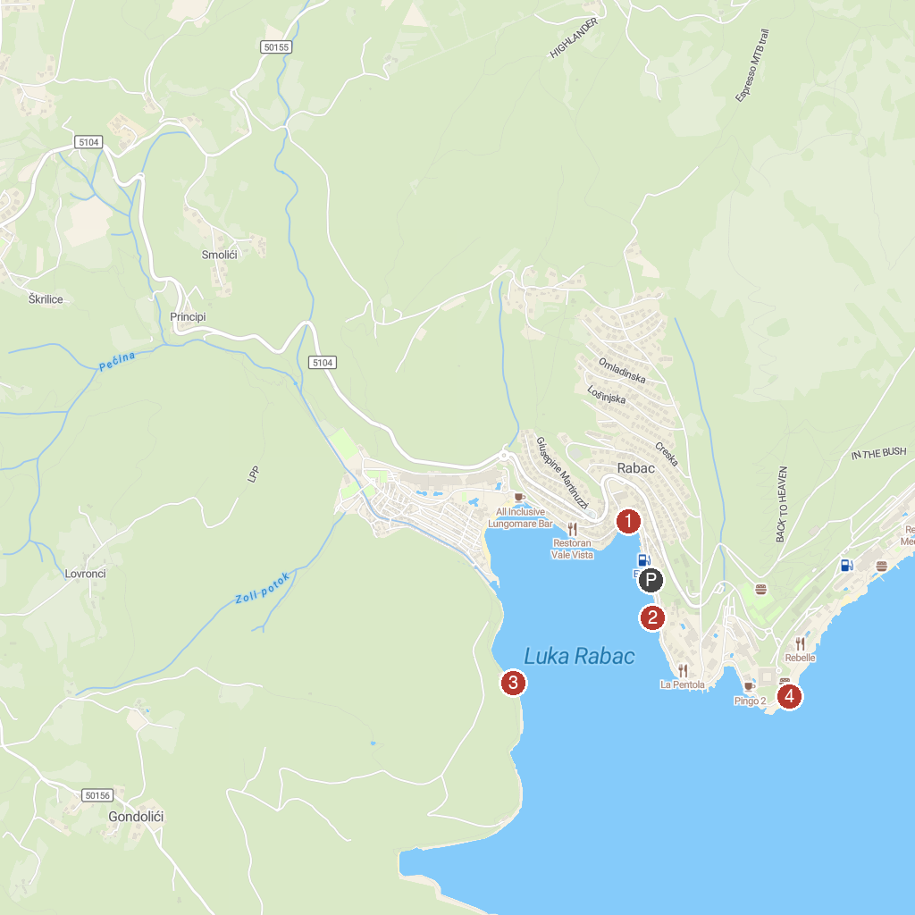
MAP KEY
1. Rabac Center | 3. Povijesna znamenitost - Teleferika
2. Glass boat Rabac | 4. Lanterna Beach
P. Cruise port / terminal
Map © MapTiler © OpenStreetMap contributors · cruiseports.org

