Rab Island, Kvarner Gulf, Croatia
The "Island of Happiness" greets cruise passengers with four soaring medieval bell towers, stone-paved alleys, and some of Croatia's rarest sandy beaches — all steps from the tender dock.
⚓ Tender (small ships may dock at Riva) · 🕒 Typical call: 6–8 hrs · 💶 Currency: Euro (€) · 🗣️ Language: Croatian · 🏛️ UNESCO-listed Old Town
✍️ MY DAY IN PORT (FILL IN)
Ship / Date
In port | arrive ______ · all aboard ______
Booked excursion
Notes / meeting point
GETTING ASHORE
- Docking: Tender to Rab Town harbor (small ships may dock at Riva quay)
- Walk to center: 0 min — you land directly in the Old Town
- Best For: Medieval history, sandy beaches, local food & wine
- Don't Miss: Climbing St. Mary's Bell Tower & tasting Rabska Torta cake
GETTING AROUND
- 🚕 Taxi: €5–€15 — Local taxis wait near the port and can reach other parts of the island such as Lopar beach (about 15 km away). Croatia d
- 📱 Rideshare: ❌ not available
TOP THINGS TO DO
- Four Bell Towers & Old Town Walk — Wander Gornja Ulica (Upper Street) past the four iconic Romanesque bell towers, ducking into St.
- Banova Vala & Padova Beaches — Banova Vala (Governor's Beach) sits at the base of the Old Town walls — a short walk from the pier with sunbeds, a beach bar, and…
- Paradise Beach (Rajska Plaža), Lopar — Croatia's most famous sandy beach stretches 1.5 km at Lopar, on the island's northern tip.
- Rabska Torta Tasting & Demonstration — The House of Rab Cake (Kuća Rabske Torte) is a bakery-museum dedicated to the island's signature dessert — a spiral…
- Kayaking & Coastal Coves — Rent a sea kayak or join a guided tour to reach secluded coves on the Frkanj Peninsula and Suha Punta that are inaccessible by…
BEST WALKS
- Three Streets Old Town Loop: 1.5 km · ~45 min · Easy · Free — From the Riva harbor, enter the Old Town via Trg Svetog Kristofora (St.
- Lungomare Promenade to Padova Beaches: 2.5 km one-way · ~35 min · Easy — Follow the scenic waterfront promenade south from the harbor, hugging the base of the Old Town…
WEATHER · DAYLIGHT · MONEY
Month | High °F | Low °F | Rainy days
May | 74 | 61 | 4
Jul | 81 | 68 | 2
Sep | 79 | 67 | 4
Daylight: May 5:33AM–8:22PM · Jul 5:29AM–8:44PM · Sep 6:39AM–7:13PM
cruiseports.org/rab-island-croatia · Confirm terminal & all-aboard time with your ship

Rab Island, Kvarner Gulf, Croatia — Port Map
Red = walkable sights · Amber = excursions farther out · P = cruise terminal
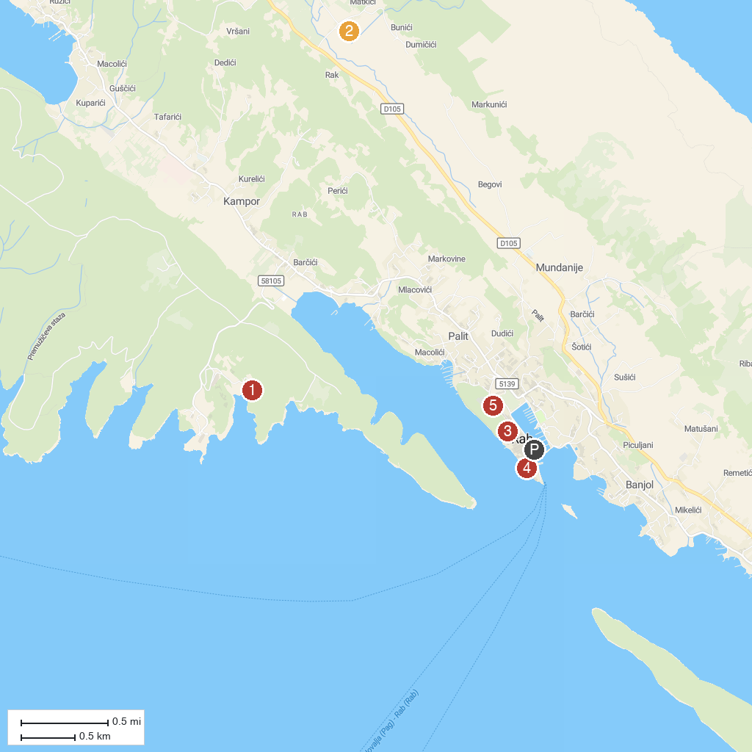
MAP KEY
1. Suha Punta Beach | 5. Town Walls
2. Church of St. Peter | 6. Tower of Rab
3. Zavratnica Cove | 7. Park-šuma Komrčar
4. Northern Velebit National Park
P. Cruise port / terminal
Map © MapTiler © OpenStreetMap contributors · cruiseports.org

