Quiberon, Brittany, France
A wind-swept Atlantic peninsula where dramatic wave-battered cliffs meet calm sandy beaches — Quiberon delivers classic Brittany in one walkable shore day, with ferry access to the island of Belle-Île for those with extra time.
⚓ Tender (no pier) · 🕒 Typical call: 6–8 hrs · 💶 Currency: Euro (€) · 🗣️ Language: French · 🌊 Brittany coast
✍️ MY DAY IN PORT (FILL IN)
Ship / Date
In port | arrive ______ · all aboard ______
Booked excursion
Notes / meeting point
GETTING ASHORE
- Docking: Tender — ships anchor in the Bay of Quiberon; tenders land at Port-Haliguen or Port Maria
- Walk to center: 5 min from Port Maria; 20–25 min from Port-Haliguen (1.8 km flat coastal walk)
- Best For: Scenic coastal walks, Breton food & souvenirs, ferry to Belle-Île, beach time
- Don't Miss: La Belle-Iloise sardine boutique, Côte Sauvage viewpoints, a galette with salted caramel
GETTING AROUND
- 🚕 Taxi: €5–€8 — Taxis available at Port Maria. Short ride to Quiberon town center (approx. 1.5–1.8 km) costs roughly €5–€8. Pick-up char
- 📱 Rideshare: ✅ Uber
TOP THINGS TO DO
- Côte Sauvage Walk — Follow the GR34 coastal path along Quiberon's wild western shore — 8 km of dramatic sea arches, blowholes, and cliff views.
- Ferry Day to Belle-Île-en-Mer — Brittany's largest and most beautiful island sits 45–50 minutes by ferry from Port Maria.
- Carnac Megaliths Excursion — Over 3,000 prehistoric standing stones — older than Stonehenge — are arranged in rows about 20 minutes from Quiberon.
- La Belle-Iloise Cannery & Boutique — Founded in 1932, this gourmet sardine conserverie near Port Maria is a Quiberon institution.
- Thalassa Quiberon Spa Day — Quiberon is the birthplace of French thalassotherapy.
BEST WALKS
- Port Maria to Grande Plage & Town Center: 0.5 km · 5–7 min · Flat · Easy — Step off the tender at Port Maria and walk directly into town.
- Côte Sauvage Viewpoint Walk: 3–4 km round trip · 1.5–2 hrs · Clifftop path · Moderate — From the town center, walk or cycle west to the start of the Côte Sauvage.
- Pointe du Conguel Tip Walk: 2 km · 30 min · Flat · Easy — Head to the southeastern tip of the peninsula for 360° views of the Bay of Quiberon, the Teignouse…
WEATHER · DAYLIGHT · MONEY
Month | High °F | Low °F | Rainy days
May | 60 | 54 | 9
Jul | 68 | 62 | 6
Sep | 66 | 60 | 7
Daylight: May 6:35AM–9:42PM · Jul 6:31AM–10:05PM · Sep 7:50AM–8:24PM
cruiseports.org/quiberon · Confirm terminal & all-aboard time with your ship

Quiberon, Brittany, France — Port Map
Red = walkable sights · Amber = excursions farther out · P = cruise terminal
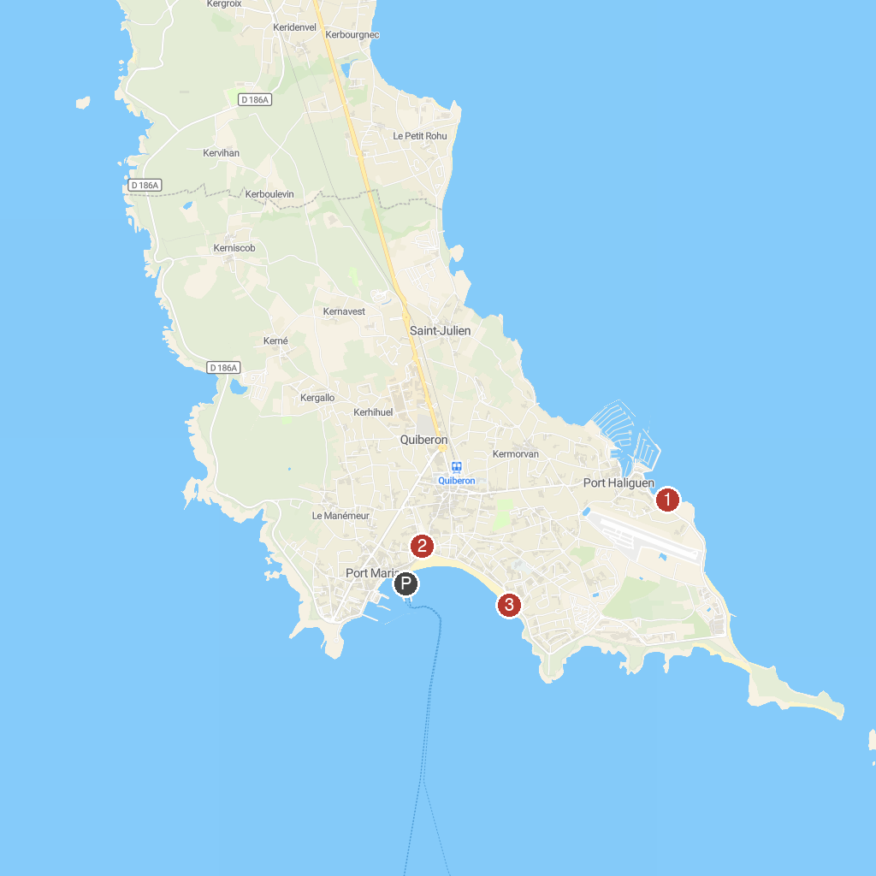
MAP KEY
1. Alignements of Carnac | 5. Abbey of St. Anne Kergonan
2. Ecole de voile A.S.N. Quiberon | 6. PETITS TRAINS TOURISTIQUES LE BAYON QUIBERON
3. Eglise Saint Joseph | 7. Poulains lighthouse
4. Golf Belle Île | 8. Casino de Quiberon
P. Cruise port / terminal
Map © MapTiler © OpenStreetMap contributors · cruiseports.org

