Queenstown, Otago, New Zealand
Ringed by the jagged Remarkables and sitting on the glacial shores of Lake Wakatipu, Queenstown is the world's adventure capital — a compact, walkable resort town where bungy jumping was born and world-class Pinot Noir flows freely.
🚌 Overland transfer (no ocean pier) · 🕒 Typical visit: 1-2 days (cruisetour) · 💵 NZD — cards accepted everywhere · 🗣️ English · ⛷️ Year-round alpine destination
✍️ MY DAY IN PORT (FILL IN)
Ship / Date
In port | arrive ______ · all aboard ______
Booked excursion
Notes / meeting point
GETTING ASHORE
- Docking: No ocean pier — reached by coach/flight from Dunedin or as small-ship embarkation
- Walk to centre: Town is fully walkable; coach/bus drop-off is 3–5 min from waterfront
- Best For: Adventure activities, alpine scenery, fine dining, wine
- Don't Miss: Skyline Gondola & Luge, TSS Earnslaw steamship cruise
GETTING AROUND
- 🚕 Taxi: NZD 10–25 — Taxis are readily available around the town centre and wharf area. Short trips within central Queenstown typically cost
- 📱 Rideshare: ✅ Uber
TOP THINGS TO DO
- Skyline Gondola & Luge — Ride the steepest gondola in the Southern Hemisphere to the summit of Bob's Peak for panoramic views of Lake Wakatipu and the…
- TSS Earnslaw Lake Cruise — Step aboard the iconic 1912 coal-fired steamship for a scenic cruise across Lake Wakatipu to Walter Peak High Country Farm — a…
- Shotover Jet & Canyon — Hold on tight as a jet boat screams through the narrow Shotover River canyon at 85 km/h, spinning 360° within inches of canyon…
- Bungy Jumping — Kawarau Bridge — Leap from the world's first commercial bungy site — the historic Kawarau Gorge Suspension Bridge, 43 m above the river.
- Gibbston Valley Wine Tour — The 'Valley of the Vines' just 25 minutes from Queenstown is New Zealand's highest-altitude wine region, famous for exceptional…
BEST WALKS
- Queenstown Waterfront & Gardens Loop: 3 km · 45 min · Easy · Flat — Start at Steamer Wharf and walk the pebbly shoreline of Queenstown Bay past street performers and…
- Queenstown Hill Time Walk: 4 km return · 2.5 hrs · Moderate · Some steep sections — A rewarding climb through fragrant pine forest from the edge of town to the 'Basket of Dreams' iron…
WEATHER · DAYLIGHT · MONEY
Month | High °F | Low °F | Rainy days
May | 70 | 47 | 3
Jul | 65 | 41 | 4
Sep | 75 | 47 | 6
Daylight: May 6:54AM–5:23PM · Jul 7:11AM–5:26PM · Sep 6:11AM–6:04PM
cruiseports.org/queenstown-nz · Confirm terminal & all-aboard time with your ship

Queenstown, Otago, New Zealand — Port Map
Red = walkable sights · Amber = excursions farther out · P = cruise terminal
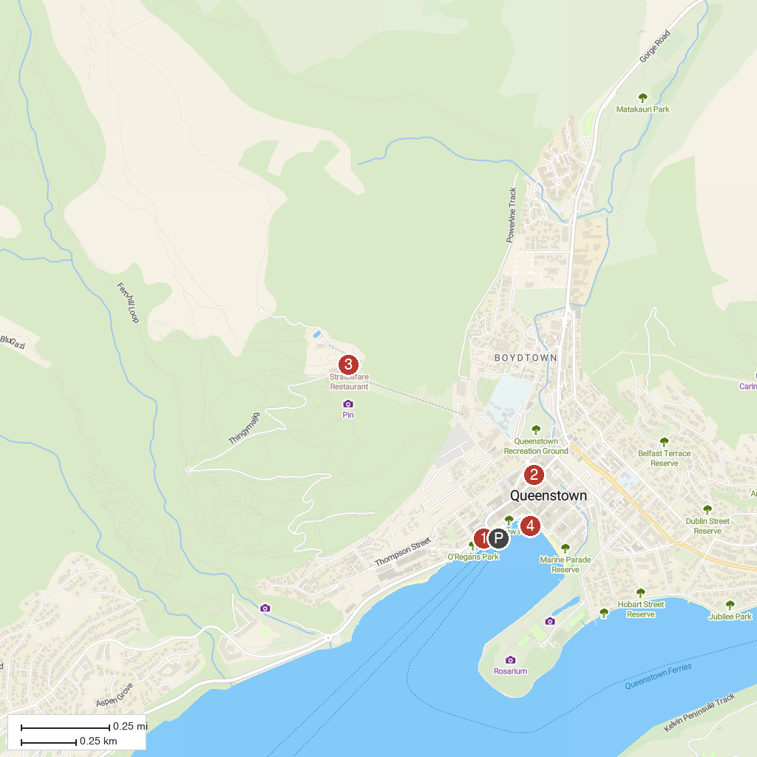
MAP KEY
1. RealNZ | Queenstown Visitor Centre | 3. G Force Paragliding
2. AJ Hackett Bungy - Queenstown Bungy Centre | 4. KJet Queenstown
P. Cruise port / terminal
Map © MapTiler © OpenStreetMap contributors · cruiseports.org

