Quebec City, Quebec, Canada
The only walled city north of Mexico, Quebec City delivers European atmosphere without the transatlantic flight — cobblestoned Petit Champlain, the towering Château Frontenac, and Montmorency Falls all within easy reach of the dock.
⚓ Docked (pier) · 🕒 Typical call: 8-10 hrs · 💵 Canadian Dollar (CAD) · 🗣️ French (English widely spoken)
✍️ MY DAY IN PORT (FILL IN)
Ship / Date
In port | arrive ______ · all aboard ______
Booked excursion
Notes / meeting point
GETTING ASHORE
- Docking: Ross Gaudreault Terminal (Quai 21/22) or Terminal 30 — both dockside, no tender
- Walk to centre: 5-10 min walk to Place Royale / Petit Champlain in Lower Town; funicular or stairs to Upper Town
- Best For: History, architecture, French-Canadian food, scenic walks
- Don't Miss: Terrasse Dufferin at sunset and a poutine in the Old City
GETTING AROUND
- 🚕 Taxi: CAD ~$10–15 — Regulated taxis wait at the terminal. Fares are metered (base CAD $3.50 + $1.75/km); the short ride to Upper Town / Plac
- 📱 Rideshare: ✅ Uber, Lyft
- 🚌 Hop-on hop-off: ✅ Les Tours du Vieux Québec
TOP THINGS TO DO
- Old Quebec Walking Tour — Wander the cobblestone streets of UNESCO-listed Vieux-Québec: Place Royale, the Funicular, Terrasse Dufferin, and the walls of…
- Montmorency Falls — At 83 m (272 ft), Montmorency Falls is 30 m taller than Niagara.
- Plains of Abraham — Battlefields Park was the site of the decisive 1759 battle between British and French forces.
- Île d'Orléans — Cross the bridge to this rural island in the St.
- Sainte-Anne-de-Beaupré Shrine — One of North America's oldest pilgrimage sites, this spectacular basilica about 35 km east of the city is adorned with Gothic…
BEST WALKS
- Lower Town Loop: Waterfront to Place Royale: 1.5 km · 30-45 min · Easy (flat) — From the terminal, walk the Promenade Samuel-De Champlain along the St.
- Upper Town: Château Frontenac & the Walls: 2.5 km · 1-1.5 hrs · Moderate (uphill) — Take the Funicular up from Petit Champlain to Dufferin Terrace, beside the Château Frontenac.
WEATHER · DAYLIGHT · MONEY
Month | High °F | Low °F | Rainy days
May | 64 | 44 | 12
Jul | 77 | 61 | 16
Sep | 68 | 52 | 11
Daylight: May 5:10AM–8:13PM · Jul 5:06AM–8:34PM · Sep 6:23AM–6:55PM
cruiseports.org/quebec-city · Confirm terminal & all-aboard time with your ship

Quebec City, Quebec, Canada — Port Map
Red = walkable sights · Amber = excursions farther out · P = cruise terminal
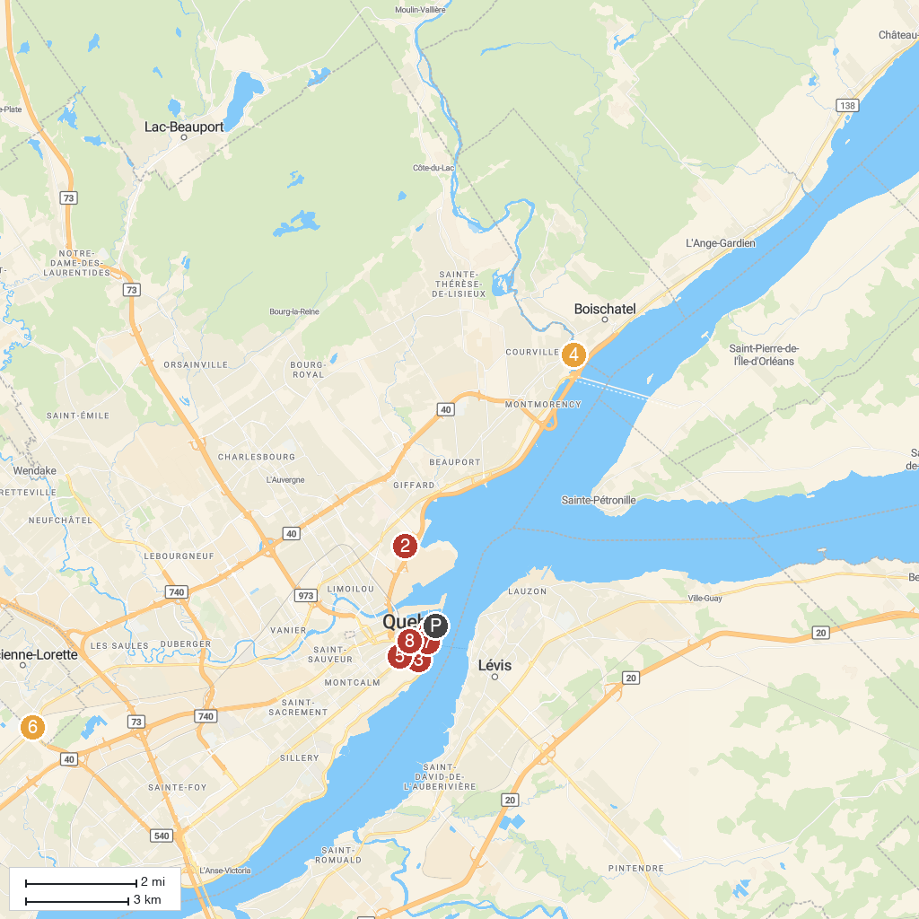
MAP KEY
1. Museum of Civilization | 5. Parliament Building
2. Domaine de Maizerets | 6. Centre Fun Carie Factory
3. The Citadelle of Québec | 7. Funiculaire du Vieux-Québec
4. Montmorency Falls | 8. Morrin Centre
P. Cruise port / terminal
Map © MapTiler © OpenStreetMap contributors · cruiseports.org

