Qingdao, Shandong, China
China's beer capital where Bavarian red-tile roofs meet the Yellow Sea — Tsingtao flows from the source, old German villas line cobblestone lanes, and the beaches are surprisingly excellent.
⚓ Pier (docked) · 🕒 Typical call: 8-10 hrs · 💵 Chinese Yuan (RMB) — mobile pay essential · 🗣️ Mandarin Chinese · 🍺 Beer capital of China
✍️ MY DAY IN PORT (FILL IN)
Ship / Date
In port | arrive ______ · all aboard ______
Booked excursion
Notes / meeting point
GETTING ASHORE
- Docking: Pier — Qingdao International Cruise Home Port, Dagang district
- Port to Center: ~15-20 min by taxi or Metro Line 2 (direct from terminal)
- Best For: History buffs, foodies, beer lovers, beach days
- Don't Miss: Tsingtao Brewery Museum + beer in a bag from street kiosks
GETTING AROUND
- 🚕 Taxi: ¥21–¥35 CNY (~$3–5 USD) — Metered taxis are readily available outside the cruise terminal. Base fare ¥10.50, then ¥2.49/km; the city center (Zhan
- 📱 Rideshare: ✅ DiDi
- 🚌 Hop-on hop-off: ✅
TOP THINGS TO DO
- Tsingtao Brewery Museum — The original 1903 German brewery is Qingdao's top paid attraction.
- German Old Town & Badaguan — Wander tree-lined streets of over 200 European-style villas built during the German concession (1898–1914).
- Zhanqiao Pier & No. 1 Beach — The 440-meter pier jutting into Qingdao Bay is the symbol of the city — its Huilan Pavilion is the Tsingtao Brewery logo.
- Mount Laoshan (Laoshan) — The birthplace of Taoism rises dramatically from the coastline east of the city, with ancient temples, waterfalls, and the spring…
- Seafood & Beer Street Food Tour — Pichai Yuan (劈柴院) is a century-old alley packed with stalls selling spicy stir-fried clams (Qingdao's signature dish), mackerel…
BEST WALKS
- Old Town Loop: Zhanqiao to German Cathedral: 3–4 km • 1.5–2 hrs • Easy — Start at Zhanqiao Pier for the harbor view, walk north through Zhongshan Road's colonial shops…
- Badaguan Villa Walk: 2–3 km • 1 hr • Easy — Stroll the eight tree-canopied lanes of Badaguan where 200+ European villas stand behind garden…
WEATHER · DAYLIGHT · MONEY
Month | High °F | Low °F | Rainy days
May | 68 | 58 | 6
Jul | 81 | 74 | 11
Sep | 78 | 68 | 6
Daylight: May 4:52AM–6:57PM · Jul 4:53AM–7:15PM · Sep 5:41AM–6:05PM
cruiseports.org/qingdao · Confirm terminal & all-aboard time with your ship

Qingdao, Shandong, China — Port Map
Red = walkable sights · Amber = excursions farther out · P = cruise terminal
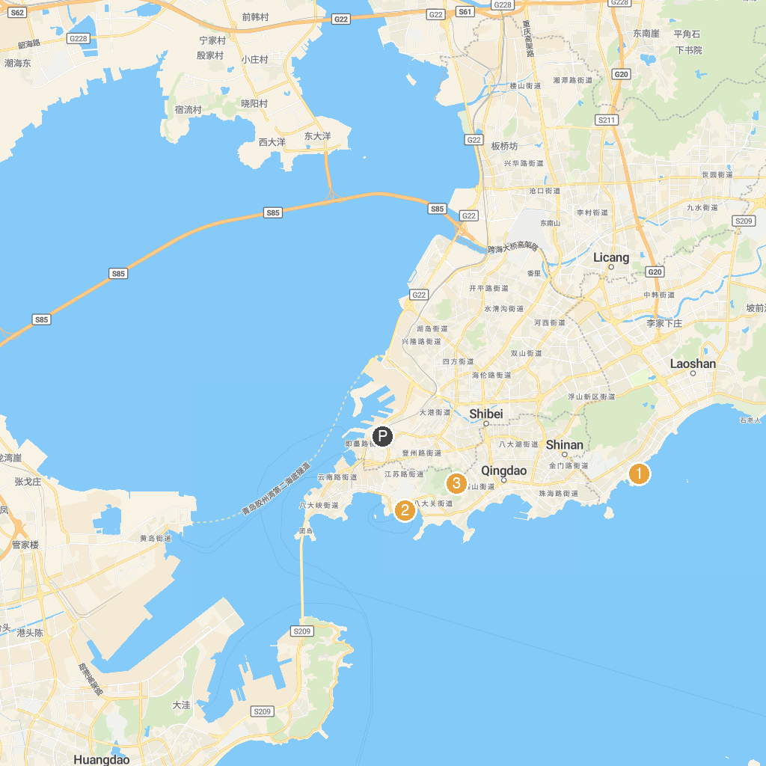
MAP KEY
1. Qingdao Polar Ocean World Co.,Ltd. | 3. Qingdao Zhongshan Park
2. Lu Xun Park
P. Cruise port / terminal
Map © MapTiler © OpenStreetMap contributors · cruiseports.org

