Punta Gorda, Florida, USA
A lovingly rebuilt historic town on Charlotte Harbor, Punta Gorda rewards small-ship visitors with royal-palm-lined streets, 30+ outdoor murals, and one of Florida's most walkable waterfronts.
⚓ Tender (Fishermen's Village docks) · 🕒 Typical call: 6–8 hrs · 💵 USD · 🗣️ English · 🚲 Free bike loaner program
✍️ MY DAY IN PORT (FILL IN)
Ship / Date
In port | arrive ______ · all aboard ______
Booked excursion
Notes / meeting point
GETTING ASHORE
- Docking: Tender to Fishermen's Village marina
- Walk to center: 0–5 min from tender dock to downtown
- Best For: History, murals, waterfront dining, dolphin spotting
- Don't Miss: The 30+ mural trail through the historic district
GETTING AROUND
- 🚕 Taxi: $15–$25 — Local taxis serve the short distance from Fishermen's Village to downtown Punta Gorda. Contact local companies directly
- 📱 Rideshare: ✅ Uber, Lyft
TOP THINGS TO DO
- Historic Mural Trail — Over 30 large-scale murals painted on downtown buildings tell the story of Punta Gorda and Southwest Florida.
- Peace River Wildlife Center — A hands-on wildlife rehabilitation center at Ponce de Leon Park where you can see bald eagles, pelicans, owls, and turtles up…
- Military Heritage Museum — 30,000+ artifacts spanning the Revolutionary War to modern conflicts, with flight simulators and VR experiences.
- King Fisher Fleet Dolphin Cruise — Narrated harbor and sunset cruises departing from Fishermen's Village marina.
- Peace River Botanical & Sculpture Gardens — A 30-acre riverside garden with world-class sculptures woven through rare botanicals along the Peace River.
BEST WALKS
- Harborwalk to Downtown Mural Trail: 2.5 miles round-trip · Easy · 60–90 min — From Fishermen's Village, follow the paved Harborwalk east past Gilchrist Park to Laishley Park…
- Fishermen's Village to Gilchrist Park Loop: 1 mile · Easy · 20–30 min — A short stroll west along the waterfront to Gilchrist Park, with panoramic Charlotte Harbor views…
WEATHER · DAYLIGHT · MONEY
Month | High °F | Low °F | Rainy days
May | 88 | 70 | 12
Jul | 89 | 76 | 24
Sep | 88 | 75 | 22
Daylight: May 6:40AM–8:08PM · Jul 6:44AM–8:23PM · Sep 7:14AM–7:32PM
cruiseports.org/punta-gorda-florida · Confirm terminal & all-aboard time with your ship

Punta Gorda, Florida, USA — Port Map
Red = walkable sights · Amber = excursions farther out · P = cruise terminal
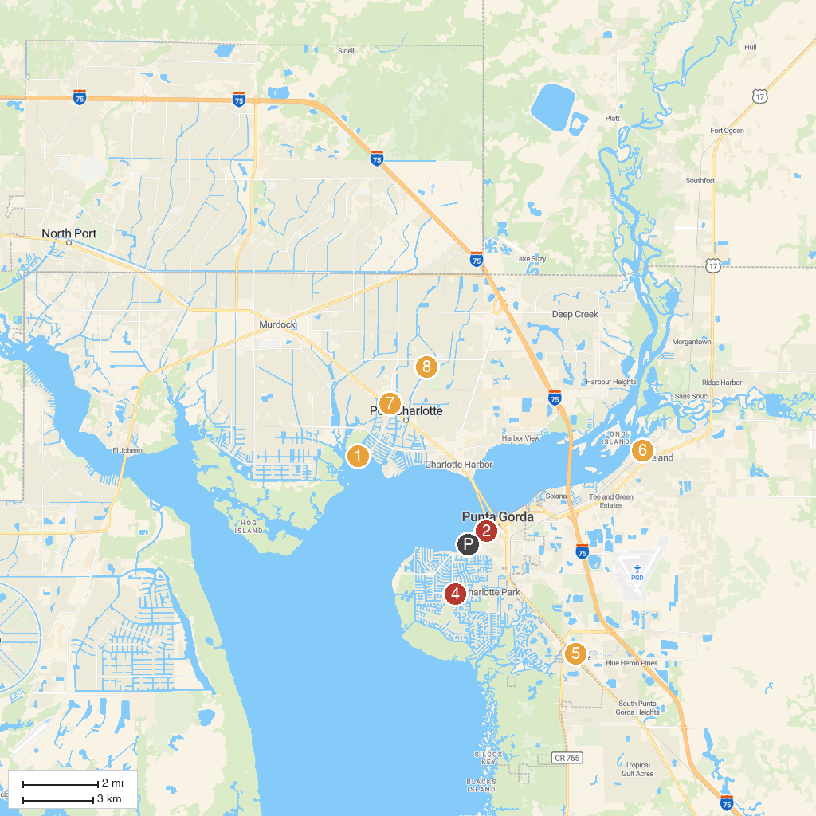
MAP KEY
1. Port Charlotte Beach Park | 5. Allapatchee Shores Park
2. Gilchrist Park | 6. Peace River Botanical & Sculpture Gardens
3. King Fisher Fleet | 7. Amaze Games- Port Charlotte
4. Punta Gorda Nature Park | 8. Lake Betty Park
P. Cruise port / terminal
Map © MapTiler © OpenStreetMap contributors · cruiseports.org

