Punta Gorda, Toledo District, Belize
Belize's southernmost town offers an unhurried, authentic Caribbean experience — Maya ruins rising from jungle, pristine caye snorkeling, and a Garifuna culture alive with drumming and chocolate traditions.
⚓ Tender port · 🕒 Typical call: 7–9 hrs · 💵 Belize Dollar (BZD) & USD accepted · 🗣️ English (official), Garifuna, Kekchi Maya
✍️ MY DAY IN PORT (FILL IN)
Ship / Date
In port | arrive ______ · all aboard ______
Booked excursion
Notes / meeting point
GETTING ASHORE
- Docking: Ships anchor offshore; passengers tender to the Fort Street pier
- Walk to center: Town center is steps from the tender dock — flat and walkable
- Best For: Maya ruins, jungle adventures, snorkeling, Garifuna culture
- Don't Miss: Lubaantun or Nim Li Punit Maya ruins; Sapodilla Cayes snorkeling
GETTING AROUND
- 🚕 Taxi: BZD $5–10 (~$3–5 USD) — Licensed taxis are available at the pier. Fares within town are low given the short distances; negotiate a rate before b
- 📱 Rideshare: ❌ not available
TOP THINGS TO DO
- Lubaantun Maya Ruins — The largest Maya site in southern Belize, Lubaantun ('Place of Fallen Stones') features precisely cut stone structures built…
- Nim Li Punit Stelae Site — This compact Maya site holds 26 stelae — including the longest carved stela in all of Belize — and sweeping views south to the…
- Sapodilla Cayes Snorkel & Beach — A remote group of shallow cayes on the southern edge of the Mesoamerican Barrier Reef.
- Monkey River Wildlife Boat Tour — Cruise the Monkey River by boat through dense jungle to spot howler monkeys, crocodiles, manatees, turtles, and abundant birdlife.
- Garifuna Drumming, Dancing & Dinner — Experience the living Garifuna culture with traditional drumming lessons, dance performances, and an authentic dinner.
BEST WALKS
- Town Center & Market Stroll: 45–60 min | Flat | Easy — A gentle loop from the pier through town, covering the main market (busiest Mon, Wed, Fri, Sat)…
- Cerro Hill Viewpoint: 1–1.5 hrs | Easy climb | Good views — A short walk to the top of Cerro Hill gives panoramic views over Punta Gorda town and the Caribbean…
WEATHER · DAYLIGHT · MONEY
Month | High °F | Low °F | Rainy days
May | 88 | 70 | 12
Jul | 89 | 76 | 24
Sep | 88 | 75 | 22
Daylight: May 6:40AM–8:08PM · Jul 6:44AM–8:23PM · Sep 7:14AM–7:32PM
cruiseports.org/punta-gorda-belize · Confirm terminal & all-aboard time with your ship

Punta Gorda, Toledo District, Belize — Port Map
Red = walkable sights · Amber = excursions farther out · P = cruise terminal
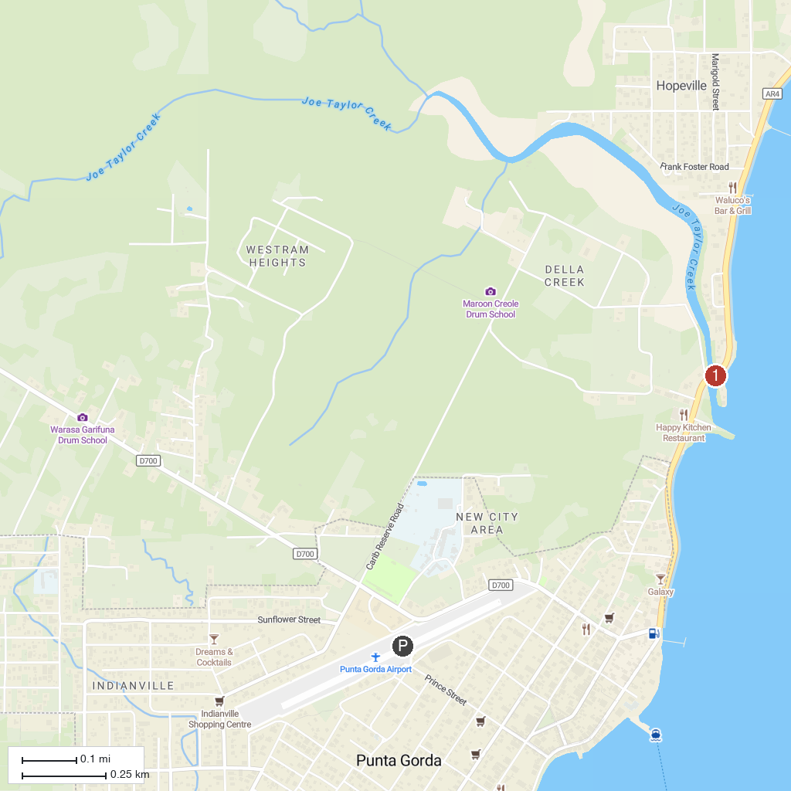
MAP KEY
1. Garbutt's Fishing Lodge | 4. Eladio's Ecofarm & Chocolate
2. Living Maya Experience | 5. Playa Blanca, Livingston
3. Belize Spicefarm and Botanical Gardens
P. Cruise port / terminal
Map © MapTiler © OpenStreetMap contributors · cruiseports.org

