Punta del Este, Uruguay
The 'Saint-Tropez of South America'
🏖️ Beach Luxury · 🛍️ High-End Shopping · 🎨 Art & Culture · 🇺🇾 Uruguayan Charm
✍️ MY DAY IN PORT (FILL IN)
Ship / Date
In port | arrive ______ · all aboard ______
Booked excursion
Notes / meeting point
GETTING ASHORE
- Currency: Uruguayan Peso (UYU)
- Language: Spanish
- Best Time: December to March (Peak Summer)
- Vibe: Upscale & Coastal
GETTING AROUND
- 🚕 Taxi: UYU 48 base + ~UYU 65/km — Taxis are available at the port. The short hop to city center costs little more than the base fare; rides to La Barra or
- 📱 Rideshare: ✅ Uber
TOP THINGS TO DO
- Casapueblo Art Museum — Visit the unique, white-washed architectural masterpiece and art gallery created by Carlos Páez Vilaró.
- Los Fingers Sculpture — See the world-famous 'La Mano' (The Fingers) sculpture, which depicts a giant hand emerging from the sand, a symbol of the city's…
- Punta Ballena Nature Reserve — Explore the rugged coastline and cliffs of the Punta Ballena peninsula, offering panoramic views of the ocean and the city.
- City Center Shopping & Dining — Explore the high-end boutiques and gourmet restaurants in the center of Punta del Este, known for its luxury and glamour.
BEST WALKS
- Beachfront Promenade Walk: Walk from the port along the coast of Playa Brava, enjoying the ocean breeze and the high-end architecture. — A relaxing stroll that takes you from the port to the iconic 'Los Fingers' sculpture.
- City Center Exploration: Walk through the main shopping streets and visit the local markets. — A guided walk through the heart of the city's luxury shopping district.
- Casapueblo Walk: Explore the white-washed walls of the museum and the surrounding cliffs. — A walk through the art gallery and the surrounding nature reserve.
WEATHER · DAYLIGHT · MONEY
Month | High °F | Low °F | Rainy days
May | 64 | 55 | 9
Jul | 58 | 48 | 12
Sep | 61 | 51 | 8
Daylight: May 7:27AM–5:44PM · Jul 7:45AM–5:46PM · Sep 6:39AM–6:31PM
cruiseports.org/punta-del-este · Confirm terminal & all-aboard time with your ship

Punta del Este, Uruguay — Port Map
Red = walkable sights · Amber = excursions farther out · P = cruise terminal
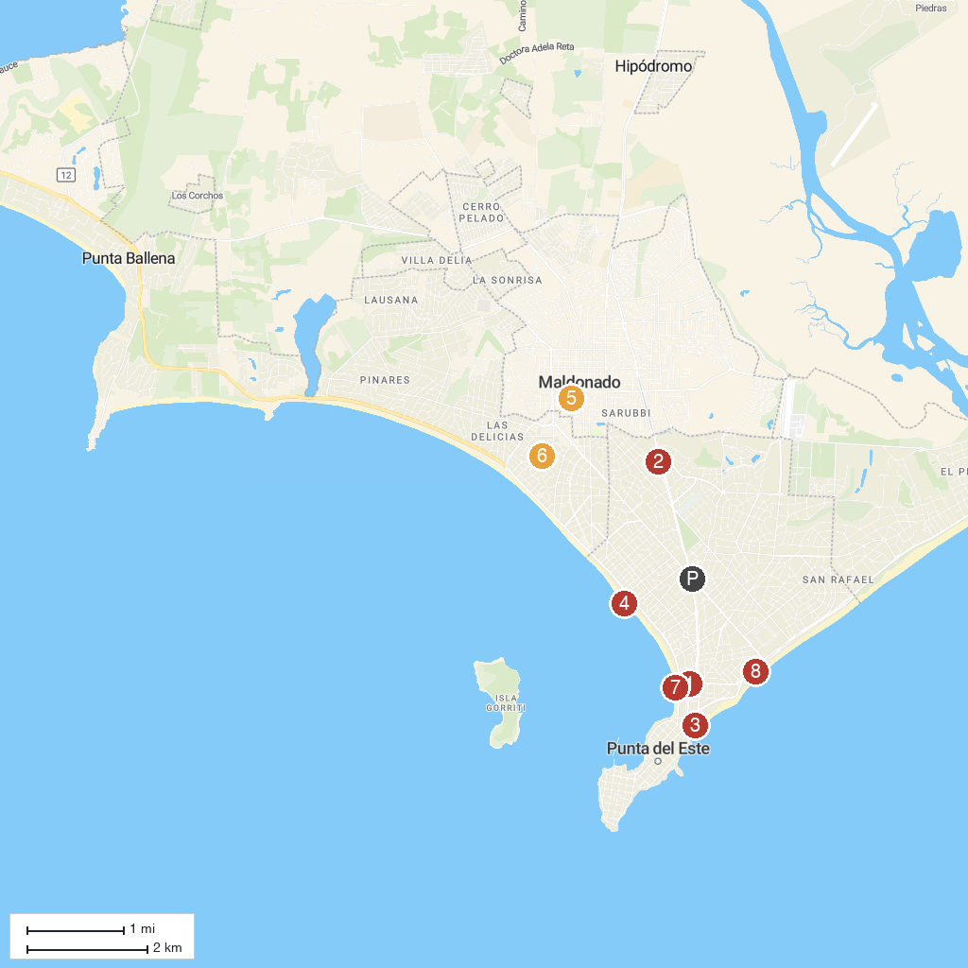
MAP KEY
1. Capilla Nuestra Señora de Fátima "Padre Pío" | 5. Museo Nicolás García Uriburu
2. Azotea de Haedo | 6. Paseo de La Aguada
3. The Fingers of Punta del Este | 7. Playa Mansa
4. Aqua Splash Park | 8. Parada 7 Brava
P. Cruise port / terminal
Map © MapTiler © OpenStreetMap contributors · cruiseports.org

