Punta Cana, La Altagracia, Dominican Republic
Where the Caribbean's longest stretch of palm-lined white sand meets an upscale marina — cruise ships tender into Cap Cana, putting Hoyo Azul, Scape Park, and Juanillo Beach within a short taxi ride.
⚓ Tender port (Cap Cana Marina) · 🕒 Typical call: 7-9 hrs · 💵 USD widely accepted · 🗣️ Spanish (English in tourist zones) · 🌊 Sargassum risk May–Sep
✍️ MY DAY IN PORT (FILL IN)
Ship / Date
In port | arrive ______ · all aboard ______
Booked excursion
Notes / meeting point
GETTING ASHORE
- Docking: Tender — anchor offshore, 15–20 min tender to Cap Cana Marina
- Walk to beach: ~10 min taxi from marina to Juanillo Beach; marina itself is walkable
- Best For: Beaches, eco-adventure (Scape Park/Hoyo Azul), golf, snorkeling
- Don't Miss: Hoyo Azul electric-blue cenote inside Scape Park
GETTING AROUND
- 🚕 Taxi: $15–$25 USD — Official taxis wait at Cap Cana Marina and are the primary transport for cruise passengers. Fares are negotiated — agree
TOP THINGS TO DO
- Hoyo Azul — The Blue Hole — A jaw-dropping natural cenote at the base of a 250-foot limestone cliff, filled with electric-blue water.
- Scape Park Full Experience — Cap Cana's adventure park pairs Hoyo Azul with ziplines, iguana trails, and cave systems.
- Juanillo Beach Day — The finest beach accessible from Cap Cana — shallow turquoise water, powdery white sand, and beach clubs.
- Saona Island Catamaran — Postcard-perfect tropical island with a natural pool and snorkeling.
- Catamaran Snorkel & Open Bar — Sail to a reef site for snorkeling, then cruise with rum punch, merengue music, and open bar.
BEST WALKS
- Cap Cana Marina Stroll: Easy · 30–45 min · Flat paved promenade — From the tender dock, walk along the marina boardwalk past superyachts, boutique shops, and the Api…
WEATHER · DAYLIGHT · MONEY
Month | High °F | Low °F | Rainy days
May | 83 | 77 | 19
Jul | 85 | 78 | 22
Sep | 85 | 78 | 19
Daylight: May 5:59AM–7:00PM · Jul 6:05AM–7:13PM · Sep 6:21AM–6:35PM
cruiseports.org/punta-cana · Confirm terminal & all-aboard time with your ship

Punta Cana, La Altagracia, Dominican Republic — Port Map
Red = walkable sights · Amber = excursions farther out · P = cruise terminal
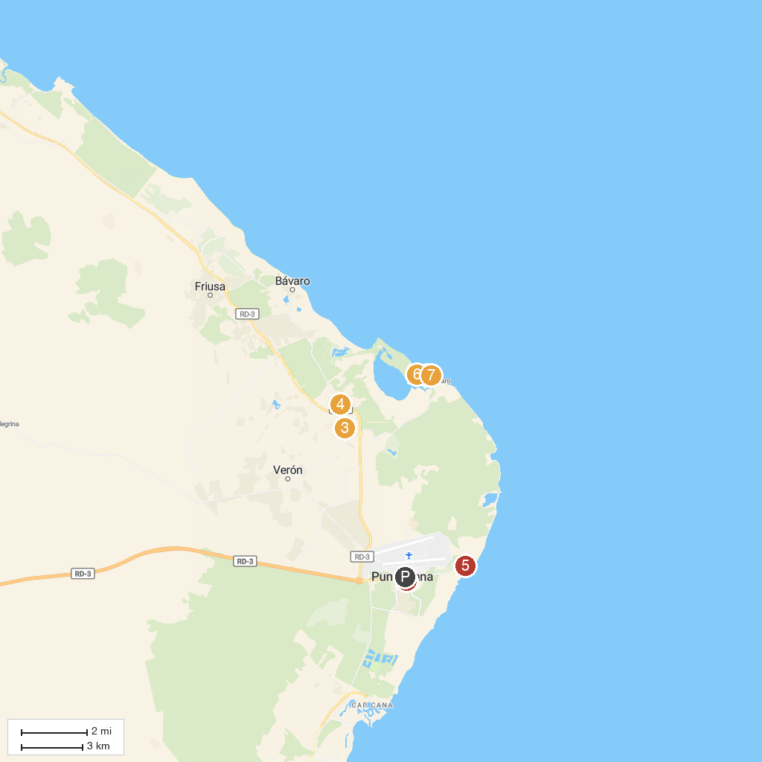
MAP KEY
1. Marinarium Snorkeling Cruise | 5. Downtown Punta Cana
2. Our Lady of the Pillar Parrish | 6. Corales Golf Course, Puntacana Resort & Club
3. Iberostar Bávaro Golf Club | 7. Kviar Show Disco & Casino Punta Cana
4. Fun Buggy Punta Cana | 8. Dolphin Explorer
P. Cruise port / terminal
Map © MapTiler © OpenStreetMap contributors · cruiseports.org

