Langkawi, Kedah, Malaysia
The Jewel of Kedah rises from the Andaman Sea as a duty-free archipelago of 99 islands — limestone karst, eagle-fed mangroves, and a cable car that crests the rainforest canopy.
⚓ Docked (pier) · 🕒 Typical call: 8–10 hrs · 💵 Malaysian Ringgit (MYR) · 🗣️ Malay / English widely spoken · 🛍️ Duty-free island
✍️ MY DAY IN PORT (FILL IN)
Ship / Date
In port | arrive ______ · all aboard ______
Booked excursion
Notes / meeting point
GETTING ASHORE
- Docking: Two pier terminals: Porto Malai (south) and Langkawi Cruise Terminal near Kuah; most large ships dock directly
- Walk to center: Porto Malai: 5 min to Resorts World complex; Kuah Jetty: 10 min walk to Eagle Square and town
- Best For: Nature lovers, duty-free shoppers, beach days, and cable-car thrill-seekers
- Don't Miss: Langkawi SkyCab & Sky Bridge on Gunung Machinchang and a mangrove kayak in Kilim Karst Geoforest Park
GETTING AROUND
- 🚕 Taxi: RM 80–100 (~$17–22 USD) to Kuah Town — Fixed-rate taxis (no meters) wait at Porto Malai cruise dock. Walk ~200m to the port exit for potentially lower fares; a
- 📱 Rideshare: ✅ Grab
TOP THINGS TO DO
- Langkawi SkyCab & Sky Bridge — Ride one of the world's steepest cable cars to the summit of Gunung Machinchang (708 m), then walk the 125 m curved Sky Bridge…
- Kilim Karst Mangrove Tour — Boat through the UNESCO-listed Kilim Karst Geoforest Park past limestone sea caves, watch wild eagles snatched fish from the…
- Pantai Cenang Beach Day — Langkawi's most popular beach is about 15 minutes from the cruise terminals.
- Island Hopping — A classic Langkawi half-day: speedboat to Dayang Bunting Marble Geoforest Park to swim in the freshwater Lake of the Pregnant…
- Kuah Town & Eagle Square Walk — Eagle Square (Dataran Lang) is a 5-minute walk from Kuah Jetty — a giant eagle sculpture overlooking the sea, flanked by gardens…
BEST WALKS
- Kuah Waterfront & Eagle Square Stroll: 1–1.5 hrs | Easy | From Kuah Jetty terminal — Walk south from the Kuah Jetty terminal along the waterfront promenade to Eagle Square (Dataran…
- Porto Malai Waterfront Walk: 30–45 min | Easy | From Porto Malai terminal — A casual stroll along the Porto Malai waterfront adjacent to Resorts World Langkawi, with views…
WEATHER · DAYLIGHT · MONEY
Month | High °F | Low °F | Rainy days
May | 87 | 77 | 24
Jul | 86 | 76 | 20
Sep | 86 | 76 | 23
Daylight: May 6:01AM–6:23PM · Jul 6:09AM–6:34PM · Sep 6:07AM–6:15PM
cruiseports.org/pulau-langkawi-island · Confirm terminal & all-aboard time with your ship

Langkawi, Kedah, Malaysia — Port Map
Red = walkable sights · Amber = excursions farther out · P = cruise terminal
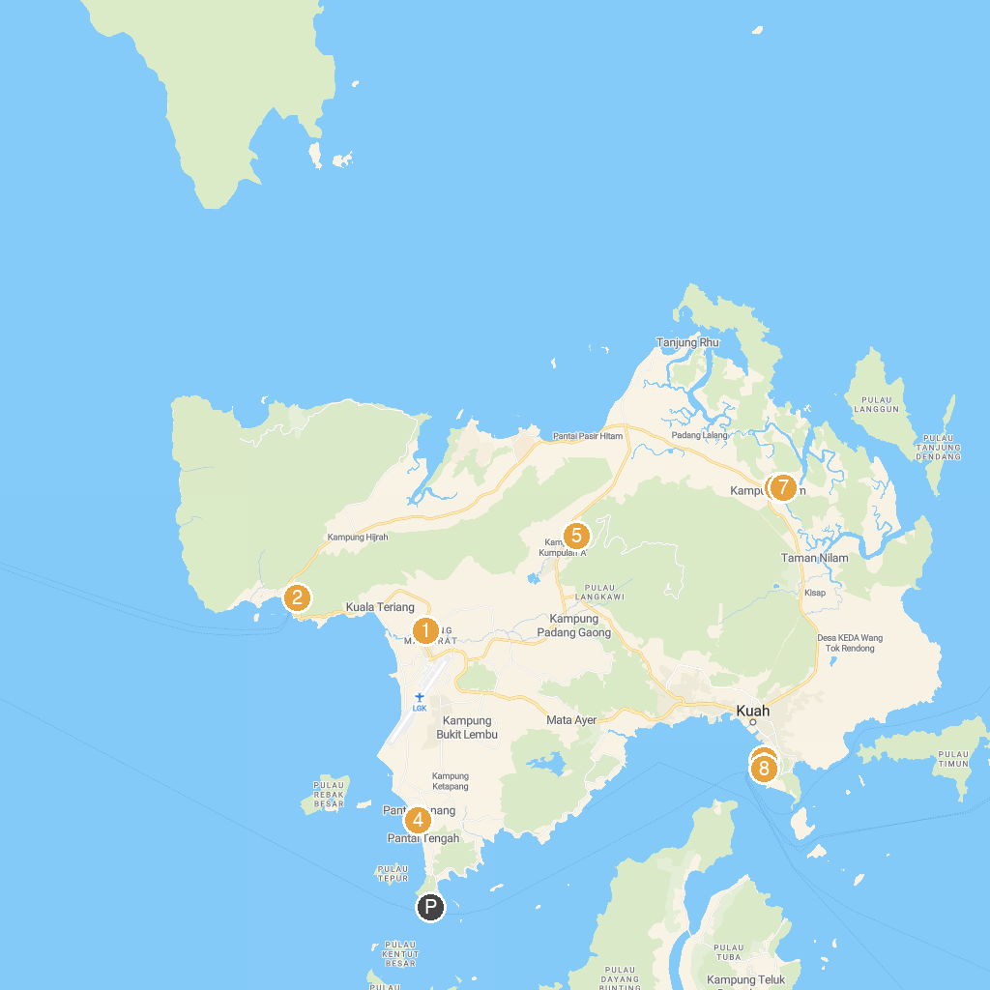
MAP KEY
1. Beras Terbakar, Kampung Raja, Langkawi, Kedah. | 5. Fauna Flora Eco
2. Telaga Harbour Marina | 6. Langkawi Mangrove Santai-Santai@Kilim Geopark
3. Dataran Lang | 7. Kilim Geoforest Park
4. Underwater World Langkawi | 8. Kuah Jetty
P. Cruise port / terminal
Map © MapTiler © OpenStreetMap contributors · cruiseports.org

