Komodo Island, East Nusa Tenggara, Indonesia
Home to the world's largest lizard and some of Indonesia's most pristine coral reefs, Komodo Island is raw, remote, and genuinely wild — a UNESCO World Heritage site where every visitor walks with an armed ranger.
⚓ Tender (no pier) · 🕒 Typical call: 5–8 hrs · 💵 Indonesian Rupiah (IDR) — no ATMs on island · 🗣️ Indonesian / Bahasa · 🦎 Wildlife destination
✍️ MY DAY IN PORT (FILL IN)
Ship / Date
In port | arrive ______ · all aboard ______
Booked excursion
Notes / meeting point
GETTING ASHORE
- Docking: Tender only — ships anchor in Loh Liang Bay; 10–15 min ride to ranger jetty
- Walk to Park Entrance: ~400 m / 5 min flat walk from jetty to Loh Liang Ranger Station
- Best For: Komodo dragons, Pink Beach, snorkeling, dramatic volcanic scenery
- Don't Miss: The short or medium dragon trek at Loh Liang — highest chance of close-up sightings
GETTING AROUND
- 📱 Rideshare: ❌ not available
TOP THINGS TO DO
- Komodo Dragon Trek (Short Trail) — The classic Loh Liang loop takes about an hour through shaded forest to a watering hole where dragons congregate.
- Long Trek to the Savanna Ridges — A strenuous 2+ hour hike through dry savanna and up the hills behind Loh Liang rewards fit hikers with panoramic views over Loh…
- Pink Beach (Pantai Merah) Snorkel Tour — A 15-minute local boat ride from the jetty reaches one of the world's handful of pink sand beaches, colored by red Foraminifera…
- Padar Island Viewpoint Hike — The icon of Komodo National Park — a roughly 30-minute climb up around 800 wooden steps to a ridge overlooking three crescent…
- Snorkeling & Island-Hopping by Phinisi — Traditional wooden phinisi schooners run half-day circuits combining Komodo dragon trekking, Pink Beach swimming, and snorkeling…
BEST WALKS
- Loh Liang Ranger Station Loop (Short Trail): 1 hr | Easy | Ranger required — From the jetty, follow the flat path to the ranger station, then walk the short loop through shaded…
- Jetty to Souvenir Market Stroll: 10 min | Very easy | No ranger needed — A short flat walk from the tender jetty along the waterfront path to the small local market outside…
WEATHER · DAYLIGHT · MONEY
Month | High °F | Low °F | Rainy days
May | 80 | 74 | 9
Jul | 78 | 72 | 4
Sep | 81 | 72 | 4
Daylight: May 6:06AM–5:50PM · Jul 6:18AM–5:58PM · Sep 5:56AM–5:58PM
cruiseports.org/pulau-komodo-island · Confirm terminal & all-aboard time with your ship

Komodo Island, East Nusa Tenggara, Indonesia — Port Map
Red = walkable sights · Amber = excursions farther out · P = cruise terminal
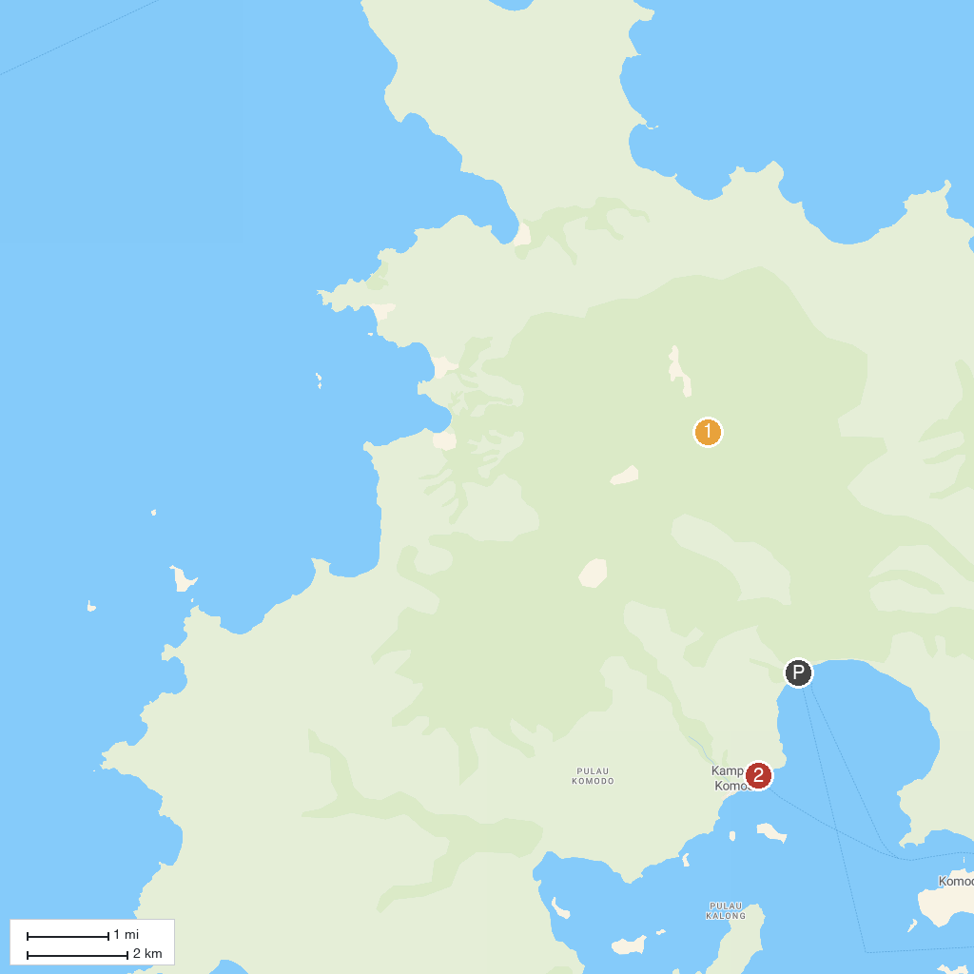
MAP KEY
1. Komodo National Park | 2. Komodo Tourism Village
P. Cruise port / terminal
Map © MapTiler © OpenStreetMap contributors · cruiseports.org

