Flores (Maumere / Ende / Larantuka), Indonesia
The cultural heart of Flores. Cruise lines call at the central and eastern Flores ports — Maumere, Ende, or Larantuka — the gateway to the surreal tri-colored crater lakes of Kelimutu, ikat-weaving villages, and a coastline shaped by volcanoes and Portuguese-Catholic heritage. (Komodo National Park is a separate port of call far to the west.)
⚓ Tender / small berth port · 🕒 Typical call: 6–10 hrs · 💵 Indonesian Rupiah (IDR) — bring cash · 🗣️ Indonesian / local Florinese languages · 🌋 Gateway to Kelimutu's tri-colored lakes
✍️ MY DAY IN PORT (FILL IN)
Ship / Date
In port | arrive ______ · all aboard ______
Booked excursion
Notes / meeting point
GETTING ASHORE
- Docking: Varies by port — Larantuka has a ~110 m berth for smaller ships; larger vessels tender at Maumere, Ende, or Larantuka
- Walk to center: Short — port areas sit near or within the respective town centers (Maumere, Ende, Larantuka)
- Best For: Kelimutu crater lakes, ikat-weaving villages, volcanic scenery, Catholic-Portuguese heritage
- Don't Miss: The tri-colored crater lakes of Kelimutu (best reached from Ende or Maumere)
GETTING AROUND
- 🚕 Taxi: Rp 30,000–80,000 (~$2–5 USD) — Taxis and private cars wait near all three ports. Fares are negotiated — agree on a price before you get in. Short town-
- 📱 Rideshare: ✅ Grab, Maxim
TOP THINGS TO DO
- Kelimutu Tri-Colored Crater Lakes — Flores's signature sight: three crater lakes near the summit of Kelimutu volcano that shift between turquoise, green, brown, and…
- Larantuka — Portuguese-Catholic Heritage — On the eastern tip of Flores, Larantuka carries an enduring Portuguese colonial and Catholic legacy.
- Ikat Weaving Village Visit — Flores is renowned for hand-woven ikat textiles, each region with its own motifs and natural dyes.
- Maumere Bay Snorkeling & Diving — Maumere Bay was once one of Indonesia's premier dive areas; after a 1992 earthquake and tsunami the reefs have been steadily…
- Bung Karno Exile House, Ende — In Ende, visit the modest house where Indonesia's first president, Sukarno, lived in political exile in the 1930s — a quietly…
BEST WALKS
- Maumere Waterfront & Market: 30–45 min | Flat | No cost — From the Maumere pier, walk into town along the waterfront to the local market and main street…
- Larantuka Town & Cathedral: 30–45 min | Flat | Free — From the Larantuka berth, stroll the waterfront and into town to see the cathedral and the small…
WEATHER · DAYLIGHT · MONEY
Month | High °F | Low °F | Rainy days
May | 85 | 76 | 12
Jul | 84 | 73 | 7
Sep | 85 | 73 | 9
Daylight: May 6:05AM–5:48PM · Jul 6:16AM–5:56PM · Sep 5:54AM–5:57PM
cruiseports.org/pulau-flores-island-indonesia · Confirm terminal & all-aboard time with your ship

Flores (Maumere / Ende / Larantuka), Indonesia — Port Map
Red = walkable sights · Amber = excursions farther out · P = cruise terminal
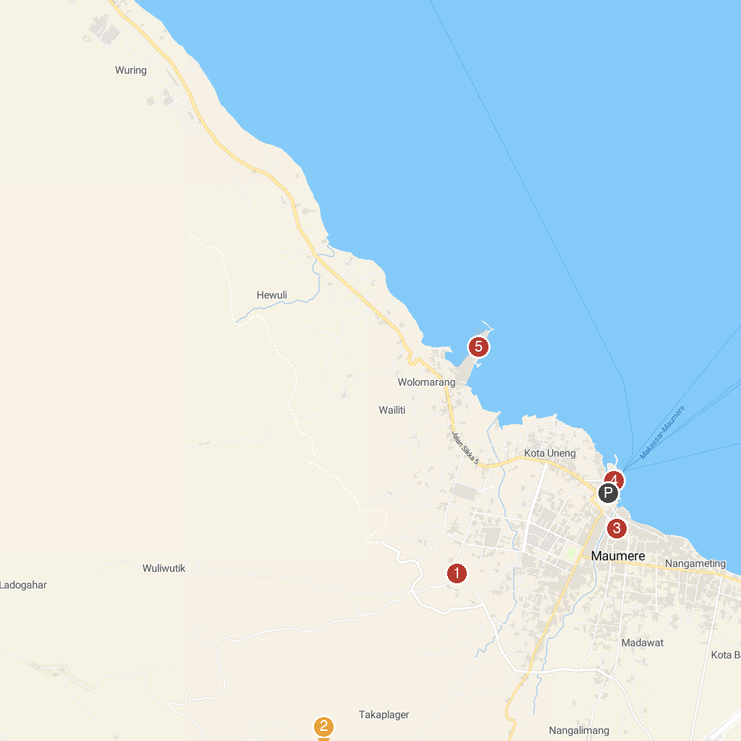
MAP KEY
1. Biara Karmel Beato Dionisius, Maumere | 4. Taman Kota Maumere
2. Museum Bikon Blewut | 5. Pelabuhan L. Say Maumere
3. Sanggar Budaya Tenun Bliran Sina - Watublapi | 6. Wuring
P. Cruise port / terminal
Map © MapTiler © OpenStreetMap contributors · cruiseports.org

