Bintan Island, Riau Islands, Indonesia
Bintan plays a compelling double game: a polished resort zone with white-sand beaches and Southeast Asia's largest saltwater lagoon in the north, and the historic Riau Sultanate heartland — stilt villages, jungle temples, and gonggong sea snails — an hour south.
⚓ Tender or pier (varies by ship/area) · 🕒 Typical call: 7–9 hrs · 💵 IDR (SGD widely accepted in resort zone) · 🗣️ Indonesian (Bahasa) · 🌴 Resort & culture combo
✍️ MY DAY IN PORT (FILL IN)
Ship / Date
In port | arrive ______ · all aboard ______
Booked excursion
Notes / meeting point
GETTING ASHORE
- Docking: Tender to BBT Ferry Terminal (Lagoi) for most ships; some dock at Tanjung Pinang
- Walk to centre: No walkable centre — transport required from tender dock
- Best For: Beach resorts, crystal lagoon, wildlife sanctuary, historic Penyengat Island
- Don't Miss: Gonggong sea snails, Penyengat Island mosque, Treasure Bay Crystal Lagoon
GETTING AROUND
- 🚕 Taxi: IDR 280,000–550,000 (~$17–34 USD) — Metered taxis are rare; most services use fixed fares. From Bandar Bentan Telani (BBT) Ferry Terminal to Tanjung Pinang
- 📱 Rideshare: ✅ Grab, Gojek
TOP THINGS TO DO
- Treasure Bay Crystal Lagoon — Southeast Asia's largest man-made saltwater lagoon — 50 Olympic pools in size — with kayaking, paddleboarding, wakeboarding, ATV…
- Penyengat Island & the Yellow Mosque — Take a short pompong (wooden boat) from Tanjung Pinang to this former seat of the Riau-Lingga Sultanate.
- Safari Lagoi & Eco Farm — A sanctuary for rescued Indonesian wildlife including orangutans, sun bears, komodo dragons, and elephants, paired with a working…
- Gurun Pasir Busung & Telaga Biru — A former clay quarry transformed into surreal white sand dunes ('Bintan's Sahara') beside a vivid turquoise lake — Telaga Biru.
- Senggarang Water Village & Chinese Temples — One of Bintan's oldest Chinese settlements, with stilted houses over the water and centuries-old temples whose roots literally…
BEST WALKS
- Lagoi Beach Promenade: 1–2 km | Easy | ~30 min — From Plaza Lagoi, walk along the white-sand Lagoi Beach shoreline.
- Tanjung Pinang Waterfront (with driver): 1 km | Easy | 30 min walk + 1 hr drive each way — If your call is long enough to reach the south, the Tanjung Pinang waterfront is a bustling…
WEATHER · DAYLIGHT · MONEY
Month | High °F | Low °F | Rainy days
May | 85 | 79 | 27
Jul | 84 | 79 | 19
Sep | 85 | 78 | 19
Daylight: May 5:53AM–6:03PM · Jul 6:03AM–6:13PM · Sep 5:54AM–6:00PM
cruiseports.org/pulau-bintan-island-indonesia · Confirm terminal & all-aboard time with your ship

Bintan Island, Riau Islands, Indonesia — Port Map
Red = walkable sights · Amber = excursions farther out · P = cruise terminal
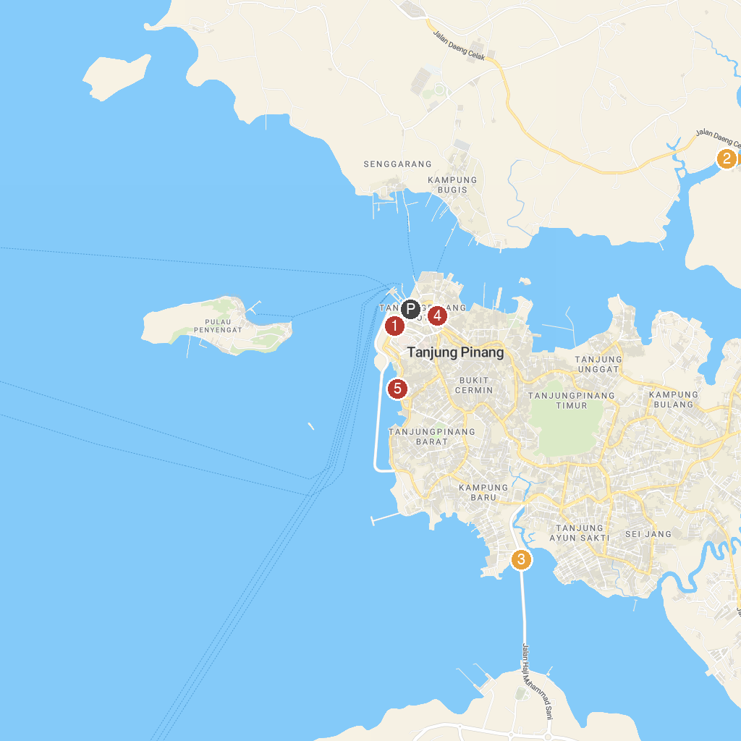
MAP KEY
1. Taman Tepi Laut | 4. Museum of Sultan Sulaiman Badrul Alamsyah
2. Avalokitesvara Graha Vihara | 5. Tugu Pensil
3. Menara Jembatan Dompak
P. Cruise port / terminal
Map © MapTiler © OpenStreetMap contributors · cruiseports.org

