Belitung Island, Bangka-Belitung, Indonesia
Colossal granite boulders tumble into crystal-clear turquoise water along Belitung's coastline—a dramatic landscape unlike anywhere else in Southeast Asia. Island-hop to a 19th-century Dutch lighthouse, snorkel pristine reefs, and fuel up on aromatic kettle-brewed coffee poured since 1943.
⚓ Tender (anchor offshore) · 🕒 Typical call: 7–9 hrs · 💵 Indonesian Rupiah (IDR) — cash essential · 🗣️ Bahasa Indonesia · 🏖️ Beach & nature focus
✍️ MY DAY IN PORT (FILL IN)
Ship / Date
In port | arrive ______ · all aboard ______
Booked excursion
Notes / meeting point
GETTING ASHORE
- Docking: Tender — ships anchor offshore; boats ferry passengers to Tanjung Pandan pier
- Walk to Center: Town center is near the tender dock; beaches are 15–30 min by car
- Best For: Island hopping, granite-boulder beaches, snorkeling, photography
- Don't Miss: Lengkuas Island lighthouse and Tanjung Tinggi Beach granite formations
GETTING AROUND
- 🚕 Taxi: IDR 75,000–200,000 (~$5–13 USD) — Taxis wait at the port and can take you to Tanjung Pandan city center in 10–15 minutes. Negotiate fare before departure
- 📱 Rideshare: ✅ Grab, GoJek, Maxim
TOP THINGS TO DO
- Island-Hopping Boat Tour — A half-day speedboat circuit visiting Lengkuas Island (Dutch lighthouse, 1882), Batu Berlayar (Sailing Rock), and Kepayang Island…
- Tanjung Tinggi Beach & Granite Boulders — The most photographed beach on Belitung—huge round granite boulders scatter across white sand and lap into calm, clear water.
- Lengkuas Island Lighthouse Climb — Board a local wooden boat to Lengkuas Island and climb the 18-floor Dutch colonial lighthouse built in 1882.
- Kaolin Lake Photography Stop — A former tin-mining pit now filled with vivid blue-white water surrounded by chalk-white mineral banks—an otherworldly landscape…
- Tanjung Pandan Town & Kopi Kong Djie — The island's capital is a laid-back market town with Chinese-Malay heritage shophouses.
BEST WALKS
- Tanjung Pandan Waterfront & Town Centre: 1.5 km · 30 min · Easy · Free — From the tender jetty, walk along the waterfront promenade past fishing boats to the Satam Monument…
- Tanjung Tinggi Beach Granite Walk: ~1 km along beach · 45 min · Easy · Free entry — Arriving by car/driver (30 min from pier), stroll the white-sand beach weaving between enormous…
WEATHER · DAYLIGHT · MONEY
Month | High °F | Low °F | Rainy days
May | 85 | 77 | 27
Jul | 85 | 76 | 18
Sep | 87 | 76 | 14
Daylight: May 5:46AM–5:45PM · Jul 5:56AM–5:54PM · Sep 5:42AM–5:47PM
cruiseports.org/pulau-belitung-island-indonesia · Confirm terminal & all-aboard time with your ship

Belitung Island, Bangka-Belitung, Indonesia — Port Map
Red = walkable sights · Amber = excursions farther out · P = cruise terminal
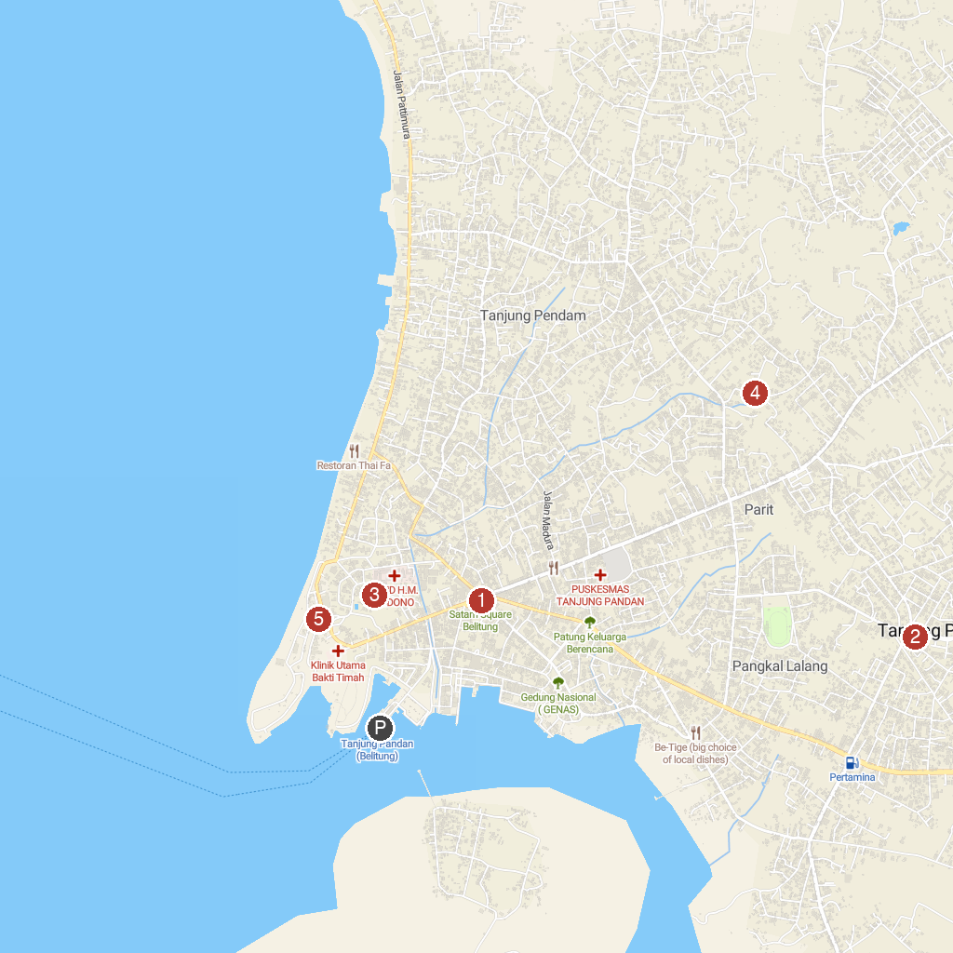
MAP KEY
1. Bundaran Satam Belitung | 4. Paket Tour Wisata Belitung Terbaik - Hopping Belitung Tour & Travel
2. Traditional House Belitung | 5. Tanjung Pendam Beach
3. Museum & Zoo Tanjungpandan
P. Cruise port / terminal
Map © MapTiler © OpenStreetMap contributors · cruiseports.org

