Ambon, Maluku, Indonesia
Once fought over by European empires for its nutmeg and cloves, Ambon is now a vibrant UNESCO City of Music with colonial forts, volcanic beaches, and some of the world's most biodiverse dive sites.
⚓ Pier (Yos Sudarso Port) · 🕒 Typical call: 7-9 hrs · 💵 Indonesian Rupiah (IDR) — cash essential · 🗣️ Indonesian / Ambonese Malay
✍️ MY DAY IN PORT (FILL IN)
Ship / Date
In port | arrive ______ · all aboard ______
Booked excursion
Notes / meeting point
GETTING ASHORE
- Docking: Alongside pier at Yos Sudarso Port, Ambon City
- Walk to center: 5-10 min (400 m) from gangway to port gates; city sights within 15-20 min on foot
- Best For: History buffs, divers, foodies, off-the-beaten-path explorers
- Don't Miss: Fort Amsterdam in Hila, Tiahahu Monument panorama, Kopi Rarobang at Cafe Sibu-Sibu
GETTING AROUND
- 🚕 Taxi: IDR 50,000–100,000 ($3–$6 USD) — Taxis wait at Yos Sudarso Port and can reach the city center in about 10 minutes (roughly 3 km). Negotiate the fare befo
- 📱 Rideshare: ✅ Grab, Maxim
TOP THINGS TO DO
- Fort Amsterdam & Old Spice Villages (Hila) — Drive an hour north to Hila on the island's north coast to see the beautifully preserved 17th-century Dutch fort built on…
- City Walk: Peace Gong & Tiahahu Monument — Stroll to the World Peace Gong park (10 min from port), then take a taxi up to the Martha Christina Tiahahu Monument for the best…
- Liang (Hunimua) Beach — Powdery white sand and incredibly clear turquoise water on Ambon's northeast coast.
- Ambon Bay Muck Diving — Ambon Bay is world-famous among divers for extreme marine biodiversity — psychedelic frogfish, flamboyant cuttlefish, and rare…
- Siwalima Museum & WWII Cemetery — The premier cultural museum of Maluku holds tribal artifacts, traditional clothing, and a marine history wing with a giant whale…
BEST WALKS
- Port to World Peace Gong & Fort Victoria: 1-1.5 hrs | Easy | 1.5 km round-trip — Walk from the port gates along Jalan A.Y.
- Ambon City Market & Waterfront: 45 min | Easy | 1 km — Head out the port gates and stroll along the waterfront to the central Pasar Mardika market.
WEATHER · DAYLIGHT · MONEY
Month | High °F | Low °F | Rainy days
May | 83 | 77 | 28
Jul | 80 | 76 | 27
Sep | 81 | 76 | 22
Daylight: May 6:25AM–6:21PM · Jul 6:35AM–6:30PM · Sep 6:20AM–6:24PM
cruiseports.org/pulau-ambon-island-indonesia · Confirm terminal & all-aboard time with your ship

Ambon, Maluku, Indonesia — Port Map
Red = walkable sights · Amber = excursions farther out · P = cruise terminal
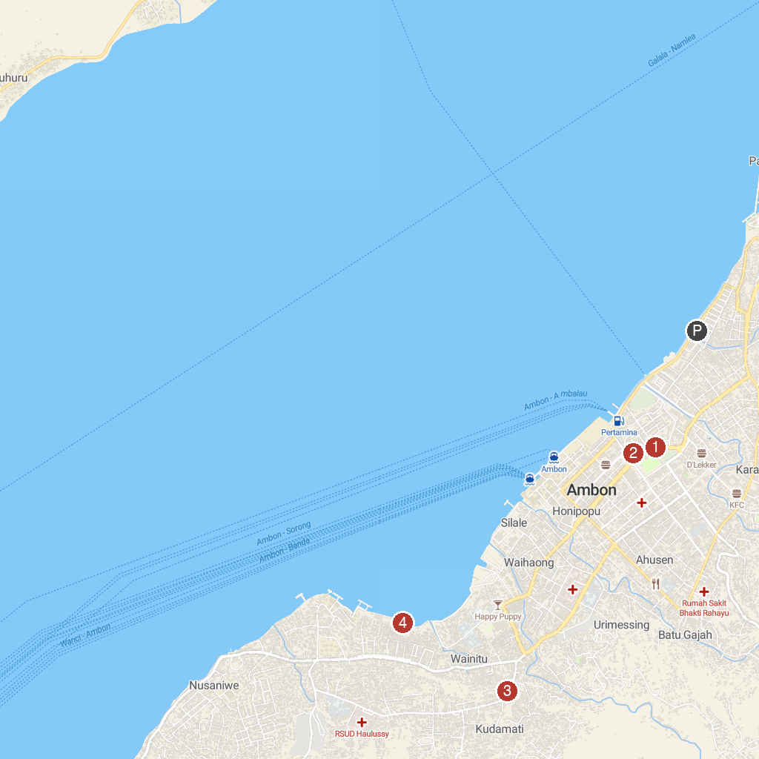
MAP KEY
1. Nieuw Victoria Fort | 3. Tugu Dolan
2. Monumen Gong Perdamaian Dunia | 4. Pantai Wainitu
P. Cruise port / terminal
Map © MapTiler © OpenStreetMap contributors · cruiseports.org

