Puerto Princesa, Palawan, Philippines
Gateway to the Philippines' most spectacular nature, Puerto Princesa pairs a UNESCO World Heritage underground river with pristine island-hopped sandbars, a remarkably litter-free city, and a food scene shaped by Vietnamese refugees.
⚓ Pier (cruise terminal) · 🕒 Typical call: 8–10 hrs · 💵 Philippine Peso (PHP) · 🗣️ English widely spoken · 🌿 Eco-Tourism Capital
✍️ MY DAY IN PORT (FILL IN)
Ship / Date
In port | arrive ______ · all aboard ______
Booked excursion
Notes / meeting point
GETTING ASHORE
- Docking: Pier — Puerto Princesa City International Cruise Port, 500 m wharf
- Walk to center: 5–10 min to port gate; Rizal Ave ~1.5 km (tricycle recommended)
- Best For: Underground river, island hopping, WWII history, local cuisine
- Don't Miss: Honda Bay island hop or book-ahead Underground River tour
GETTING AROUND
- 🚕 Taxi: ₱150–₱300 — Metered taxis are rare; most are flat-rate vans arranged via hotels or tour operators. Reliable for port-to-city transfe
TOP THINGS TO DO
- Puerto Princesa Underground River — Paddle the navigable 4.3 km of an 8.2 km UNESCO World Heritage cave system where the river flows directly into the sea.
- Honda Bay Island Hopping — Boat tour among Starfish Island, Luli Island, and Cowrie Island — white sandbars, crystal water, snorkeling, and a floating lunch.
- Plaza Cuartel & WWII Memorial Walk — Open-air ruins of the Japanese garrison where roughly 139 American POWs were massacred in December 1944 (only 11 of ~150 survived).
- Palawan Wildlife Rescue & Conservation Center — Sanctuary for hundreds of Palawan crocodiles (both species), endemic birds, and the Palawan bearcat.
- Palawan Food & Culture Tour — Sample chaolong (Vietnamese-Filipino noodle soup), crocodile sisig, and tamilok (raw woodworm) at local eateries.
BEST WALKS
- Port Gate to Plaza Cuartel & Cathedral: 1.5 km · ~20 min · Flat · Free — Walk the baywalk promenade from the port gate, then head inland past the city hall to Plaza Cuartel…
- Rizal Avenue Market Stroll: 1 km · ~15 min · Flat · Free — Tricycle or walk to Rizal Avenue, the main commercial strip.
WEATHER · DAYLIGHT · MONEY
Month | High °F | Low °F | Rainy days
May | 86 | 79 | 25
Jul | 85 | 77 | 28
Sep | 85 | 77 | 27
Daylight: May 5:44AM–6:18PM · Jul 5:52AM–6:30PM · Sep 5:55AM–6:05PM
cruiseports.org/puerto-princesa · Confirm terminal & all-aboard time with your ship

Puerto Princesa, Palawan, Philippines — Port Map
Red = walkable sights · Amber = excursions farther out · P = cruise terminal
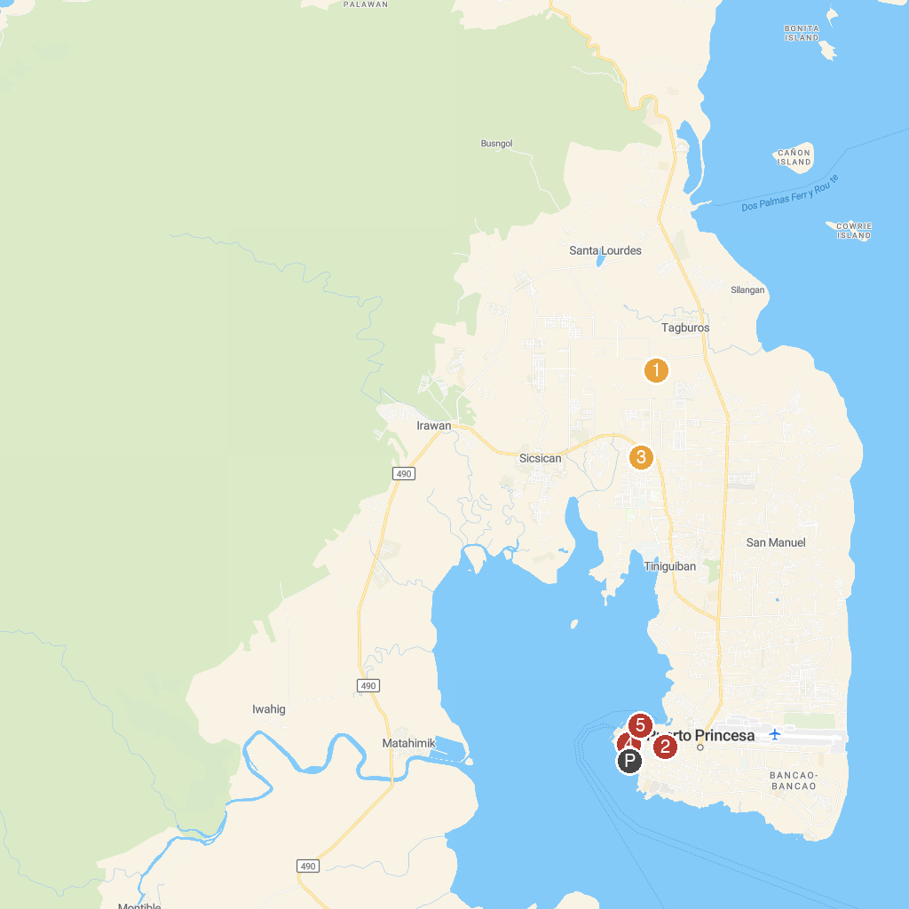
MAP KEY
1. Mitra's Ranch | 4. Immaculate Conception Cathedral
2. Mendoza Park | 5. Puerto Princesa City Baywalk Park
3. Palawan Butterfly Ecological Garden and Tribal Village
P. Cruise port / terminal
Map © MapTiler © OpenStreetMap contributors · cruiseports.org

