Puerto Peñasco, Sonora, Mexico
Arizona's beach in Mexico: where the Sonoran Desert meets the Sea of Cortez in a blaze of tides, shrimp, and sun. Rocky Point's Old Port drops you steps from fresh seafood, a famous boardwalk, and one of the world's most extreme tidal landscapes.
⚓ Tender port (no completed pier) · 🕒 Typical call: 6–8 hrs · 💵 Mexican Peso / USD common in tourist areas · 🗣️ English widely spoken · 🌊 Extreme tidal range
✍️ MY DAY IN PORT (FILL IN)
Ship / Date
In port | arrive ______ · all aboard ______
Booked excursion
Notes / meeting point
GETTING ASHORE
- Docking: Tender — ships anchor offshore; boats ferry to marina near Old Port
- Walk to center: 5–10 min from tender dock to El Malecón boardwalk
- Best For: Seafood, tide pools, Bird Island sea lions, desert biosphere
- Don't Miss: Isla San Jorge boat trip or low-tide pools at Cholla Bay
GETTING AROUND
- 🚕 Taxi: $9–$25 USD — Local taxis are the primary transport option. Fares within the city typically run 170–200 MXN (~$9–10 USD) for short tri
- 📱 Rideshare: ✅ Uber
TOP THINGS TO DO
- Isla San Jorge (Bird Island) Boat Trip — A 2-hour boat ride to a protected rocky sanctuary where sea lions haul out in the hundreds.
- El Pinacate Biosphere Reserve — UNESCO World Heritage site an hour north — volcanic craters (Elegante Crater is stunning), ancient lava fields, and the largest…
- ATV & Dune Riding — Rent ATVs near the port or join a guided tour to tackle Competition Hill sand dunes and the surrounding desert terrain — a…
- Sandy Beach & Resort Strip — Taxi out to the main resort beach for calm, shallow waters, banana boats, jet skis, and beachfront bars like Wrecked at the Reef.
- Tide Pool Exploration — Rocky Point's Northern Gulf tides can swing more than 20 vertical feet (spring tides exceed 24 ft) — one of the world's most…
BEST WALKS
- Old Port Malecón Walk: 1–2 hrs · Flat paved boardwalk · Free — Stroll from the marina along El Malecón Fundadores, past the giant shrimp fisherman statue…
- Old Port to CEDO Interpretive Center: 45 min each way · Easy · Free/donation — Walk or take a short taxi to CEDO (Intercultural Center for the Study of Deserts and Oceans) in Las…
WEATHER · DAYLIGHT · MONEY
Month | High °F | Low °F | Rainy days
May | 80 | 68 | 0
Jul | 92 | 84 | 1
Sep | 91 | 81 | 2
Daylight: May 5:38AM–7:23PM · Jul 5:40AM–7:39PM · Sep 6:18AM–6:39PM
cruiseports.org/puerto-penasco · Confirm terminal & all-aboard time with your ship

Puerto Peñasco, Sonora, Mexico — Port Map
Red = walkable sights · Amber = excursions farther out · P = cruise terminal
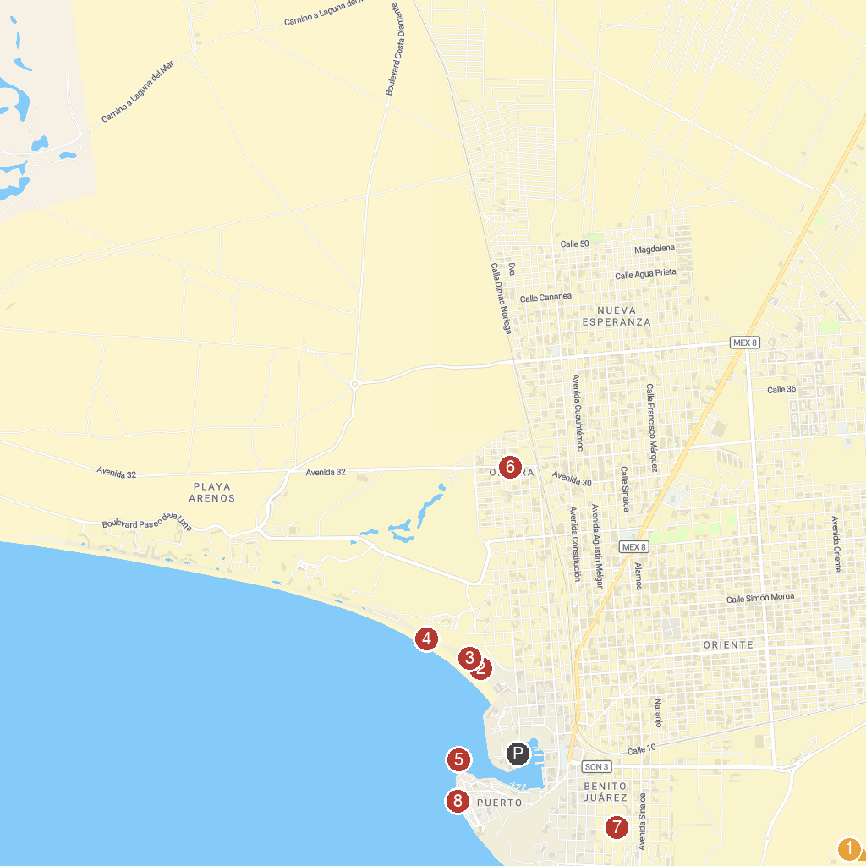
MAP KEY
1. The Seashell Museum at CEDO | 5. Viewpoint on the Pier
2. Playa Hermosa Beach | 6. Avenida 32 Mercado de Artesanías
3. Playa bonita, Puerto Peñasco, Sonora | 7. Acuario Peñasco
4. Playa Bonita Beach | 8. Malecón Puerto Peñasco
P. Cruise port / terminal
Map © MapTiler © OpenStreetMap contributors · cruiseports.org

