Puerto Morelos, Quintana Roo, Mexico
A bohemian fishing village between Cancun and Playa del Carmen, Puerto Morelos protects one of the healthiest stretches of the Mesoamerican Barrier Reef — calm turquoise waters, a famously tilted lighthouse, and zero high-rise hotels.
⚓ Small pier / tender · 🕒 Typical call: 6–8 hrs · 💵 USD & MXN accepted · 🗣️ Spanish · 🪸 Reef National Park
✍️ MY DAY IN PORT (FILL IN)
Ship / Date
In port | arrive ______ · all aboard ______
Booked excursion
Notes / meeting point
GETTING ASHORE
- Docking: Small pier in town center; boutique/luxury ships dock or tender directly
- Walk to Center: 1 min from pier to town square and leaning lighthouse
- Best For: Reef snorkeling, cenote day trips, authentic Mexican beach town
- Don't Miss: El Faro Inclinado (Leaning Lighthouse) and a guided reef snorkel
GETTING AROUND
- 🚕 Taxi: $3–5 USD (50–80 MXN) — Local taxis are available near the port and town square. Short rides within Puerto Morelos cost roughly 50 MXN; confirm
- 📱 Rideshare: ✅ Uber
TOP THINGS TO DO
- Puerto Morelos Reef National Park Snorkel — The Mesoamerican Barrier Reef sits just 400 m offshore in a protected national marine park.
- Ruta de los Cenotes — A highway stretching inland from Puerto Morelos leads to dozens of limestone sinkholes.
- Croco Cun Zoo Interactive Tour — A conservation-focused zoo just off Highway 307 where a guide walks you through the grounds to hold baby crocs, feed spider…
- Selvatica Zip-Line & Cenote Adventure — Award-winning adventure park on the Cenote Route offering extreme zip-lines over the jungle canopy, ATV mud riding, and a…
- Beach Club Day Pass — Skip the planning — Unico Beach Club (north of pier, trendy vibe) and My Paradise Beach Club (relaxed reggae vibe, great…
BEST WALKS
- Town Center & Leaning Lighthouse Loop: ~30 min | Easy | 1 km — From the pier, walk south to the iconic El Faro Inclinado — Hurricane Beulah tilted this lighthouse…
- Beach Walk to Ojo de Agua: ~45 min each way | Easy | 2 km — Head north along the public beach (Ventana al Mar) toward Ojo de Agua, a beach fed by an underwater…
WEATHER · DAYLIGHT · MONEY
Month | High °F | Low °F | Rainy days
May | 85 | 78 | 18
Jul | 87 | 80 | 14
Sep | 86 | 79 | 22
Daylight: May 6:10AM–7:17PM · Jul 6:15AM–7:31PM · Sep 6:34AM–6:49PM
cruiseports.org/puerto-morelos · Confirm terminal & all-aboard time with your ship

Puerto Morelos, Quintana Roo, Mexico — Port Map
Red = walkable sights · Amber = excursions farther out · P = cruise terminal
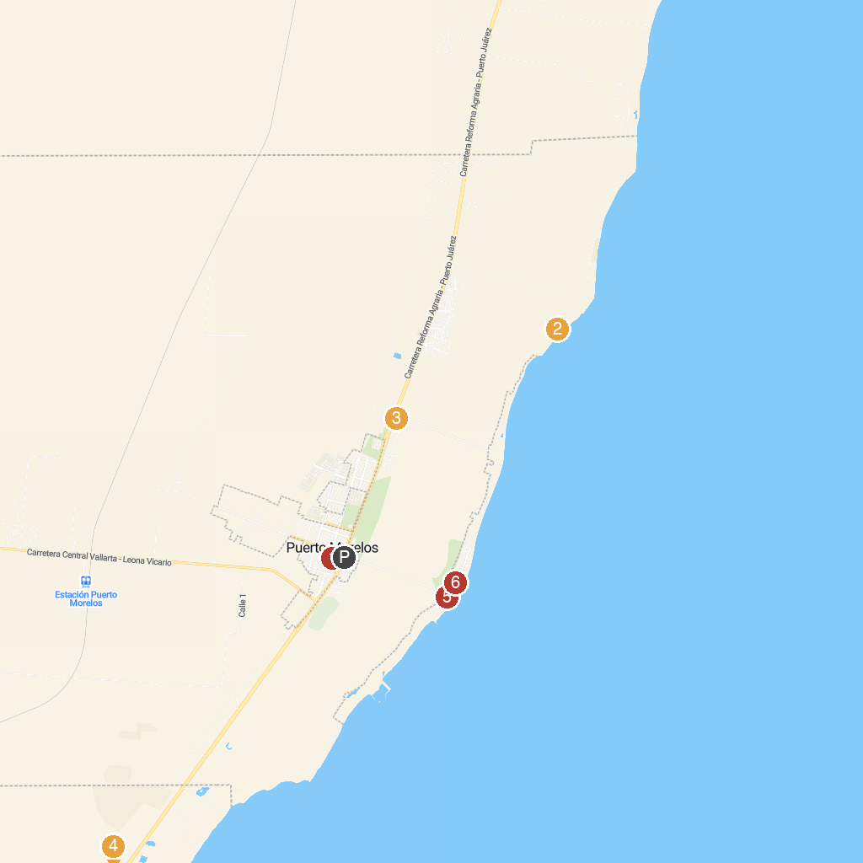
MAP KEY
1. Parque la Colonia | 4. Bonanza Ranch - Rancho Bonanza
2. Snorkeling Adventure | 5. Parroquia San José Obrero
3. Croco Cun Zoo | 6. Lighthouse Tours
P. Cruise port / terminal
Map © MapTiler © OpenStreetMap contributors · cruiseports.org

