Puerto Madryn, Argentina
Marine Wildlife & Coastal Beauty
🐋 Whale Watching · 🐧 Penguin Colonies · 🏖️ Atlantic Coast · UNESCO Heritage
✍️ MY DAY IN PORT (FILL IN)
Ship / Date
In port | arrive ______ · all aboard ______
Booked excursion
Notes / meeting point
GETTING ASHORE
- Currency: Argentine Peso (ARS)
- Language: Spanish
- Climate: Semi-arid, windy Atlantic coast
- Best Season: June to December (Whale season)
GETTING AROUND
- 🚕 Taxi: ~$5–6 USD — Taxis are available at the port for the ~5 km ride to the city center. Fares are inexpensive due to the Argentine peso e
- 📱 Rideshare: ✅ Uber
TOP THINGS TO DO
- Whale Watching from the Coast — Experience the Southern Right Whale (Eubalaena australis) directly from the shore or via a boat tour.
- Península Valdés UNESCO Site — A full-day excursion to the UNESCO World Heritage site.
- Punta Tombo Penguin Colony — Visit one of the world's largest colonies of Magellanic Penguins.
- City Center & Waterfront — A guided walk through the city center, visiting local seafood restaurants and boutiques selling artisanal crafts.
BEST WALKS
- Costanera Promenade Walk: Walk from the port to the Costanera, enjoy the Atlantic views, and look for whales from the shore. — A flat, easy walk along the waterfront.
- City Center Loop: Port -> City Center -> Local Boutiques -> Port — Explore the local architecture and the central plaza, focusing on the seafood-focused gastronomy of…
- Nature Reserve Walk: Port -> Nature Reserve -> Coastline — A guided walk through the coastal reserve to observe local bird species and marine life.
WEATHER · DAYLIGHT · MONEY
Month | High °F | Low °F | Rainy days
May | 60 | 45 | 3
Jul | 53 | 38 | 5
Sep | 62 | 44 | 4
Daylight: May 8:25AM–6:06PM · Jul 8:46AM–6:06PM · Sep 7:21AM–7:09PM
cruiseports.org/puerto-madryn · Confirm terminal & all-aboard time with your ship

Puerto Madryn, Argentina — Port Map
Red = walkable sights · Amber = excursions farther out · P = cruise terminal
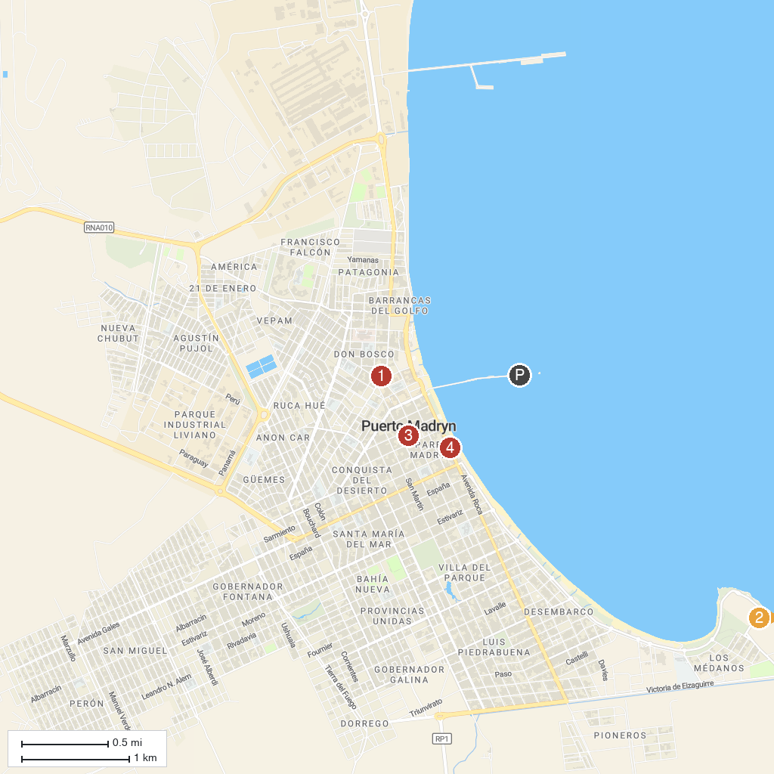
MAP KEY
1. Museo Provincial del Hombre y el Mar | 3. Plaza Puerto Madryn
2. Fundación Ecocentro | 4. Municipal Museum of Art
P. Cruise port / terminal
Map © MapTiler © OpenStreetMap contributors · cruiseports.org

