Puerto Escondido, Oaxaca, Mexico
A bohemian Pacific surf town with no cruise terminal and no chain restaurants — just world-class waves, turquoise coves, and the best food in Mexico.
⚓ Tender (no pier) · 🕒 Typical call: 6-8 hrs · 💵 Mexican Pesos (MXN) — carry cash · 🗣️ Spanish (some English in tourist areas) · 🏄 Surf & beach destination
✍️ MY DAY IN PORT (FILL IN)
Ship / Date
In port | arrive ______ · all aboard ______
Booked excursion
Notes / meeting point
GETTING ASHORE
- Docking: Tender to Muelle Principal next to Playa Principal
- Walk to center: 5–10 min uphill to El Adoquín pedestrian street
- Best For: Beaches, surfing spectacle, Oaxacan cuisine, sea turtles
- Don't Miss: Playa Carrizalillo cove and watching the Mexican Pipeline at Zicatela
GETTING AROUND
- 🚕 Taxi: 30–200 MXN ($2–$10 USD) — Local taxis are plentiful but do not use meters — always agree on the fare before getting in. Short hops within the beac
- 📱 Rideshare: ❌ not available
TOP THINGS TO DO
- Playa Carrizalillo — Best Swimming Cove — A sheltered turquoise cove reached by 167 stone steps down a cliff.
- Surf Lesson at Playa Zicatela — The world-famous Mexican Pipeline breaks here.
- Baby Sea Turtle Release — Local conservancy Vive Mar runs daily turtle releases at Playa Bacocho.
- Dolphin & Whale Watching Lancha — Charter a local fishing boat (lancha) at the tender pier.
- Oaxacan Food Walk & Cooking Class — Oaxaca is Mexico's culinary heartland.
BEST WALKS
- El Adoquín Stroll & Mirador: 30–45 min · Flat to gentle uphill · Free — From the tender pier, walk up to the pedestrian strip of Calle Alfonso Pérez Gasga (El Adoquín).
- Pier to Playa Puerto Angelito & Manzanillo: 15–20 min walk · Easy · Free beaches — Head west from the pier along the coast path to the twin coves of Puerto Angelito and Manzanillo…
WEATHER · DAYLIGHT · MONEY
Month | High °F | Low °F | Rainy days
May | 85 | 77 | 28
Jul | 85 | 77 | 28
Sep | 84 | 76 | 28
Daylight: May 5:45AM–6:17PM · Jul 5:53AM–6:28PM · Sep 5:55AM–6:04PM
cruiseports.org/puerto-escondido · Confirm terminal & all-aboard time with your ship

Puerto Escondido, Oaxaca, Mexico — Port Map
Red = walkable sights · Amber = excursions farther out · P = cruise terminal
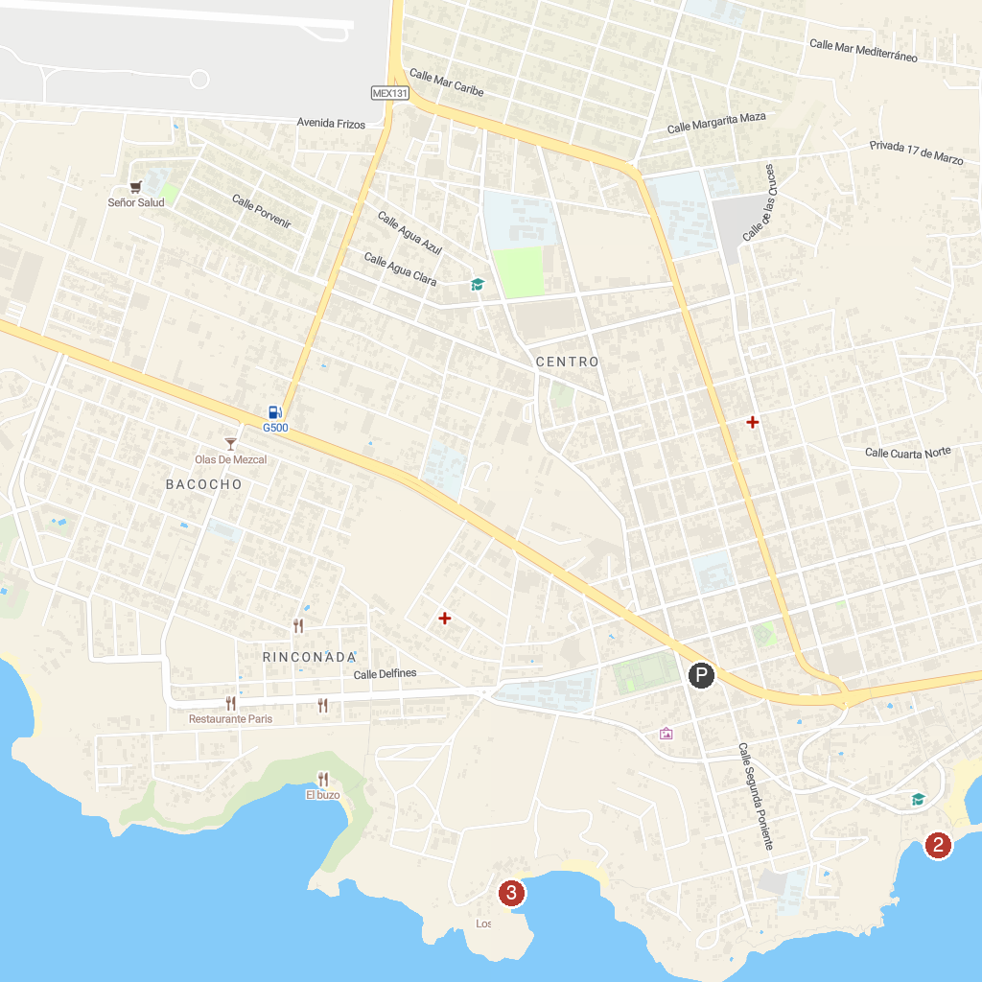
MAP KEY
1. Robert's Ecotours | 3. Puerto angelito
2. Andador Turístico
P. Cruise port / terminal
Map © MapTiler © OpenStreetMap contributors · cruiseports.org

