Puerto del Rosario, Fuerteventura, Spain
Known as the City of Sculptures, Fuerteventura's windswept capital blends open-air art with laid-back Canarian life — and the island's legendary beaches start right at the pier.
⚓ Pier (docked) · 🕒 Typical call: 7-9 hrs · 💶 Euro (€) · 🗣️ Spanish
✍️ MY DAY IN PORT (FILL IN)
Ship / Date
In port | arrive ______ · all aboard ______
Booked excursion
Notes / meeting point
GETTING ASHORE
- Docking: Berthed at Muelle de los Cruceros; new terminal opened May 2025
- Walk to center: 10-15 min to Parque Escultórico and main streets
- Best For: Beach days, windsurfing, island drives, open-air art
- Don't Miss: Corralejo Dunes National Park (25-35 min drive north)
GETTING AROUND
- 🚕 Taxi: €8–€12 — Taxi rank is located at the cruise terminal. The ride to the city center takes 5–15 minutes; fares are regulated. A loca
- 📱 Rideshare: ❌ not available
TOP THINGS TO DO
- Corralejo Dunes National Park — Vast golden dunes meeting brilliant turquoise water in a protected natural park.
- Windsurfing & Kitesurfing Lessons — Fuerteventura is a world-class wind-sports destination.
- Betancuria & Island Drive — The ancient capital of Fuerteventura sits in a dramatic mountain valley.
- Dolphin & Whale Watching — Boat trips from Puerto del Rosario or Corralejo offer reliable dolphin sightings; pilot whales and loggerhead turtles spotted…
- Playa Blanca Beach Day — A 2 km walk south along the coastal promenade from the port, Playa Blanca is a wide, calm beach with a beach bar, lifeguards…
BEST WALKS
- Waterfront Sculpture Trail: 1.5 km · 30-45 min · Flat & paved — From the cruise terminal, walk north along the promenade past the whale skeleton sculpture and into…
- Coastal Path to Playa Blanca: 2 km · 25 min · Easy coastal walk — Head south from the port along the coastal promenade past lime kilns and more sculptures.
WEATHER · DAYLIGHT · MONEY
Month | High °F | Low °F | Rainy days
May | 74 | 64 | 1
Jul | 79 | 69 | 0
Sep | 79 | 70 | 1
Daylight: May 7:05AM–8:38PM · Jul 7:08AM–8:54PM · Sep 7:40AM–7:59PM
cruiseports.org/puerto-del-rosario · Confirm terminal & all-aboard time with your ship

Puerto del Rosario, Fuerteventura, Spain — Port Map
Red = walkable sights · Amber = excursions farther out · P = cruise terminal
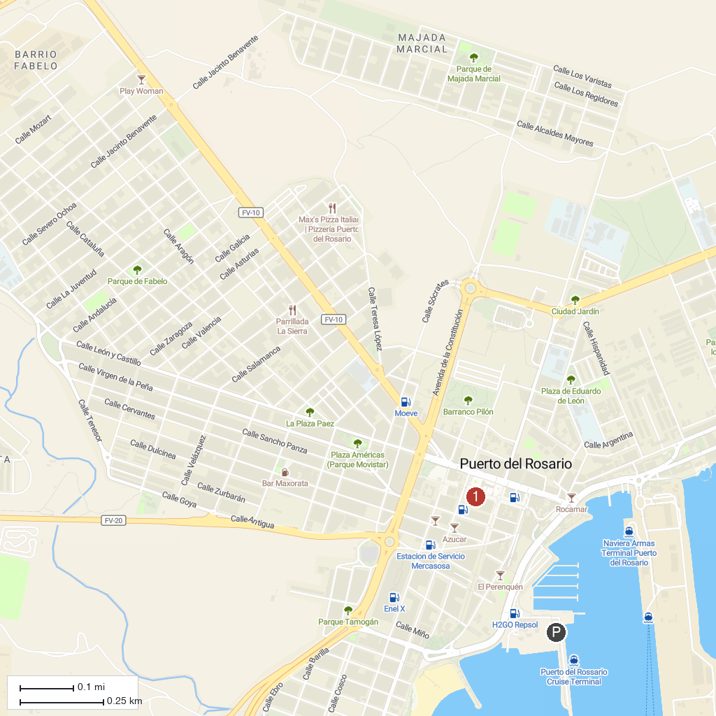
MAP KEY
1. Iglesia de Nuestra Señora de la Candelaria | 3. Casa Museo Miguel de Unamuno
2. Museo del Grano "La Cilla"
P. Cruise port / terminal
Map © MapTiler © OpenStreetMap contributors · cruiseports.org

