Puerto Cortés, Cortés, Honduras
Central America's busiest port isn't a tourist resort — it's the real thing. Authentic Honduran street life, Garifuna drumming, an 18th-century Spanish fortress, and some of the best baleadas you'll ever eat.
⚓ Pier (commercial dock) · 🕒 Typical call: 8-10 hrs · 💵 USD widely accepted / Lempira · 🗣️ Spanish (limited English) · 🌿 Mainland gateway
✍️ MY DAY IN PORT (FILL IN)
Ship / Date
In port | arrive ______ · all aboard ______
Booked excursion
Notes / meeting point
GETTING ASHORE
- Docking: Pier — commercial terminal; shuttle to port gate
- Walk to center: ~1.5 mi to Parque Central; taxi recommended
- Best For: History, culture, jungle excursions, authentic food
- Don't Miss: Fortaleza de San Fernando de Omoa (18th-century fortress)
GETTING AROUND
- 🚕 Taxi: $5–$20 USD — Taxis are the primary transport option from the port. The city center is a short distance away; confirm the fare before
TOP THINGS TO DO
- Fortaleza de San Fernando de Omoa — One of the largest Spanish colonial forts in Central America, built in the 1750s to repel pirates.
- Pulhapanzak Waterfall — A 43-metre cascade roaring through dense jungle.
- Garifuna Village of Bajamar — A short drive from port, Bajamar is a living Garifuna community — descendants of Carib, Arawak, and West African people.
- San Pedro Sula & Guamilito Market — Honduras's industrial capital is a 1-hour drive and home to the sprawling Guamilito Market, where hand-woven hammocks, Lenca…
- Lancetilla Botanical Garden — One of the largest tropical botanical gardens in the world, east of Puerto Cortés near Tela.
BEST WALKS
- Parque Central & Town Waterfront: 1-2 hrs · Easy · Cultural — Ride a taxi from the port gate to Parque Central, then stroll the shaded square past the cathedral…
WEATHER · DAYLIGHT · MONEY
Month | High °F | Low °F | Rainy days
May | 83 | 74 | 29
Jul | 82 | 73 | 29
Sep | 82 | 73 | 29
Daylight: May 5:14AM–5:46PM · Jul 5:22AM–5:57PM · Sep 5:24AM–5:33PM
cruiseports.org/puerto-cortes · Confirm terminal & all-aboard time with your ship

Puerto Cortés, Cortés, Honduras — Port Map
Red = walkable sights · Amber = excursions farther out · P = cruise terminal
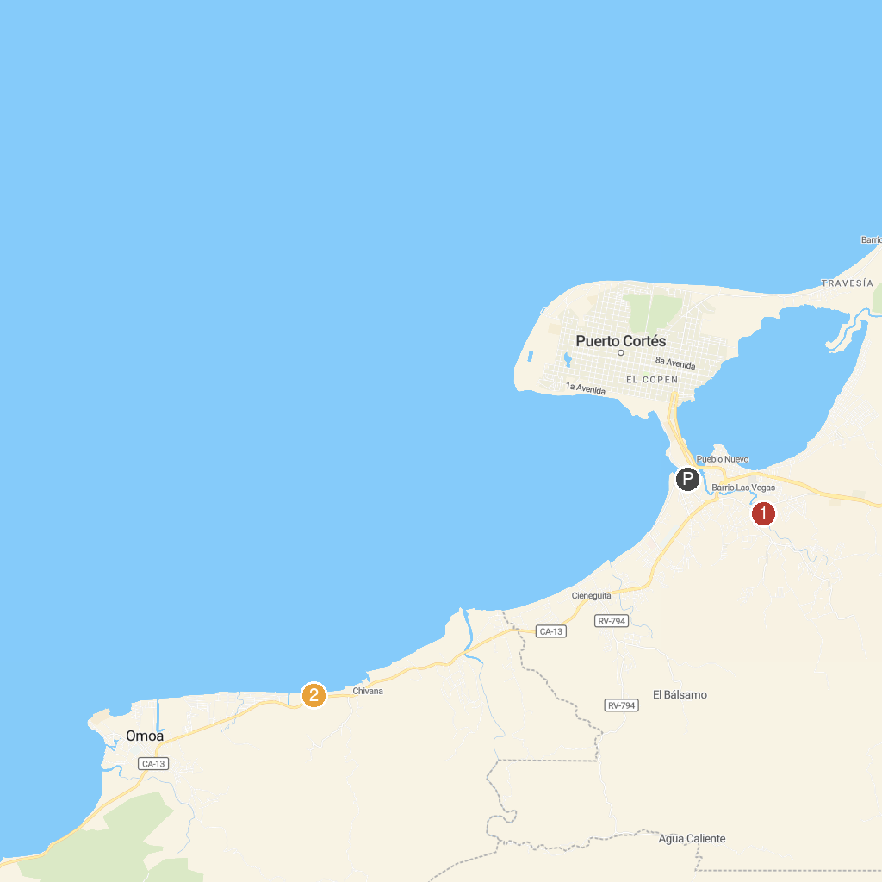
MAP KEY
1. Parque Ecológico y Turístico Safari | 2. BALNEARIO VALLE BONITO
P. Cruise port / terminal
Map © MapTiler © OpenStreetMap contributors · cruiseports.org

