Puerto Chacabuco, Chile
Gateway to the Glaciers and Fjords
🚢 Port Town · 🏔️ Glacial Landscapes · 🌲 Rain Forest · 🌊 Pacific Coast
✍️ MY DAY IN PORT (FILL IN)
Ship / Date
In port | arrive ______ · all aboard ______
Booked excursion
Notes / meeting point
GETTING ASHORE
- Currency: Chilean Peso (CLP)
- Language: Spanish
- Climate: Cool, rainy, and temperate
- Main Attraction: Glacier trekking and fjord cruising
GETTING AROUND
- 🚕 Taxi: $14–$17 — Puerto Aysén is 14 km (~15 min) from the port and is the closest town. Taxis are readily available dockside; fares are u
- 📱 Rideshare: ✅ Uber
TOP THINGS TO DO
- Parque Aiken del Sur — Explore this private 250-hectare reserve with native forests, waterfalls, and well-marked hiking trails just 15 minutes from the…
- Río Simpson National Reserve — Drive through dramatic river gorges and visit the reserve's visitor center, waterfalls, and Patagonian birdlife about 30 minutes…
- Laguna San Rafael Glacier — Cruise by catamaran through fjords to the iconic San Rafael Glacier, a UNESCO site, with opportunities for close-up Zodiac views…
- Coyhaique & Puerto Aysén — Visit the regional hub of Coyhaique for local crafts and cuisine, plus the historic suspension bridge at nearby Puerto Aysén.
BEST WALKS
- Coastal Promenade: Easy — A relaxing walk along the waterfront, offering views of the Pacific Ocean and surrounding mountains.
- Town Center Loop: Moderate — A short walk through the residential areas and local markets of Puerto Chacabuco.
- Nature Trail: Easy — A walk through the outskirts of town into the surrounding greenery.
WEATHER · DAYLIGHT · MONEY
Month | High °F | Low °F | Rainy days
May | 49 | 40 | 21
Jul | 42 | 34 | 22
Sep | 49 | 38 | 20
Daylight: May 9:04AM–6:30PM · Jul 9:26AM–6:28PM · Sep 7:53AM–7:39PM
cruiseports.org/puerto-chacabuco · Confirm terminal & all-aboard time with your ship

Puerto Chacabuco, Chile — Port Map
Red = walkable sights · Amber = excursions farther out · P = cruise terminal
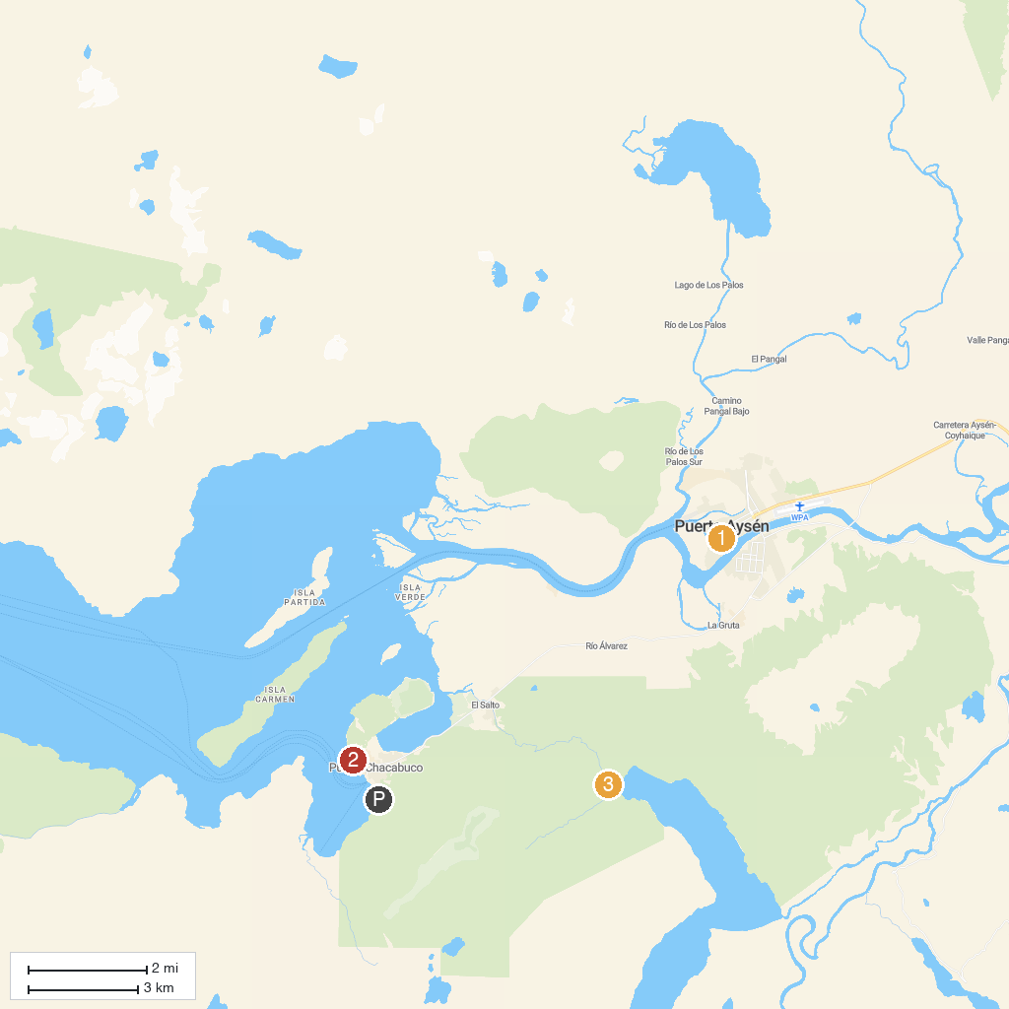
MAP KEY
1. Plaza de Armas | 3. Cascada Barba de Viejo
2. Barco Varado - Viña del Mar
P. Cruise port / terminal
Map © MapTiler © OpenStreetMap contributors · cruiseports.org

