Puerto Bolívar, El Oro, Ecuador
Ecuador's busiest banana-export port doubles as the gateway to Machala — a real, unpolished South American city where shrimp ceviche is made fresh and cargo ships tower over the waterfront.
⚓ Docked (deep-water pier) · 🕒 Typical call: 6-8 hrs · 💵 USD (US dollars) · 🗣️ Spanish
✍️ MY DAY IN PORT (FILL IN)
Ship / Date
In port | arrive ______ · all aboard ______
Booked excursion
Notes / meeting point
GETTING ASHORE
- Docking: Deep-water pier — no tender required
- Walk to Center: Port is industrial; shuttle or $3-5 taxi to Malecón/Machala
- Best For: Authentic Ecuador, banana plantation tours, fresh seafood
- Don't Miss: Lancha boat to Isla de Jambelí through the mangroves
GETTING AROUND
- 🚕 Taxi: $5–$10 — Taxis wait at the port and are the most common option for reaching Machala city center (~6–8 km, 15–20 min). Agree on a
- 📱 Rideshare: ✅ Uber
TOP THINGS TO DO
- Banana Plantation Tour — Walk a working plantation to see how Ecuador's most famous export is grown, harvested, washed, and packed into those blue boxes.
- Lancha Ride to Isla de Jambelí — Board a small motorboat on the Malecón and weave through mangrove channels to this car-free island.
- Buenaventura Cloud Forest Reserve — About 90 minutes into the Andes foothills, this Jocotoco Foundation reserve protects the endangered El Oro Parakeet and dozens of…
- Machala City Highlights — Walk Parque Juan Montalvo with its fountains and shady plaza, and visit the cathedral that overlooks it.
- Malecón Seafood Lunch — The waterfront restaurants of Puerto Bolívar are legendary among Ecuadorians for fresh shrimp and fish.
BEST WALKS
- Puerto Bolívar Malecón Stroll: 1-2 km · Flat · 30-45 min — The waterfront boardwalk runs along the estuary, lined with seafood restaurants, bench seating, and…
- Machala Central Plaza Walk: ~1 km loop · Flat · 30 min — Parque Juan Montalvo sits at the heart of Machala.
WEATHER · DAYLIGHT · MONEY
Month | High °F | Low °F | Rainy days
May | 80 | 74 | 20
Jul | 77 | 70 | 12
Sep | 77 | 70 | 8
Daylight: May 6:17AM–6:15PM · Jul 6:27AM–6:24PM · Sep 6:12AM–6:17PM
cruiseports.org/puerto-bolivar-machala · Confirm terminal & all-aboard time with your ship

Puerto Bolívar, El Oro, Ecuador — Port Map
Red = walkable sights · Amber = excursions farther out · P = cruise terminal
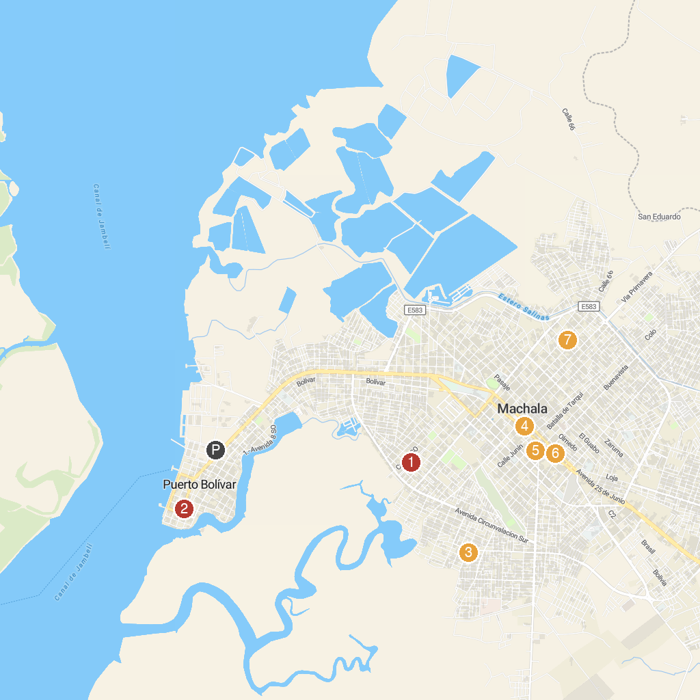
MAP KEY
1. Parque Lineal | 5. S.O.S AUTOCENTRE
2. Infantil Acuático de Puerto Bolivar Park | 6. Parque De La Madre
3. Picapiedra Park | 7. Centenary Park
4. Municipal Center for Art and Culture
P. Cruise port / terminal
Map © MapTiler © OpenStreetMap contributors · cruiseports.org

