Provincetown, Massachusetts, USA
At the very tip of Cape Cod, P-town packs history, art, wild dunes, whale-rich waters, and a famously exuberant street scene into one of New England's most walkable cruise calls.
⚓ Tender (most ships) / Pier (small vessels) · 🕒 Typical call: 6–9 hrs · 💵 USD · 🗣️ English · 🏳️‍🌈 LGBTQ+ welcoming
✍️ MY DAY IN PORT (FILL IN)
Ship / Date
In port | arrive ______ · all aboard ______
Booked excursion
Notes / meeting point
GETTING ASHORE
- Docking: Tender to MacMillan Pier (most ships); small coastal vessels can dock directly
- Walk to center: 1 min — Commercial Street begins at the pier head
- Best For: Whale watching, Cape Cod beaches, history, art galleries, seafood
- Don't Miss: Climb the Pilgrim Monument for panoramic Cape Cod views
GETTING AROUND
- 🚕 Taxi: $12–$19/person — Regulated fares: $18/person from the pier (ferry terminal rate) or $12/person within town, plus a $1/person surcharge. M
- 📱 Rideshare: ✅ Uber, Lyft
TOP THINGS TO DO
- Whale Watch — Stellwagen Bank National Marine Sanctuary lies just offshore and delivers near-100% sighting rates for humpbacks, finbacks, and…
- Art's Dune Tours — Off-road vehicles take you into the protected Cape Cod National Seashore dunes, passing historic shacks once used by artists like…
- Pilgrim Monument & Museum — The 252-foot granite tower — the tallest all-granite structure in the USA — marks where the Mayflower Pilgrims first landed in…
- Race Point & Herring Cove Beaches — Race Point faces the open Atlantic — wild surf, seals, and the Race Point Lighthouse.
- Commercial Street Gallery Walk — America's oldest continuous art colony fills Commercial Street's East End with dozens of galleries showcasing painters…
BEST WALKS
- Commercial Street End-to-End: 2–3 hrs | Flat | ~1.5 miles one way — Start at the pier entrance and walk Commercial Street west to east.
- Pilgrim Monument Loop: 45 min | Easy–Moderate | 0.5-mile walk + climb — Walk up Bradford Street from the pier to the Pilgrim Monument.
WEATHER · DAYLIGHT · MONEY
Month | High °F | Low °F | Rainy days
May | 55 | 50 | 11
Jul | 72 | 67 | 8
Sep | 68 | 63 | 9
Daylight: May 5:20AM–7:54PM · Jul 5:18AM–8:14PM · Sep 6:21AM–6:49PM
cruiseports.org/provincetown-ma · Confirm terminal & all-aboard time with your ship

Provincetown, Massachusetts, USA — Port Map
Red = walkable sights · Amber = excursions farther out · P = cruise terminal
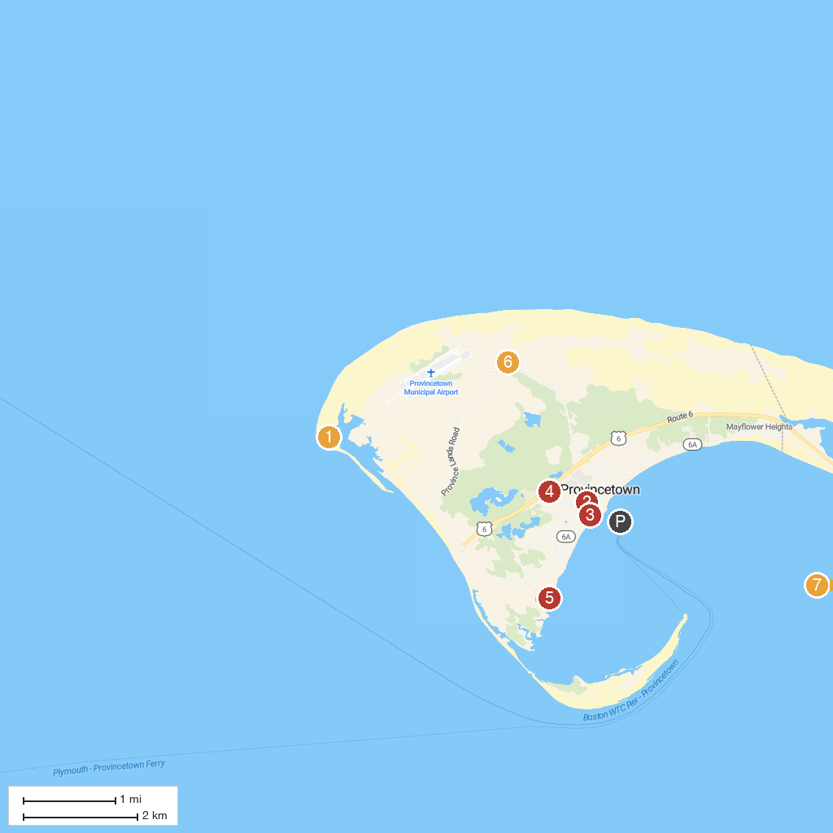
MAP KEY
1. Cape Cod National Seashore | 5. Pilgrim Bark Park
2. Race Point Lighthouse | 6. Pilgrims' First Landing Park
3. Pilgrim Monument and Provincetown Museum | 7. Province Lands Visitor Center
4. Whalers Wharf | 8. Highland Lighthouse
P. Cruise port / terminal
Map © MapTiler © OpenStreetMap contributors · cruiseports.org

