Providenciales, Turks and Caicos Islands
Home to Grace Bay Beach — consistently rated one of the world's best — Providenciales glows with neon-turquoise water, powder-white sand, and some of the finest snorkeling in the Caribbean. Small ships tender here; big-ship cruisers dock at nearby Grand Turk.
⚓ Tender port (no deep-water pier) · 🕒 Typical call: 6–8 hrs · 💵 US Dollar (USD) · 🗣️ English · 🏖️ World-class beach
✍️ MY DAY IN PORT (FILL IN)
Ship / Date
In port | arrive ______ · all aboard ______
Booked excursion
Notes / meeting point
GETTING ASHORE
- Docking: Tender — ships anchor offshore; boats land at South Dock or Turtle Cove Marina
- Walk to center: Not walkable from South Dock — taxi or excursion required
- Best For: Beaches, snorkeling, conch dining, luxury shore days
- Don't Miss: Grace Bay Beach swim + Da Conch Shack lunch
GETTING AROUND
- 🚕 Taxi: ~$7 for 2 passengers — Government-regulated fixed fares; taxis are typically large shared vans. Confirm fare before boarding and carry cash as
- 📱 Rideshare: ❌ not available
TOP THINGS TO DO
- Grace Bay Beach Day — Claim a stretch of the world-ranked beach at Grace Bay — roughly 3 miles of powder sand (part of a longer continuous stretch)…
- Little Water Cay Iguana Tour — A short boat ride to this protected nature reserve where endangered Turks and Caicos Rock Iguanas roam boardwalk trails above…
- Snorkeling at Bight Reef (Coral Gardens) — Wade straight off Grace Bay's western end into a protected reef teeming with sea turtles, spotted eagle rays, and technicolor…
- Chalk Sound Kayak or Paddleboard — Electric-blue Chalk Sound National Park is a shallow inland lagoon dotted with rocky islets.
- Clear-Kayak Mangrove Tour — Guided paddle through Mangrove Cay in a clear-bottom kayak revealing baby sharks, sea turtles, and inverted jellyfish just inches…
BEST WALKS
- Grace Bay Beach Stroll: ~2 km, flat, 30 min one-way — Walk the full sweep of Grace Bay from Coral Gardens to the eastern hotels.
- Turtle Cove to Grace Bay: ~1.5 km, flat, 20 min — From Turtle Cove Marina, follow Suzie Turn Road east through low scrubland to reach the western…
cruiseports.org/providenciales-island · Confirm terminal & all-aboard time with your ship

Providenciales, Turks and Caicos Islands — Port Map
Red = walkable sights · Amber = excursions farther out · P = cruise terminal
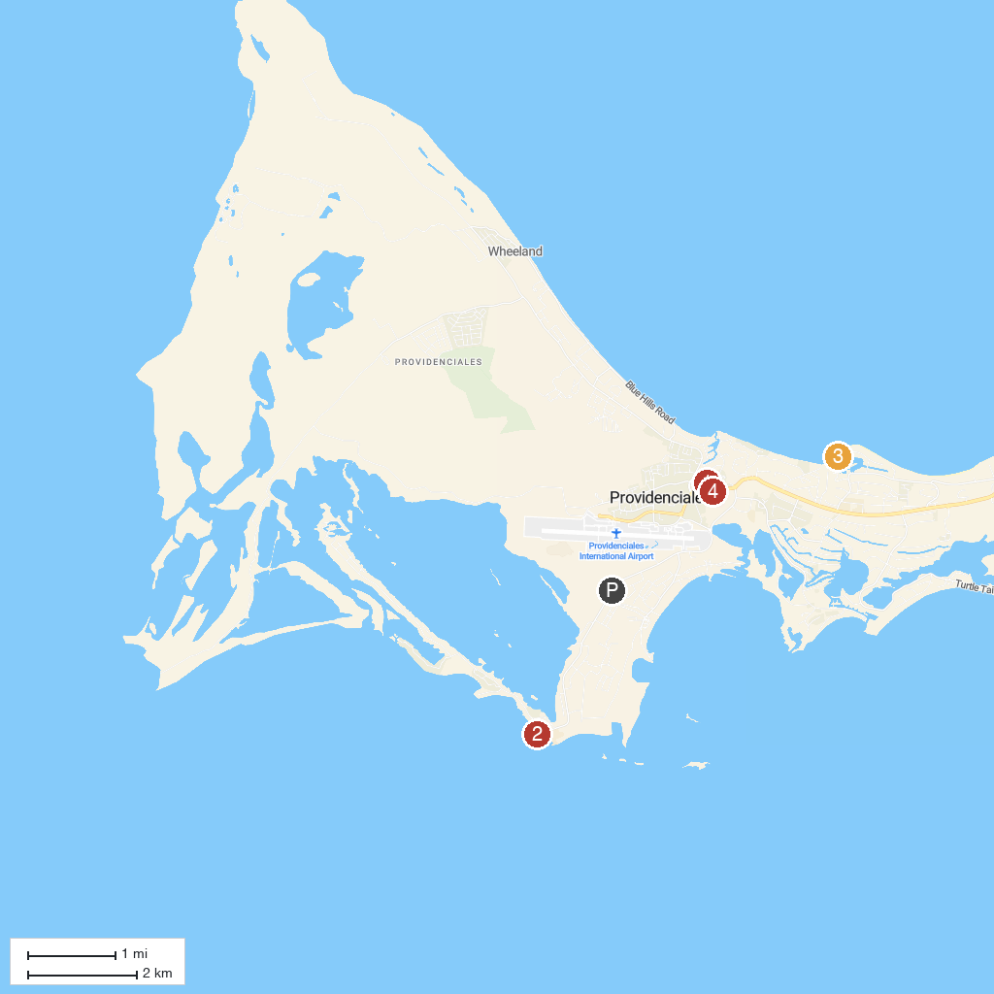
MAP KEY
1. Our Lady of Divine Providence Roman Catholic Church | 4. Dive Provo
2. Sapodilla Hill | 5. Smith’s Reef
3. Provo Ponies | 6. Cheshire Hall Plantation
P. Cruise port / terminal
Map © MapTiler © OpenStreetMap contributors · cruiseports.org

