Providence, Rhode Island, USA
One of America's oldest cities, Providence blends Ivy League energy with Italian-American flavors, a mile of Colonial architecture, and rivers set ablaze at WaterFire festivals.
⚓ Pier (floating dock, India St) · 🕒 Typical call: 6-8 hrs · 💵 USD · 🗣️ English
✍️ MY DAY IN PORT (FILL IN)
Ship / Date
In port | arrive ______ · all aboard ______
Booked excursion
Notes / meeting point
GETTING ASHORE
- Docking: Floating pier at 25 India St (India Point area); small coastal ships only
- Walk to center: ~20-30 min along riverwalk to downtown; East Side 15 min
- Best For: History walks, Italian dining on Federal Hill, RISD Museum
- Don't Miss: Benefit Street (Mile of History), grilled pizza at Al Forno, State House dome
GETTING AROUND
- 🚕 Taxi: $10–$20 — Licensed taxis are available at the terminal. Fares start at $3.00 base + $3.52/mile; the short trip to downtown typical
- 📱 Rideshare: ✅ Uber, Lyft
TOP THINGS TO DO
- Benefit Street — Mile of History — The highest concentration of restored Colonial, Federal, and Victorian homes in the US.
- RISD Museum — The Rhode Island School of Design's world-class museum holds over 100,000 works — from ancient Egyptian artifacts to contemporary…
- Federal Hill — Little Italy — Walk Atwells Avenue for Rhode Island's legendary Italian-American food scene.
- Rhode Island State House — The fourth-largest self-supporting marble dome in the world.
- Gondola Ride on the Providence Rivers — La Gondola operates authentic Venetian gondola rides along the downtown canals — singing gondoliers included.
BEST WALKS
- India Point to Waterplace Park Riverwalk: 2.5 km · ~30 min · Flat · Free — Follow the paved Providence River path from India Point Park northwest to Waterplace Park at the…
- Benefit Street Historic Walk: 1.5 km · ~45 min · Hilly · Free — From Brown University, stroll south along Benefit Street past the Providence Athenaeum, John Brown…
WEATHER · DAYLIGHT · MONEY
Month | High °F | Low °F | Rainy days
May | 70 | 50 | 1
Jul | 84 | 66 | 1
Sep | 76 | 58 | 1
Daylight: May 5:25AM–7:59PM · Jul 5:24AM–8:18PM · Sep 6:26AM–6:54PM
cruiseports.org/providence-ri · Confirm terminal & all-aboard time with your ship

Providence, Rhode Island, USA — Port Map
Red = walkable sights · Amber = excursions farther out · P = cruise terminal
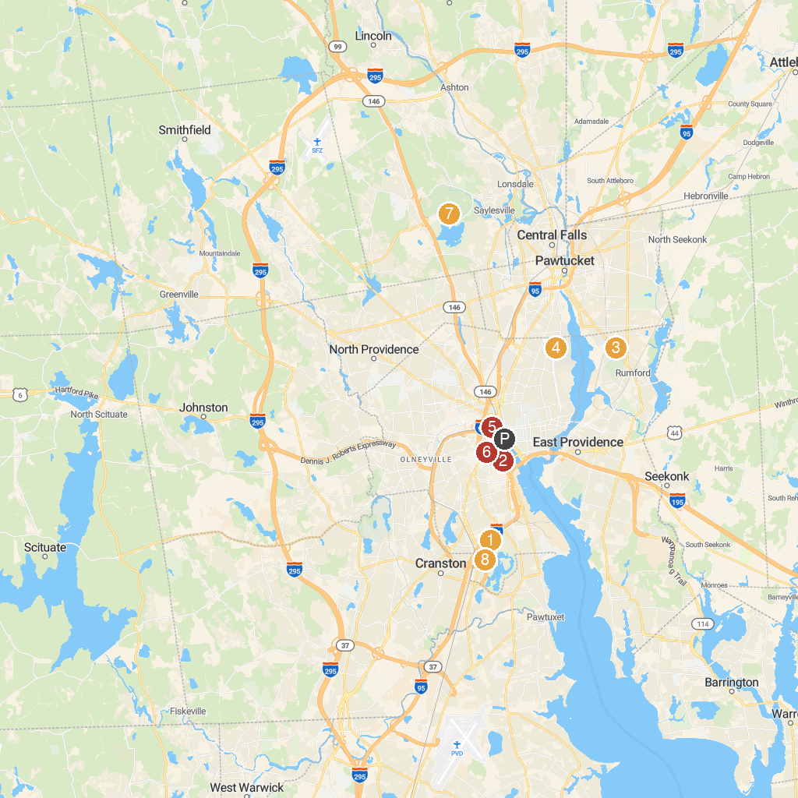
MAP KEY
1. Roger Williams Park Zoo | 5. Waterplace Park
2. Providence Children's Museum | 6. Cathedral of Saints Peter & Paul
3. United Skates of America | 7. Lincoln Woods State Park
4. Swan Point Cemetery | 8. Roger Williams Park Casino
P. Cruise port / terminal
Map © MapTiler © OpenStreetMap contributors · cruiseports.org

