Progreso, Yucatán, Mexico
Home to the world's longest pier, Progreso punches far above its size — a real Yucatecan town that flings open the door to colonial cities, jungle cenotes, and some of Mexico's finest Mayan ruins.
⚓ Docked (pier) · 🕒 Typical call: 8–10 hrs · 💵 MXN / USD accepted · 🗣️ Spanish · 🏛️ Cultural gateway
✍️ MY DAY IN PORT (FILL IN)
Ship / Date
In port | arrive ______ · all aboard ______
Booked excursion
Notes / meeting point
GETTING ASHORE
- Docking: Docked at the world's longest pier — about 8 km into the Gulf of Mexico
- Walk to center: Free shuttle bus ~15 min to town; pier cannot be walked
- Best For: Mayan ruins, colonial Mérida, cenotes, authentic Mexican culture
- Don't Miss: Cochinita pibil tacos and the Malecón boardwalk
GETTING AROUND
- 🚕 Taxi: ~$10 USD — Taxis are available at the pier once you arrive by shuttle. Confirm the fare before departing — US dollars are widely ac
- 📱 Rideshare: ✅ Uber
TOP THINGS TO DO
- Colonial Mérida Day — Catch the AutoProgreso bus (~55 min) into the White City — stroll Plaza Grande, visit the Governor's Palace murals, browse the…
- Uxmal Mayan Ruins — One of Mexico's most beautiful Mayan sites — the towering Pyramid of the Magician is extraordinary.
- Dzibilchaltún Ruins & Cenote Xlacah — The closest ruins to Progreso (~25 min).
- El Corchito Cenotes & Mangroves — A short taxi from town, this local cooperative runs boat rides through mangrove channels to three swimming cenotes in a wildlife…
- Xtampú Pink Salt Lakes & Xcambó Ruins — About 30 minutes east, the Xtampú salt flats turn a vivid pink from algae — spectacular for photos.
BEST WALKS
- Malecón & Town Center Walk: 1.5 km · Flat · 30–45 min — From the AutoProgreso terminal, walk three blocks south to the waterfront Malecón boardwalk.
- Callejón del Amor & Beach Clubs: 1 km · Flat · 20 min — Head east along Calle 19 from the main pier drop to find the colorful Callejón del Amor mural alley…
WEATHER · DAYLIGHT · MONEY
Month | High °F | Low °F | Rainy days
May | 92 | 76 | 1
Jul | 90 | 76 | 1
Sep | 91 | 76 | 1
Daylight: May 5:22AM–6:12PM · Jul 5:28AM–6:25PM · Sep 5:39AM–5:52PM
cruiseports.org/progreso · Confirm terminal & all-aboard time with your ship

Progreso, Yucatán, Mexico — Port Map
Red = walkable sights · Amber = excursions farther out · P = cruise terminal
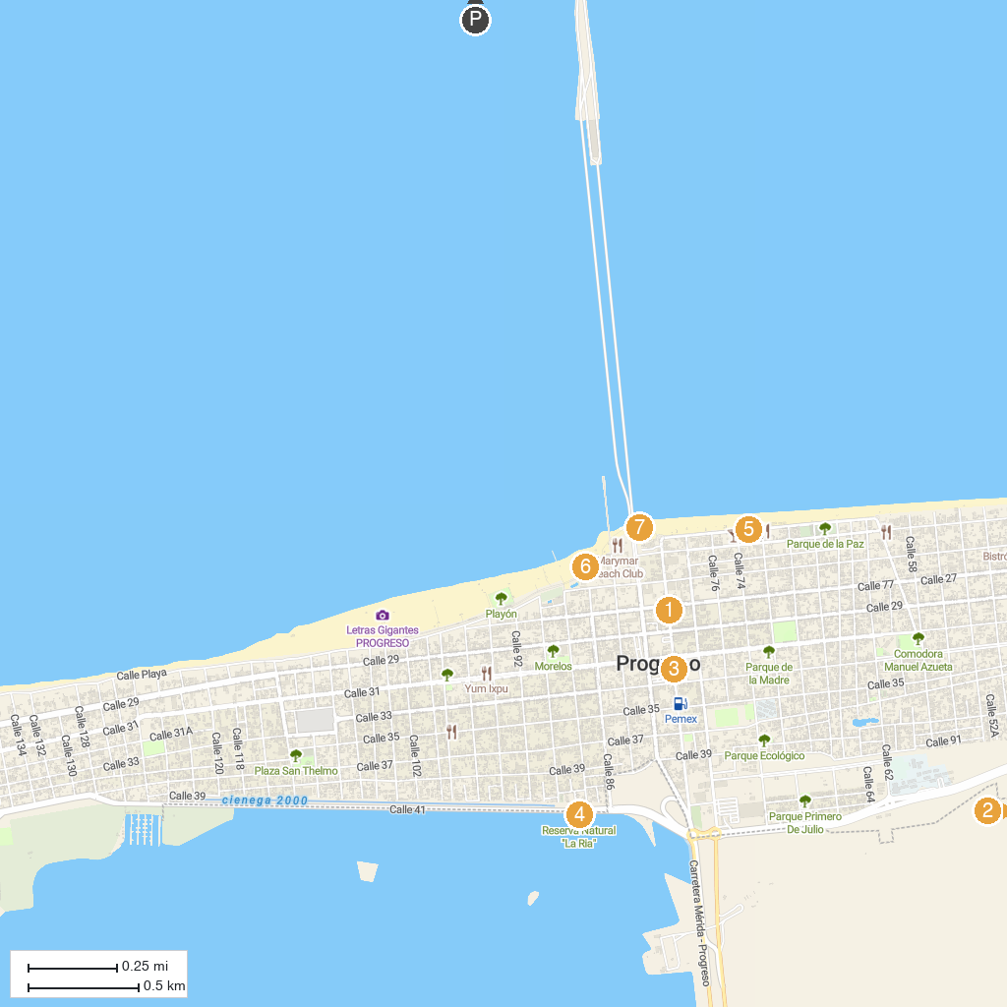
MAP KEY
1. City Tour | 5. Malecón de Progreso
2. Reserva Ecológica El Corchito | 6. Nuevo malecón internacional - El Playon de progreso
3. Parque de Independencia | 7. Muelle De Chocolate
4. La Ría Progreso
P. Cruise port / terminal
Map © MapTiler © OpenStreetMap contributors · cruiseports.org

