Charlottetown, Prince Edward Island, Canada
"The Gentle Island" delivers red sandstone cliffs, fresh lobster, and a walkable Victorian capital that gave birth to Canadian Confederation — all steps from your gangway.
⚓ Pier (usually docked) · 🕒 Typical call: 8-10 hrs · 💵 Canadian Dollar (CAD) · 🗣️ English · 🦞 Anne of Green Gables country
✍️ MY DAY IN PORT (FILL IN)
Ship / Date
In port | arrive ______ · all aboard ______
Booked excursion
Notes / meeting point
GETTING ASHORE
- Docking: Pier at Historic Charlottetown Seaport; small ships may anchor & tender
- Walk to center: 5-10 min flat walk to downtown Queen Street
- Best For: Seafood, Canadian history, scenic drives to Green Gables
- Don't Miss: PEI mussels and a lobster roll; Province House birthplace of Canada
GETTING AROUND
- 🚕 Taxi: CAD $10 flat (downtown) — Flat CAD $10 rate covers the Downtown Charlottetown Zone; a CAD $2 surcharge applies for card payments. Taxis wait just
- 📱 Rideshare: ✅ Uride, Kari
TOP THINGS TO DO
- Green Gables Heritage Place — The red farmhouse that inspired L.M.
- Province House — Birthplace of Canada — This 1847 sandstone building hosted the 1864 Charlottetown Conference that led to Canadian Confederation.
- PEI Lobster & Seafood Experience — PEI is Canada's seafood capital — mussels, oysters, and lobster rolls are the stars.
- Red Sand Beach & Dunes — PEI's signature red cliffs and warm-water beaches are 25-45 min from port.
- Confederation Centre of the Arts — Award-winning gallery and performing arts centre in the heart of Charlottetown.
BEST WALKS
- Waterfront to Downtown Heritage Loop: 2 km · 45 min · Flat & easy — Start at Peake's Quay beside the cruise terminal, stroll the harbour boardwalk past Victoria Park…
- Old Charlottetown Stroll: 1.5 km · 30 min · Flat — Walk Great George Street from the waterfront to St.
WEATHER · DAYLIGHT · MONEY
Month | High °F | Low °F | Rainy days
May | 58 | 39 | 1
Jul | 75 | 59 | 1
Sep | 68 | 51 | 1
Daylight: May 5:39AM–8:38PM · Jul 5:36AM–9:00PM · Sep 6:51AM–7:23PM
cruiseports.org/prince-edward-island · Confirm terminal & all-aboard time with your ship

Charlottetown, Prince Edward Island, Canada — Port Map
Red = walkable sights · Amber = excursions farther out · P = cruise terminal
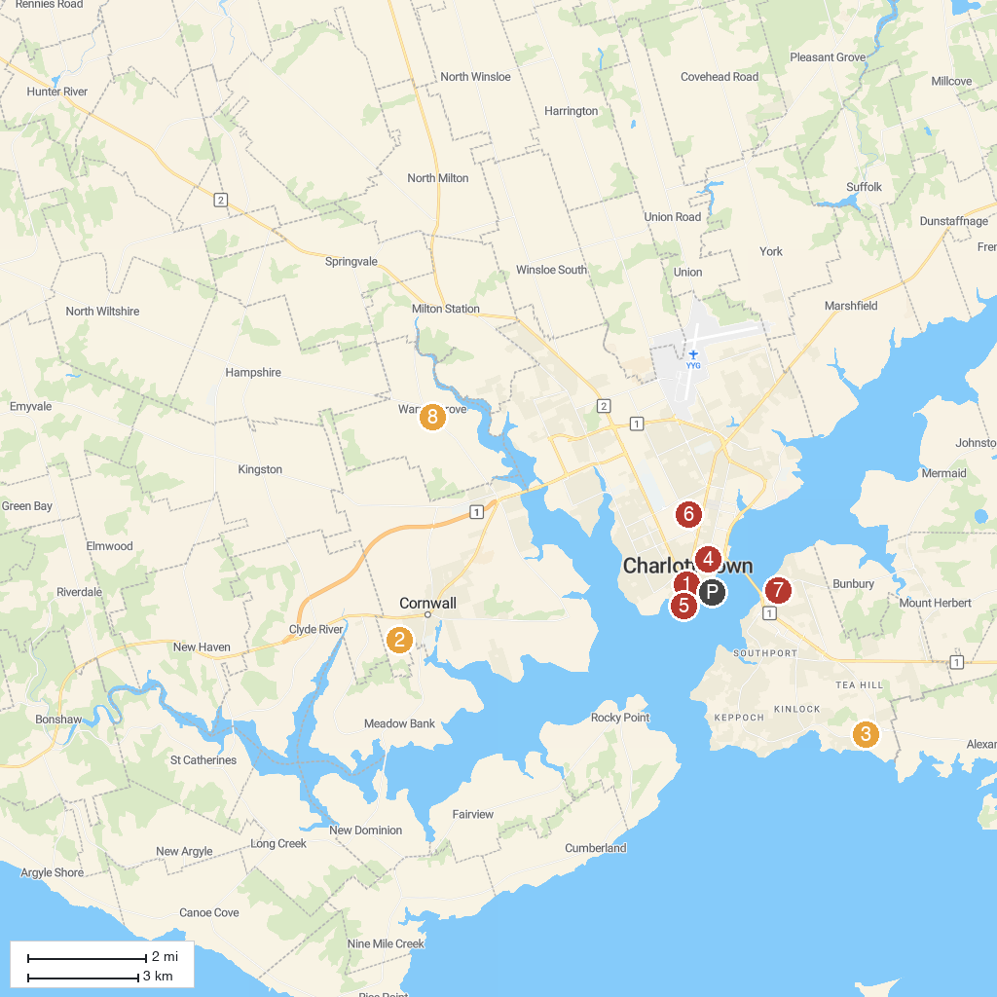
MAP KEY
1. Confederation Centre of the Arts | 5. LCol. J. David Stewart Armoury
2. Rise and Climb Adventure Course | 6. Ardgowan National Historic Site
3. Tea Hill Park & Beach | 7. Robert Cotton Park
4. Joseph A. Ghiz Memorial Park | 8. Deep Roots Distillery
P. Cruise port / terminal
Map © MapTiler © OpenStreetMap contributors · cruiseports.org

