Prickly Bay Marina, L'Anse aux Epines, Grenada
A sheltered yacht haven on Grenada's sun-drenched southern coast, Prickly Bay Marina is the gateway to the Spice Island's finest beaches, otherworldly underwater art, and crater-lake rainforest just a short ride inland.
⚓ Tender (no cruise pier) · 🕒 Typical call: 6-8 hrs · 💵 EC Dollar (USD widely accepted) · 🗣️ English · 🌶️ Spice Island vibes
✍️ MY DAY IN PORT (FILL IN)
Ship / Date
In port | arrive ______ · all aboard ______
Booked excursion
Notes / meeting point
GETTING ASHORE
- Docking: Tender — ships anchor in the bay; superyachts may berth at the marina's concrete pier
- Walk to center: L'Anse aux Epines village is walkable; Grand Anse is ~10 min by taxi
- Best For: Beaches, underwater sculpture diving, rainforest hikes, rum & chocolate
- Don't Miss: Molinere Underwater Sculpture Park — snorkeling or glass-bottom boat
GETTING AROUND
- 🚕 Taxi: $20–$25 USD — Taxis available at the marina for hire. Negotiate fare before departure; ~$20–25 USD to St. George's city center, cash (
- 📱 Rideshare: ✅ Haylup, Ryde Go, Dash
- 🚌 Hop-on hop-off: ✅
TOP THINGS TO DO
- Underwater Sculpture Park — Molinere Bay hosts dozens of life-sized sculptures submerged in 10–40 ft of water — one of the world's most unique snorkel or…
- Grand Anse Beach — Grenada's famous two-mile arc of white sand is a short taxi ride from the marina.
- Grand Etang Rainforest & Crater Lake Hike — Drive up into the misty central highlands to Grand Etang National Park, centered on a volcanic crater lake.
- Rum & Chocolate Tasting Tour — Grenada is the Spice Island — and also produces fine single-estate chocolate and award-winning rum.
- St. George's & Fort Frederick — Grenada's horseshoe-shaped capital is one of the prettiest in the Caribbean.
BEST WALKS
- L'Anse aux Epines Peninsula Stroll: 1.5 km · Easy · 20-30 min — From the marina, walk the quiet road along the peninsula past private villas and glimpses of calm…
- Prickly Bay Beach to True Blue Beach: 2 km · Easy · 25-35 min — Head south from the marina along the shoreline road to reach True Blue Bay, a quiet anchorage with…
WEATHER · DAYLIGHT · MONEY
Month | High °F | Low °F | Rainy days
May | 87 | 76 | 8
Jul | 87 | 76 | 16
Sep | 88 | 75 | 15
Daylight: May 5:43AM–6:23PM · Jul 5:50AM–6:35PM · Sep 5:56AM–6:07PM
cruiseports.org/prickly-bay-marina-grenada · Confirm terminal & all-aboard time with your ship

Prickly Bay Marina, L'Anse aux Epines, Grenada — Port Map
Red = walkable sights · Amber = excursions farther out · P = cruise terminal
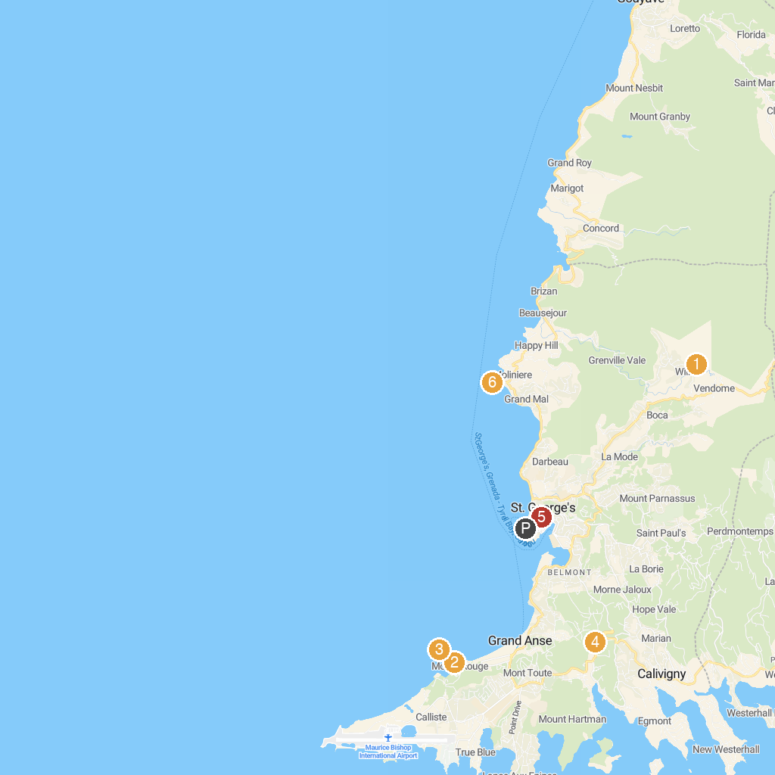
MAP KEY
1. Annandale Waterfall & Forest Park | 4. Clarke's Court Rum
2. BBC Beach | 5. Cathedral of the Immaculate Conception
3. Quarantine Point | 6. Grenada Underwater Sculpture Park
P. Cruise port / terminal
Map © MapTiler © OpenStreetMap contributors · cruiseports.org

