Preveza, Epirus, Greece
Where Octavian defeated Cleopatra and Mark Antony — and where Greece is still genuinely Greek. Preveza delivers Roman history, Venetian charm, superb seafood, and one of Europe's longest beaches, with almost no crowds.
⚓ Pier (small vessels) / Tender possible (larger ships) · 🕒 Typical call: 6–8 hrs · 💶 Currency: Euro (€) · 🗣️ Language: Greek (English widely spoken)
✍️ MY DAY IN PORT (FILL IN)
Ship / Date
In port | arrive ______ · all aboard ______
Booked excursion
Notes / meeting point
GETTING ASHORE
- Docking: Town quay (pier) for smaller ships; some larger vessels tender
- Walk to center: Immediate — old town begins at the dock
- Best For: Roman history, seafood, beaches, authentic Greek atmosphere
- Don't Miss: Ancient Nicopolis ruins and shrimp in Seytan Pazar
GETTING AROUND
- 🚕 Taxi: €6–€10 — Taxis are available at the port and the short ride to the city center costs roughly €6–€10 on the meter. Fares increase
TOP THINGS TO DO
- Ancient Nicopolis — Founded by Octavian (later Augustus) around 29 BC to commemorate his victory at the nearby Battle of Actium (31 BC), Nicopolis is…
- Ambracian Gulf Boat Tour — The Ambracian Gulf is a protected national park and one of the most important wetlands in Europe.
- Monolithi Beach — One of the longest sandy beaches in the European Union, Monolithi stretches nearly 22 km and is backed by fragrant forest.
- Seytan Pazar & Old Town Walk — Wander the Ottoman-era Devil's Bazaar — a maze of flower-draped alleyways lined with traditional ouzeries, local shops, and…
- Pantokratoras Castle & Coastal Walk — Follow the coastal path about 3 km west from the port to reach this early 19th-century castle built by Ali Pasha around 1807.
BEST WALKS
- Waterfront to Seytan Pazar Loop: 1.5 km · 30–45 min · Flat & easy — Start at the cruise quay, stroll the promenade past yachts and cafes, then duck into the Seytan…
- Coastal Walk to Pantokratoras Castle: ~6 km round trip · 1.5–2 hrs · Flat coastal path — Head west along the seafront past the small marina.
- Kyani Akti Beach Walk: 1.5 km one-way · 20 min · Shaded eucalyptus path — Walk west from the port along a tree-lined coastal path to Kyani Akti (Blue Coast) beach.
cruiseports.org/preveza · Confirm terminal & all-aboard time with your ship

Preveza, Epirus, Greece — Port Map
Red = walkable sights · Amber = excursions farther out · P = cruise terminal
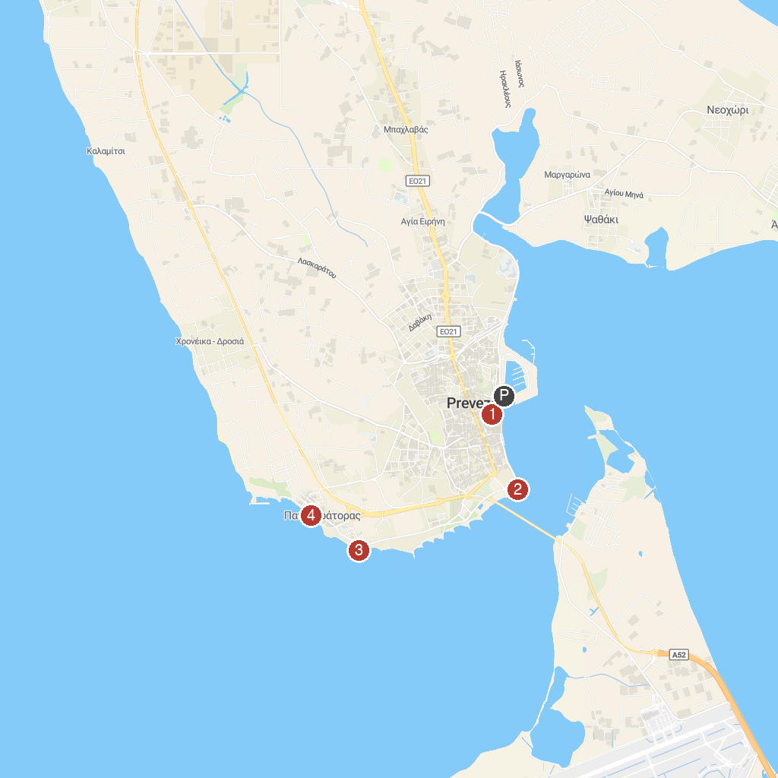
MAP KEY
1. Πύργος του Ρολογιού Πρέβεζας | 3. Pantocrator Castle
2. Sailor's Monument | 4. Pantokratoras promenade
P. Cruise port / terminal
Map © MapTiler © OpenStreetMap contributors · cruiseports.org

