Praslin Island, Seychelles
The second-largest island in the Seychelles shelters the Garden of Eden — a primeval coco de mer forest — and beaches that routinely top the world's best lists. Small ships anchor in Baie Sainte Anne and tender passengers into an island unlike anywhere else on Earth.
⚓ Tender port (Baie Sainte Anne) · 🕒 Typical call: 6–8 hrs · 💵 Seychellois Rupee (SCR); USD/EUR accepted · 🗣️ Seychellois Creole, English, French · 🌴 Small-ship & expedition calls only
✍️ MY DAY IN PORT (FILL IN)
Ship / Date
In port | arrive ______ · all aboard ______
Booked excursion
Notes / meeting point
GETTING ASHORE
- Docking: Tender to Baie Sainte Anne Jetty (~15–20 min)
- Walk to centre: Baie Sainte Anne village is steps from the jetty; main beaches require taxi
- Best For: Beaches, UNESCO nature reserve, island-hopping
- Don't Miss: Vallée de Mai coco de mer forest & Anse Lazio beach
GETTING AROUND
- 🚕 Taxi: €10–€25 (short trips); €40–€55 (Anse Lazio) — Taxis wait at Baie Sainte Anne Jetty. Fares are government-regulated by zone/destination (non-metered); always confirm t
- 📱 Rideshare: ❌ not available
TOP THINGS TO DO
- Vallée de Mai Nature Reserve — Walk ancient trails through the world's only wild coco de mer forest, a UNESCO World Heritage Site.
- Anse Lazio Beach — Consistently ranked among the world's best beaches: powder-white sand, turquoise water framed by smooth granite boulders.
- Curieuse Island — Giant Tortoises & Creole BBQ — A 20-minute boat ride takes you to Curieuse, a protected island where hundreds of free-roaming Aldabra giant tortoises share the…
- La Digue Island Day Trip — Ferry across to La Digue, home of Anse Source d'Argent — arguably the most photographed beach in the world, with extraordinary…
- Snorkelling & Diving at Anse Volbert — Côte d'Or's calm, sheltered waters and offshore coral gardens make it Praslin's best spot for families and beginner snorkellers.
BEST WALKS
- Baie Sainte Anne Village Stroll: 30–45 min · Flat · Free — From the jetty, walk the main road through Baie Sainte Anne to find the local market, small shops…
- Anse Volbert (Côte d'Or) Beach Walk: 1–2 hrs · Flat · Free · taxi to start — Praslin's longest beach runs for over a kilometre.
WEATHER · DAYLIGHT · MONEY
Month | High °F | Low °F | Rainy days
May | 82 | 78 | 22
Jul | 77 | 75 | 16
Sep | 78 | 76 | 18
Daylight: May 6:16AM–6:10PM · Jul 6:26AM–6:19PM · Sep 6:10AM–6:14PM
cruiseports.org/praslin-island-seychelles · Confirm terminal & all-aboard time with your ship

Praslin Island, Seychelles — Port Map
Red = walkable sights · Amber = excursions farther out · P = cruise terminal
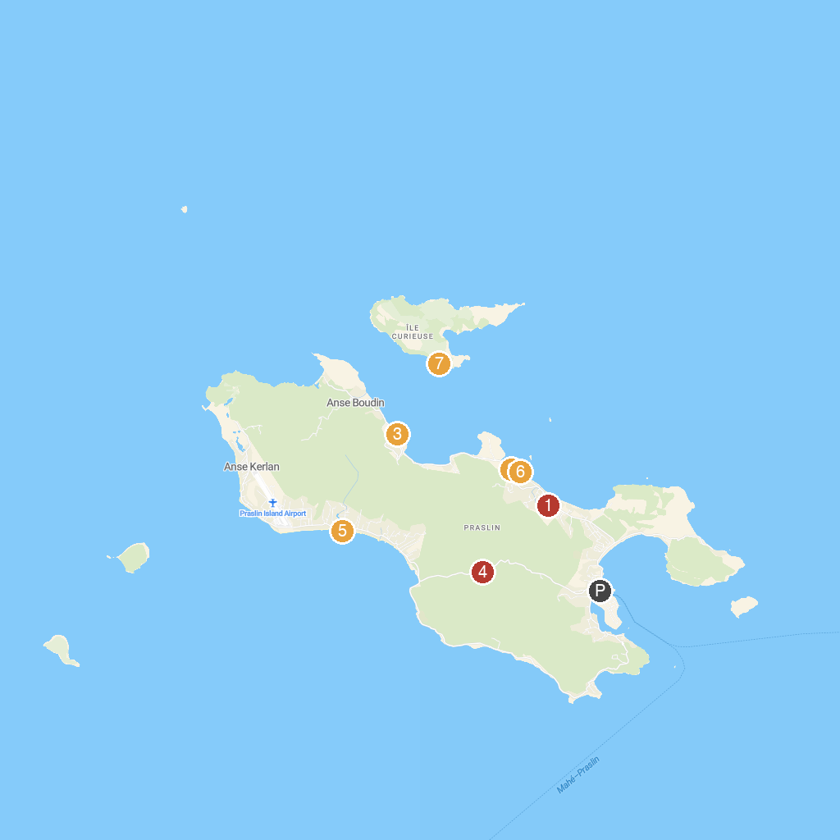
MAP KEY
1. Praslin Museum | 5. Praslin National Park Waterfall
2. Geoli Charters - Group Tours, Private Charters & Glass Bottom Boat | 6. Grand Anse Beach
3. L’Union Estate Farm | 7. Gallery Passerose’s horizontal palm tree
4. Anse Takamaka | 8. Anse St. Jose
P. Cruise port / terminal
Map © MapTiler © OpenStreetMap contributors · cruiseports.org

