Prague, Bohemia, Czech Republic
A medieval capital spared by history, Prague rewards river cruisers with Gothic spires, cobblestone alleys, and some of the world's best beer — all steps from the Vltava embankment.
⚓ Docked — Dvořák Embankment · 🕒 Typical call: full day (8-10 hrs) · 💵 Czech Koruna (CZK) — cards widely accepted · 🗣️ Czech — English common in tourist areas · 🏙️ River cruise port (Elbe/Vltava routes)
✍️ MY DAY IN PORT (FILL IN)
Ship / Date
In port | arrive ______ · all aboard ______
Booked excursion
Notes / meeting point
GETTING ASHORE
- Docking: Dvořák Embankment, right bank of the Vltava (small Elbe ships dock here; Danube ships arrive by coach from Nuremberg/Passau)
- Walk to center: 5 min to Jewish Quarter, 10 min to Old Town Square, 15 min to Charles Bridge
- Best For: History, architecture, beer culture, walkability
- Don't Miss: Charles Bridge at dawn, Astronomical Clock hourly show, a cold Pilsner at a local pub
GETTING AROUND
- 🚕 Taxi: CZK 150–300 (~$7–14) — Licensed taxis charge ~CZK 36/km with a CZK 60 base fare. Use AAA Radiotaxi or order via app; avoid unmarked cabs flagge
- 📱 Rideshare: ✅ Uber, Bolt
- 🚌 Hop-on hop-off: ✅
TOP THINGS TO DO
- Prague Castle & St. Vitus Cathedral — Europe's largest ancient castle complex dominates the left bank skyline.
- Jewish Quarter (Josefov) — One of Europe's best-preserved Jewish heritage sites.
- Klementinum Baroque Library Tour — A guided tour through one of the world's most beautiful libraries — a floor-to-ceiling gilded Baroque hall — and up the…
- Czech Beer & Food Experience — The Czech Republic invented Pilsner.
- Petřín Hill & Lookout Tower — Ride the historic funicular up wooded Petřín Hill to a mini-Eiffel Tower offering the highest views in Prague.
BEST WALKS
- River to Old Town Square: 1.2 km · 15 min · flat · free — From the Dvořák Embankment, walk south along the riverside past the grand Art Nouveau Hotel…
- Charles Bridge Loop: 2.5 km · 30-40 min · mostly flat · free — From Old Town Square, follow Karlova Street to the Old Town Bridge Tower, cross Charles Bridge…
- Castle District Self-Guide: 4 km · 2-3 hrs · hilly · free grounds, paid interiors — Take Tram 22 from Náměstí Republiky to the Pražský hrad stop (castle's back entrance, flat approach).
WEATHER · DAYLIGHT · MONEY
Month | High °F | Low °F | Rainy days
May | 67 | 48 | 12
Jul | 79 | 60 | 11
Sep | 70 | 53 | 9
Daylight: May 5:16AM–8:42PM · Jul 5:09AM–9:06PM · Sep 6:38AM–7:15PM
cruiseports.org/prague · Confirm terminal & all-aboard time with your ship

Prague, Bohemia, Czech Republic — Port Map
Red = walkable sights · Amber = excursions farther out · P = cruise terminal
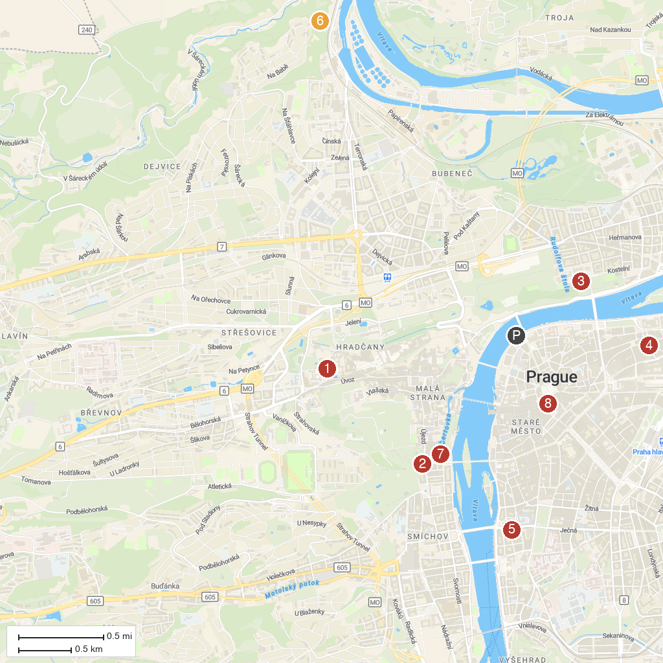
MAP KEY
1. Loreto | 5. Kostel svatého Václava na Zderaze
2. Memorial to the Victims of Communism | 6. Baba ruins
3. Letna Park Carousel | 7. Kostel Jana Křtitele Na Prádle
4. St. Peter at Poříčí | 8. Sex Machines Museum
P. Cruise port / terminal
Map © MapTiler © OpenStreetMap contributors · cruiseports.org

