Pozzallo, Sicily, Italy
A sun-baked Sicilian fishing town on the island's southern tip, Pozzallo pairs Blue Flag beaches with some of Italy's finest Baroque architecture just 30–50 minutes inland.
⚓ Pier (commercial port — shuttle recommended) · 🕒 Typical call: 7–9 hrs · 💶 Euro (€) · 🗣️ Italian (English limited) · ☀️ Hot, sunny summers
✍️ MY DAY IN PORT (FILL IN)
Ship / Date
In port | arrive ______ · all aboard ______
Booked excursion
Notes / meeting point
GETTING ASHORE
- Docking: Docked at Porto di Pozzallo (Molo di Ponente); smaller ships berth directly, larger vessels may tender
- Walk to center: 1.5–2 km along industrial port road — take the ship shuttle or a taxi
- Best For: Beach days, Baroque day trips to Ragusa Ibla & Modica, Modican chocolate, Malta ferry connections
- Don't Miss: Ragusa Ibla's UNESCO Baroque skyline, Modican cold-process chocolate at Antica Dolceria Bonajuto, Torre Cabrera at sunset
GETTING AROUND
- 🚕 Taxi: €5–€15 within town — Local taxis are available at the port for short hops around Pozzallo or longer transfers to nearby towns like Modica or
- 📱 Rideshare: ✅ Uber
TOP THINGS TO DO
- Ragusa Ibla — Baroque Hilltop Gem — Sicily's most photogenic old town, rebuilt in exuberant Baroque style after the 1693 earthquake.
- Modica & the Ancient Chocolate Tradition — Modica's cold-process chocolate — made using an Aztec technique unchanged since the 16th century — is an Intangible Cultural…
- Noto — Capital of Sicilian Baroque — Built entirely in golden limestone after the 1693 earthquake, Noto is the purest expression of Baroque urbanism in Europe.
- Blue Flag Beach Day in Pozzallo — Stay local and sink into Spiaggia Pietre Nere, Pozzallo's award-winning stretch of fine golden sand.
- Val di Noto Baroque Circuit — Combine Ragusa Ibla, Modica, and Scicli (all UNESCO-listed) in one private minivan tour.
BEST WALKS
- Town Center & Torre Cabrera Stroll: 1.5 km · Easy · 30 min — From Piazza delle Rimembranze, head south past the Liberty-style Palazzo Pandolfi and the Chiesa di…
- Pietre Nere Beach Promenade: 1 km one way · Easy · Flat — Stroll the full length of Pozzallo's main beach promenade, lined with lidos, gelaterias, and…
WEATHER · DAYLIGHT · MONEY
Month | High °F | Low °F | Rainy days
May | 70 | 61 | 4
Jul | 84 | 73 | 1
Sep | 80 | 71 | 6
Daylight: May 5:53AM–8:01PM · Jul 5:53AM–8:19PM · Sep 6:43AM–7:07PM
cruiseports.org/pozzallo · Confirm terminal & all-aboard time with your ship

Pozzallo, Sicily, Italy — Port Map
Red = walkable sights · Amber = excursions farther out · P = cruise terminal
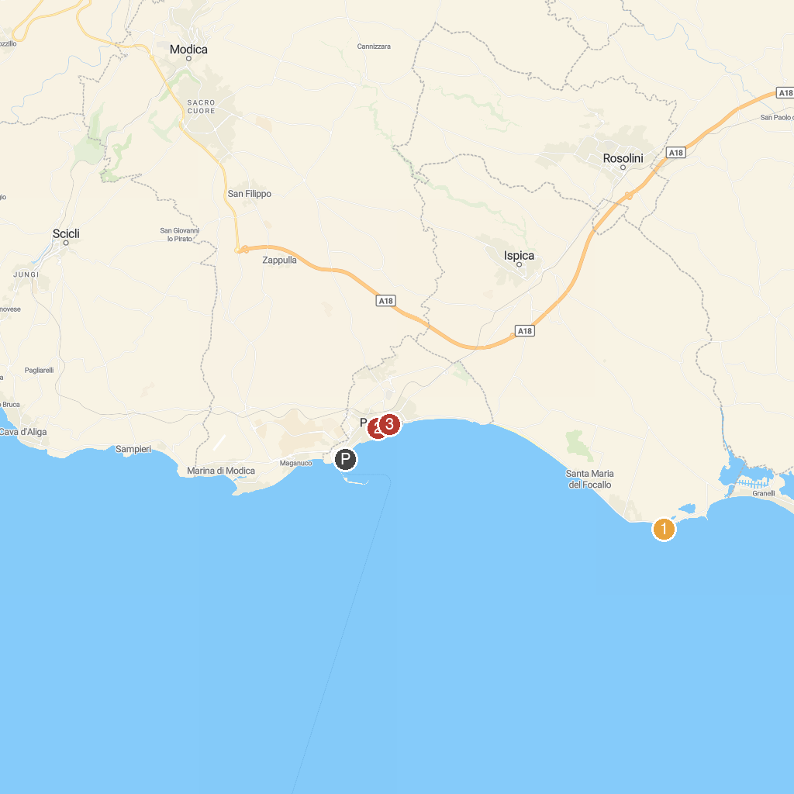
MAP KEY
1. Punta Cirica o Cozzo Ciriga | 5. Palazzo Spadaro
2. Parco Archeologico di Cava d'Ispica | 6. Chiesa Madre della Madonna del Rosario
3. Water Mill Museum in Grotte | 7. Piazzetta Padre Pio
4. Centro storico di Scicli
P. Cruise port / terminal
Map © MapTiler © OpenStreetMap contributors · cruiseports.org

