Poulsbo, Washington, USA
Poulsbo earns its 'Little Norway' nickname with Viking-themed storefronts, Norwegian pastries, and a scenic waterfront on Liberty Bay. American Cruise Lines small ships anchor in Liberty Bay and tender passengers to the Port of Poulsbo dock, steps from downtown — this is one of Puget Sound's most walkable and charming ports.
⚓ Anchor & tender (small ships only) · 🕒 Typical call: 5–7 hrs · 💵 US Dollar · 🗣️ English · 🇳🇴 Norwegian heritage town
✍️ MY DAY IN PORT (FILL IN)
Ship / Date
In port | arrive ______ · all aboard ______
Booked excursion
Notes / meeting point
GETTING ASHORE
- Docking: Ships anchor in Liberty Bay; passengers tender to the Port of Poulsbo dock — small vessels only (American Cruise Lines–size)
- Walk to Center: Steps from the dock to Front Street shops and Sluys Bakery
- Best For: Scandinavian food, boutique shopping, waterfront strolls, kayaking
- Don't Miss: Sluys Bakery Viking Donuts and the SEA Discovery Center touch tanks
GETTING AROUND
- 🚕 Taxi: $3 base + $3/mile — Local taxis serve the area. For the short marina-to-downtown trip the fare is minimal; fares increase for longer trips a
- 📱 Rideshare: ✅ Uber, Lyft
TOP THINGS TO DO
- Front Street Scandinavian Stroll — Wander Poulsbo's Norwegian-themed main street, ducking into Nordiska for Nordic homewares, Liberty Bay Books for local reads, and…
- Poulsbo Maritime Museum — Small but engaging museum documenting Poulsbo's Norwegian fishing heritage, traditional boat building, and the Scandinavian…
- Liberty Bay Kayaking — Paddle the calm waters of Liberty Bay from Olympic Outdoor Center — spot harbor seals, great blue herons, and the forested…
- SEA Discovery Center — Interactive marine science center with touch tanks featuring local Puget Sound species — sea stars, anemones, crabs.
- Poulsbo Fish Park — A 40-acre natural park along Dogfish Creek where you can watch salmon on their spawning runs, walk forest trails, and enjoy quiet…
BEST WALKS
- Waterfront to Front Street Loop: 1 mile · Easy · 30–45 min — From the marina, walk the boardwalk past Waterfront Park and the Viking statue, then up to Front…
- Maritime Museum & SEA Discovery Center: 0.5 miles · Easy · 30 min walk (plus time inside) — Head north along the waterfront from the marina to visit both the Poulsbo Historical Museum and the…
WEATHER · DAYLIGHT · MONEY
Month | High °F | Low °F | Rainy days
May | 65 | 49 | 10
Jul | 76 | 58 | 5
Sep | 69 | 55 | 11
Daylight: May 5:32AM–8:42PM · Jul 5:28AM–9:04PM · Sep 6:48AM–7:21PM
cruiseports.org/poulsbo-wa · Confirm terminal & all-aboard time with your ship

Poulsbo, Washington, USA — Port Map
Red = walkable sights · Amber = excursions farther out · P = cruise terminal
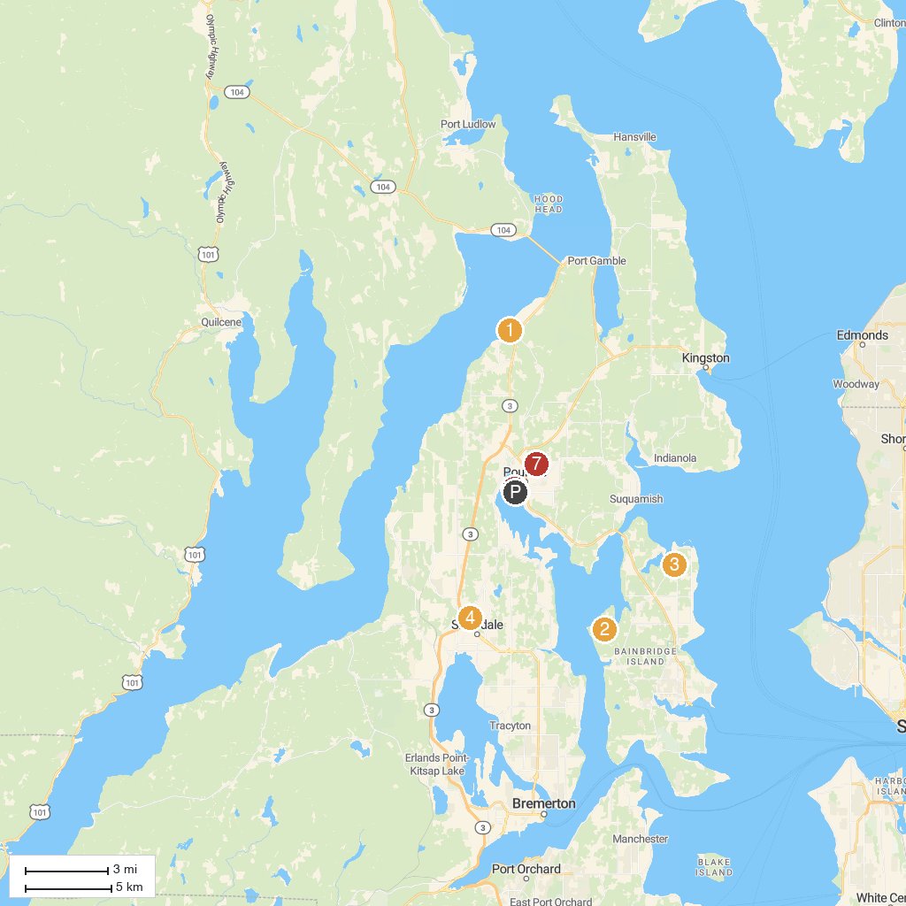
MAP KEY
1. Kitsap Memorial State Park | 5. Historic Downtown Poulsbo Association
2. Battle Point Park | 6. Poulsbo Heritage Museum
3. Frog Rock | 7. Forest Rock Hills Park
4. Silverdale Dog Park
P. Cruise port / terminal
Map © MapTiler © OpenStreetMap contributors · cruiseports.org

