Potsdam, Brandenburg, Germany
Former seat of Prussian kings, Potsdam is a city of lakeside palaces, Cold War history, and 700 acres of royal park — all within easy reach of the river dock.
⚓ River pier (no tender) · 🕒 Typical call: 8-10 hrs · 💶 Currency: Euro (€) · 🗣️ Language: German · 🏛️ UNESCO World Heritage Site
✍️ MY DAY IN PORT (FILL IN)
Ship / Date
In port | arrive ______ · all aboard ______
Booked excursion
Notes / meeting point
GETTING ASHORE
- Docking: Pier — Hafen Potsdam near Hauptbahnhof (river cruise ships)
- Walk to center: 5 min to Alter Markt; 25 min to Sanssouci Park entrance
- Best For: Palace history, Prussian architecture, Cold War sites
- Don't Miss: Sanssouci Palace (pre-book!), Cecilienhof, Glienicke Bridge
GETTING AROUND
- 🚕 Taxi: €10–€20 — Metered taxis are readily available near the dock. Fares start at €4.40 base plus €2.10–€2.50 per km depending on time o
- 📱 Rideshare: ✅ Uber, Bolt
- 🚌 Hop-on hop-off: ✅ City Sightseeing Potsdam
TOP THINGS TO DO
- Sanssouci Palace & Park — Frederick the Great's intimate Rococo summer palace sits atop terraced vineyards.
- Cecilienhof & the Potsdam Conference — In this English Tudor-style palace in the New Garden, Truman, Churchill, and Stalin divided post-war Germany in 1945.
- Dutch Quarter Walking Tour — 134 red-brick Dutch-style houses built in the 18th century for craftsmen recruited from the Netherlands.
- Glienicke Bridge (Bridge of Spies) — The famous bridge where the US and USSR exchanged captured spies during the Cold War.
- Museum Barberini — World-class Impressionist collection housed in the reconstructed Barberini Palace on Alter Markt, including one of the largest…
BEST WALKS
- Dock to Dutch Quarter & Alter Markt: 1.5 km · 20 min · Easy — Leave the dock, cross Lange Brücke to Alter Markt (St.
- Sanssouci Park Terrace Walk: 3 km · 45-60 min · Easy — From the park's east entrance (tram from station), walk the central axis past the Great Fountain…
WEATHER · DAYLIGHT · MONEY
Month | High °F | Low °F | Rainy days
May | 65 | 49 | 9
Jul | 76 | 60 | 11
Sep | 69 | 54 | 8
Daylight: May 5:12AM–8:56PM · Jul 5:04AM–9:22PM · Sep 6:42AM–7:22PM
cruiseports.org/potsdam · Confirm terminal & all-aboard time with your ship

Potsdam, Brandenburg, Germany — Port Map
Red = walkable sights · Amber = excursions farther out · P = cruise terminal
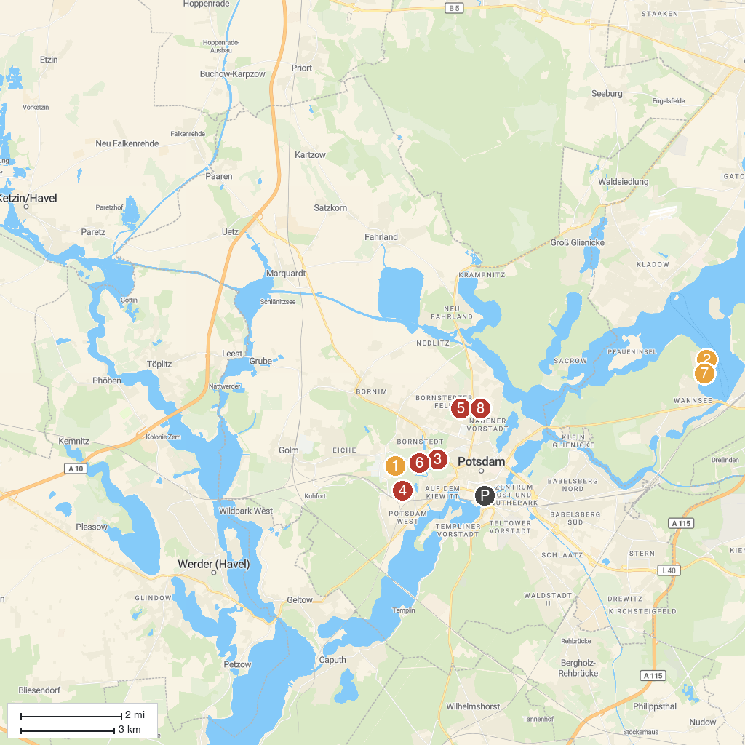
MAP KEY
1. Antique Temple | 5. Biosphäre Potsdam
2. House of the Wannsee Conference | 6. Sanssouci Park
3. Sanssouci Palace | 7. Liebermann-Villa
4. Hippodrom | 8. Belvedere Castle on the Pfingstberg
P. Cruise port / terminal
Map © MapTiler © OpenStreetMap contributors · cruiseports.org

