Portsmouth, New Hampshire, USA
New Hampshire's colonial gem sits where the Piscataqua River meets the sea — a walkable, tax-free town of lobster shacks, living-history museums, and 18th-century brick lanes that small-ship cruisers keep coming back to.
⚓ Pier (Market Street Terminal) · 🕒 Typical call: 6-8 hrs · 💵 USD — No sales tax in NH · 🗣️ English
✍️ MY DAY IN PORT (FILL IN)
Ship / Date
In port | arrive ______ · all aboard ______
Booked excursion
Notes / meeting point
GETTING ASHORE
- Docking: Pier — Port of NH, 555 Market St (small/mid ships only)
- Walk to center: ~0.6 mi / 10-12 min flat walk to Market Square
- Best For: History, seafood, boutique shopping, colonial architecture
- Don't Miss: Strawbery Banke Museum & a lobster roll on Bow Street
GETTING AROUND
- 🚕 Taxi: $10–$20 — Annie's Taxi serves the port area with a base fare of $15 minimum plus $4/mile. A short ride to downtown typically runs
- 📱 Rideshare: ✅ Uber, Lyft
TOP THINGS TO DO
- Strawbery Banke Museum — A 10-acre outdoor living-history museum tracing Portsmouth's evolution from 1695 to the 1950s — preserved homes, costumed…
- USS Albacore Submarine Museum — Go inside a real 1953 Navy research submarine built at the Portsmouth Naval Shipyard.
- Market Square & Colonial District Walk — Explore Market Square anchored by the 1854 North Church, browse independent bookshops and galleries, then wind through Bow Street…
- Walk to Maine: Memorial Bridge — Cross the award-winning vertical-lift pedestrian bridge over the Piscataqua River and set foot in Kittery, Maine — two states in…
- New England Seafood Lunch — Portsmouth is a legendary food town — more restaurant seats per capita than almost any U.S.
BEST WALKS
- Pier to Market Square & Prescott Park: 1.2 mi round trip • Easy • 30-40 min — Walk Market Street to the city center, explore Market Square and the North Church, then continue…
- Colonial History Loop: 1.5 mi loop • Easy • 45-60 min — From Market Square, walk to Strawbery Banke Museum on Hancock Street, loop through South End…
- Bridge to Maine Walk: 1.4 mi round trip • Easy • 30-40 min — From Prescott Park, walk north along the riverfront path to Memorial Bridge and cross into Kittery…
WEATHER · DAYLIGHT · MONEY
Month | High °F | Low °F | Rainy days
May | 61 | 49 | 11
Jul | 70 | 59 | 10
Sep | 66 | 55 | 10
Daylight: May 5:15AM–8:46PM · Jul 5:08AM–9:11PM · Sep 6:40AM–7:17PM
cruiseports.org/portsmouth-nh · Confirm terminal & all-aboard time with your ship

Portsmouth, New Hampshire, USA — Port Map
Red = walkable sights · Amber = excursions farther out · P = cruise terminal
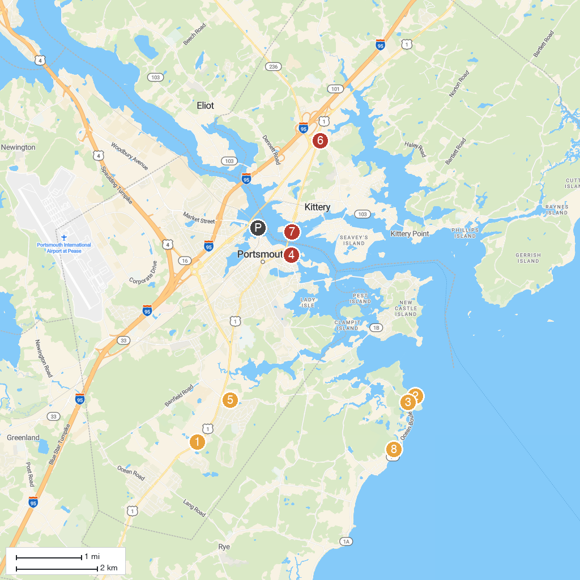
MAP KEY
1. Water Country Water Park | 5. Urban Forestry Center
2. Seacoast Science Center | 6. Kittery Historical & Naval Museum
3. Odiorne Point State Park | 7. Piscataqua Marina
4. Prescott Park | 8. Pulpit Rock Tower
P. Cruise port / terminal
Map © MapTiler © OpenStreetMap contributors · cruiseports.org

