Portrush, County Antrim, Northern Ireland
Perched on a basalt peninsula jutting into the Atlantic, Portrush punches above its size — world-class golf, Blue Flag beaches, and one of the planet's great geological wonders just eight miles up the coast.
⚓ Tender port (no pier) · 🕒 Typical call: 8-10 hrs · 💷 Currency: British Pound (£) · 🗣️ Language: English (Ulster accent) · 🌧️ Weather: changeable — pack a waterproof
✍️ MY DAY IN PORT (FILL IN)
Ship / Date
In port | arrive ______ · all aboard ______
Booked excursion
Notes / meeting point
GETTING ASHORE
- Docking: Tender into Portrush Harbour (10–15 min ride)
- Walk to center: 2–5 min from tender pier
- Best For: Giant's Causeway, whiskey tours, coastal walks, golf
- Don't Miss: Ramore Restaurant Complex right on the harbour
GETTING AROUND
- 🚕 Taxi: £10–£15 (5 miles) — Multiple local firms operate in Portrush (AK Taxis, KM Taxis, North West Taxis). Fares start around £3–4 for the first m
TOP THINGS TO DO
- Giant's Causeway — UNESCO World Heritage Site featuring 40,000 interlocking basalt columns formed by ancient volcanic activity.
- Old Bushmills Distillery — The world's oldest licensed whiskey distillery (licensed 1608) in the village of Bushmills, just 6 miles from port.
- Dunluce Castle — Atmospheric medieval ruin clinging to a basalt cliff edge above the Atlantic, 4 miles east of Portrush.
- Carrick-a-Rede Rope Bridge — Sway across a narrow rope bridge 30 meters above the sea to a tiny island once used by salmon fishermen.
- Causeway Coast DIY by Bus — The Causeway Rambler (Bus 402) is an open-top hop-on/hop-off service running from Portrush through Dunluce, Bushmills, and the…
BEST WALKS
- Ramore Head Loop: 45 min · Easy · Free — From the harbour, walk north past the Ramore Restaurant Complex and loop around Ramore Head.
- East Strand & White Rocks: 4–5 km one way · Easy · Free — Head east through town to East Strand, Northern Ireland's finest Blue Flag beach, then continue to…
- Town Center Stroll: 30 min · Easy · Free — Quick loop from the harbour up to Main Street, along the seafront promenade, and back — good for…
WEATHER · DAYLIGHT · MONEY
Month | High °F | Low °F | Rainy days
May | 56 | 47 | 17
Jul | 62 | 54 | 18
Sep | 61 | 52 | 16
Daylight: May 5:18AM–9:29PM · Jul 5:07AM–9:56PM · Sep 6:59AM–7:42PM
cruiseports.org/portrush · Confirm terminal & all-aboard time with your ship

Portrush, County Antrim, Northern Ireland — Port Map
Red = walkable sights · Amber = excursions farther out · P = cruise terminal
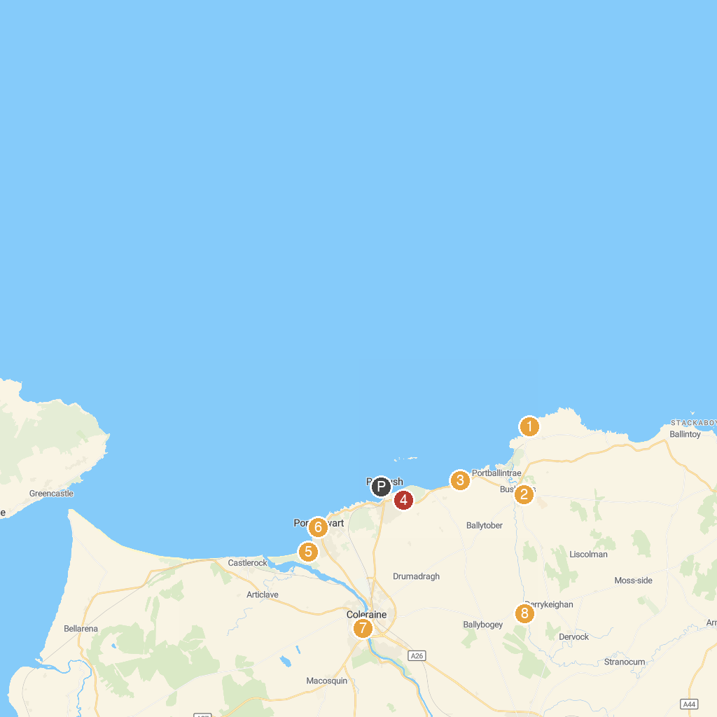
MAP KEY
1. Giant's Causeway | 5. National Trust - Portstewart Strand
2. Old Bushmills Distillery | 6. Visit Portstewart
3. Dunluce Castle | 7. Christie Park
4. Royal Portrush Golf Club | 8. Benvarden Gardens & Stableyard Tearoom
P. Cruise port / terminal
Map © MapTiler © OpenStreetMap contributors · cruiseports.org

