Portoferraio, Elba, Italy
The island that held Napoleon captive and still refuses to let visitors leave. Elba's capital packs Medici fortresses, turquoise coves, and genuinely good Tuscan seafood into a port you can conquer on foot.
⚓ Mixed: pier or tender (ship-size dependent) · 🕒 Typical call: 7-10 hrs · 💶 Euro (EUR) · 🗣️ Italian
✍️ MY DAY IN PORT (FILL IN)
Ship / Date
In port | arrive ______ · all aboard ______
Booked excursion
Notes / meeting point
GETTING ASHORE
- Docking: Smaller ships dock at Alto Fondale pier; larger vessels anchor and tender to Darsena Medicea
- Walk to center: Immediate — tender jetty and pier are both steps from the old town gate
- Best For: History (Napoleon), beaches, Italian food, scenic island drives
- Don't Miss: Villa dei Mulini (Napoleon's residence) and Spiaggia delle Ghiaie
GETTING AROUND
- 🚕 Taxi: ~€10–13 — Taxis wait near the port entrance. The fare to the city center is roughly €10–13 based on a ~€1.40 base plus per-km mete
TOP THINGS TO DO
- Napoleon's Elba: Villa dei Mulini & Forte Falcone — Walk up through the old town to Napoleon's official island residence — still furnished with his library and Empire-style…
- Spiaggia delle Ghiaie — Elba's Walking Beach — A 15-minute flat walk from the pier brings you to this postcard-perfect pebble cove with clear turquoise water in a protected…
- Sansone & Sorgente Beaches — Regularly ranked among Italy's most beautiful, these white-cliff coves sit 15 minutes by taxi from town.
- Island Loop: Porto Azzurro & Capoliveri — Combine the pastel-painted fishing harbour of Porto Azzurro with the hilltop village of Capoliveri — both beloved by Italian…
- Scooter or E-Bike Rental — Rental shops cluster near the port.
BEST WALKS
- Harbor to Forte Falcone via Old Town: 1.2 km | 30-40 min one-way | Steep ascent via stone steps — From the tender jetty, pass through Porta del Mare into the old town and climb the salite (stepped…
- Harbor to Spiaggia delle Ghiaie: 0.9 km | 15 min | Flat and easy — Head north from Calata Mazzini along the harbor road, rounding the headland to reach Elba's most…
WEATHER · DAYLIGHT · MONEY
Month | High °F | Low °F | Rainy days
May | 68 | 61 | 8
Jul | 83 | 74 | 2
Sep | 77 | 69 | 8
Daylight: May 5:56AM–8:34PM · Jul 5:54AM–8:54PM · Sep 6:58AM–7:28PM
cruiseports.org/portoferraio · Confirm terminal & all-aboard time with your ship

Portoferraio, Elba, Italy — Port Map
Red = walkable sights · Amber = excursions farther out · P = cruise terminal
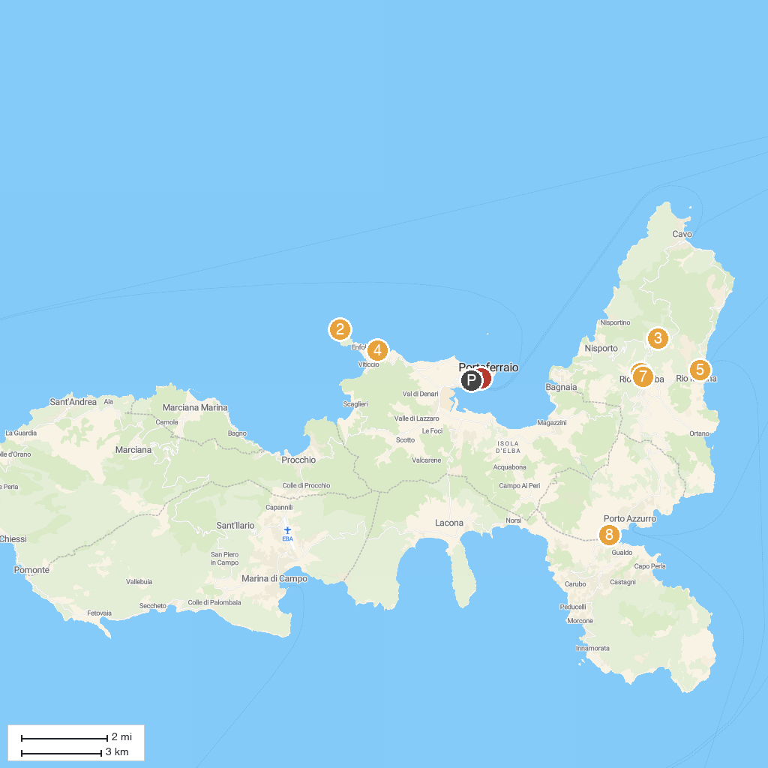
MAP KEY
1. Fortezze Medicee di Portoferraio | 5. Parco Minelba
2. Capo d'Enfola | 6. Lavatoio Pubblico
3. Orto dei Semplici Elbano | 7. Museo civico archeologico del Distretto minerario
4. Spiaggia di Sansone | 8. dog beach Porto Azzurro
P. Cruise port / terminal
Map © MapTiler © OpenStreetMap contributors · cruiseports.org

