Porto Vecchio, Corsica, France
The St. Tropez of Corsica — a Genoese hilltop citadel ringed by some of the Mediterranean's most dazzling beaches. Small ships dock; larger vessels tender into the marina.
⚓ Tender (most ships) or docked (small ships) · 🕒 Typical call: 7-9 hrs · 💶 Euro (€) · 🗣️ French / Corsican
✍️ MY DAY IN PORT (FILL IN)
Ship / Date
In port | arrive ______ · all aboard ______
Booked excursion
Notes / meeting point
GETTING ASHORE
- Docking: Tender for medium/large ships; small ships may dock at Quai de Syracuse
- Walk to Old Town: 15-20 min uphill from marina; steep — tourist train available (~€7-8)
- Best For: Beaches, Corsican cuisine, history, boat excursions
- Don't Miss: Palombaggia Beach & a day trip to dramatic clifftop Bonifacio
GETTING AROUND
- 🚕 Taxi: ~€12–16 — Official taxis charge a €2 base fare plus ~€2.54/km. The port to city center is roughly 5 km, putting the fare around €1
TOP THINGS TO DO
- Palombaggia Beach Day — Corsica's most iconic beach: white sand, turquoise water, umbrella pines and pink granite rocks.
- Lavezzi Islands Boat Tour — A protected marine reserve of granite boulders and impossibly clear water, south of Porto Vecchio.
- Bonifacio Day Trip — One of the Mediterranean's most jaw-dropping sights: a medieval town perched on white limestone cliffs 70 m above the sea, just…
- Porto Vecchio Citadel & Old Town — Climb or train up to the Genoese citadel and wander cobblestone lanes past boutiques, charcuterie shops and the panoramic Porte…
- Aiguilles de Bavella & Ospedale Forest — Swap the beach for dramatic red-granite needle peaks and fragrant pine forest just 30-45 min inland — a completely different side…
BEST WALKS
- Marina to Citadel: 1 km · 20 min · Steep uphill — Walk from the marina along the waterfront, then follow signs uphill through the residential streets…
- Salt Marshes Stroll: 2-3 km · 45 min · Flat & easy — From the port, walk south along the shore of the gulf past the historic salt marshes.
WEATHER · DAYLIGHT · MONEY
Month | High °F | Low °F | Rainy days
May | 60 | 46 | 15
Jul | 76 | 61 | 6
Sep | 68 | 54 | 10
Daylight: May 6:02AM–8:37PM · Jul 6:01AM–8:57PM · Sep 7:03AM–7:32PM
cruiseports.org/porto-vecchio · Confirm terminal & all-aboard time with your ship

Porto Vecchio, Corsica, France — Port Map
Red = walkable sights · Amber = excursions farther out · P = cruise terminal
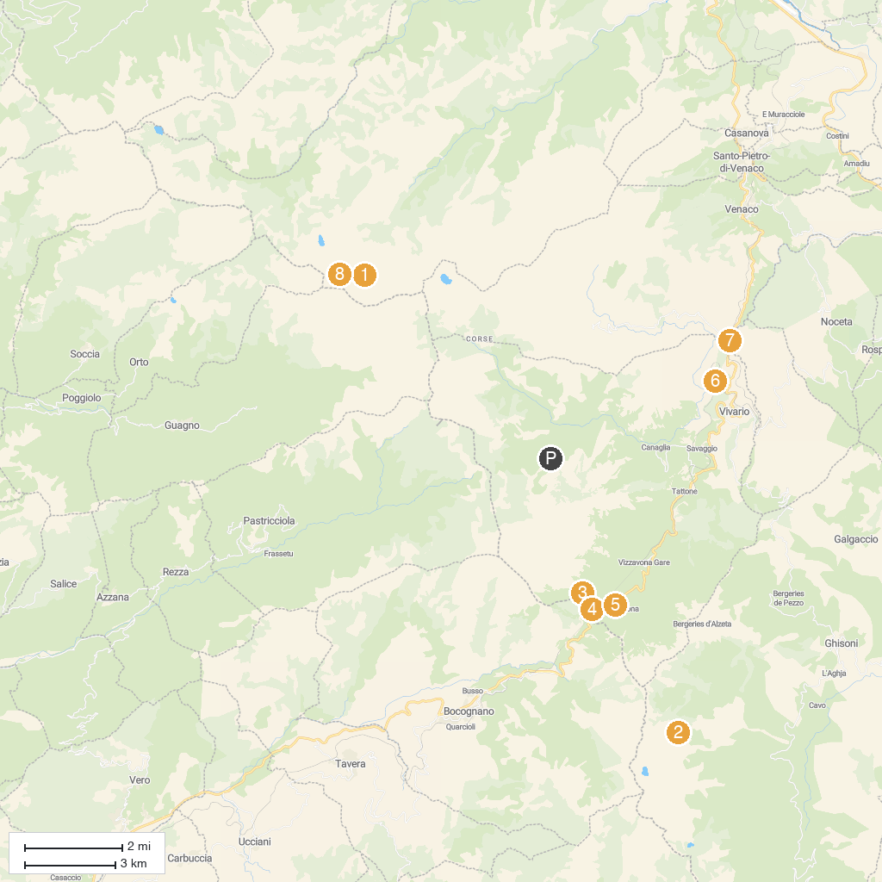
MAP KEY
1. Lac de Melu | 5. Tree Adventure Park Vizzavona
2. Ski resort of Ghisoni | 6. Fortin de Pasciola - Bastione di Pasciola
3. Cascade des Anglais | 7. Rivière du Vecchio - Fiumicellu d'U Vechju
4. Fort de Vaux - U Forte di Vaux | 8. Lac de Capitellu
P. Cruise port / terminal
Map © MapTiler © OpenStreetMap contributors · cruiseports.org

