Porto Torres, Sardinia, Italy
Sardinia's ancient Roman port opens onto turquoise waters and millennia of history. From a rugged medieval basilica to a wild island national park, Porto Torres rewards those who go beyond the terminal.
⚓ Pier (direct dock) · 🕒 Typical call: 6-8 hrs · 💶 Euro (EUR) · 🗣️ Italian · 🏛️ Roman history
✍️ MY DAY IN PORT (FILL IN)
Ship / Date
In port | arrive ______ · all aboard ______
Booked excursion
Notes / meeting point
GETTING ASHORE
- Docking: Pier — direct berth, no tender
- Walk to center: ~10 min on foot from terminal
- Best For: Roman ruins, Asinara day trips, Sassari city
- Don't Miss: Basilica di San Gavino — oldest Romanesque church in Sardinia
GETTING AROUND
- 🚕 Taxi: €4–6 — Taxis are available at the port and reach the city center in about 1–2 minutes. Useful for those with heavy luggage or h
- 📱 Rideshare: ✅ Uber
TOP THINGS TO DO
- Roman Porto Torres Walk — Explore the ancient city of Turris Libisonis on foot: the Ponte Romano (one of Sardinia's best-preserved Roman bridges), the…
- Basilica di San Gavino — The largest and oldest Romanesque church in Sardinia, built between 1030 and 1080, with a striking double-apse layout and carved…
- Asinara National Park — Wild, car-free island national park about 20 km offshore (roughly an hour by boat), once a supermax prison and now an ecological…
- Sassari City Day Trip — Sardinia's second city is 20 minutes by train.
- Platamona Beach — Long sandy beach with shallow turquoise water about 10 km east of Porto Torres, popular with locals.
BEST WALKS
- Roman & Medieval Porto Torres: 2.5 km • ~45 min • Easy • History — From the cruise terminal, walk through the port gate into town, head to Ponte Romano over the Rio…
- Balai Beach Stroll: 1.5 km one-way • 20 min • Easy • Beach — Head northwest from the port along the coastline to Balai Beach, a small sandy cove popular for a…
WEATHER · DAYLIGHT · MONEY
Month | High °F | Low °F | Rainy days
May | 70 | 58 | 7
Jul | 84 | 71 | 2
Sep | 79 | 68 | 5
Daylight: May 6:09AM–8:36PM · Jul 6:08AM–8:56PM · Sep 7:07AM–7:35PM
cruiseports.org/porto-torres · Confirm terminal & all-aboard time with your ship

Porto Torres, Sardinia, Italy — Port Map
Red = walkable sights · Amber = excursions farther out · P = cruise terminal
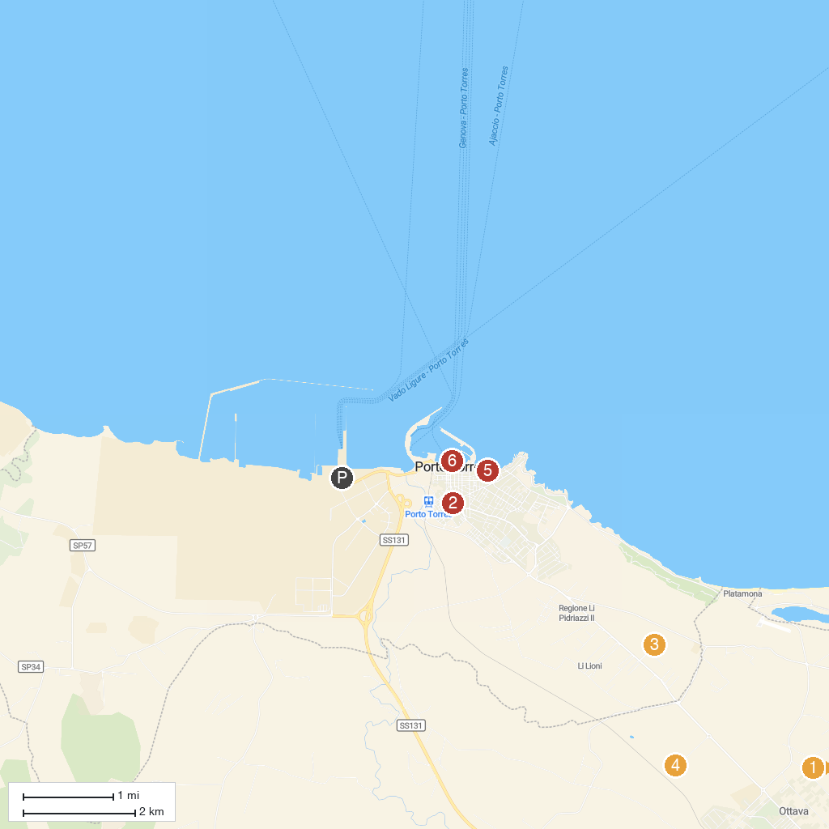
MAP KEY
1. Church of Saint Michael | 4. Santuario prenuragico Monte d'Accoddi - Biglietteria
2. Parco San Gavino | 5. Spiaggia Scoglio Lungo
3. Necropoli di Su Crucifissu Mannu | 6. Aragonese Tower
P. Cruise port / terminal
Map © MapTiler © OpenStreetMap contributors · cruiseports.org

