Porto Santo Stefano, Tuscany, Italy
A former Spanish military enclave turned Italian Riviera gem, Porto Santo Stefano clings to the dramatic cliffs of Monte Argentario with pastel houses, a yacht-filled harbor, and some of the clearest Tyrrhenian water you'll ever see.
⚓ Pier (small ships) / Tender (large ships) · 🕒 Typical call: 6–9 hrs · 💶 Currency: Euro (€) · 🗣️ Language: Italian
✍️ MY DAY IN PORT (FILL IN)
Ship / Date
In port | arrive ______ · all aboard ______
Booked excursion
Notes / meeting point
GETTING ASHORE
- Docking: Smaller ships dock at Porto Vecchio; large ships anchor and tender in
- Walk to center: 2–5 min flat walk from tender/pier to Piazza dei Rioni
- Best For: Upscale Tuscan ambiance, beach walks through WWII tunnels, history
- Don't Miss: Spanish Fortress panorama & the walk to Cantoniera beach via old railway tunnels
GETTING AROUND
- 🚕 Taxi: €5–€15 — Taxis are available near the port. For short in-town rides fares are minimal; agree on price before departing as meters
TOP THINGS TO DO
- Spanish Fortress (Fortezza Spagnola) — Climb to this massive hilltop fort, built between the late 16th and early 17th centuries during the Spanish State of the Presidii…
- WWII Tunnel Walk to Cantoniera Beach — A unique shore-day walk: head west along the coast and pass through two decommissioned railway tunnels (bombed in WWII, never…
- Ferry to Isola del Giglio — Hop a Toremar or Maregiglio ferry for a 1-hour crossing to this rugged, car-free island with crystal coves and a medieval hilltop…
- Feniglia & Giannella Sandy Beaches — A 10-minute taxi ride reaches the long sandy tombolo spits connecting Monte Argentario to the mainland.
- Porto Ercole & Roman Ruins at Ansedonia — Porto Ercole is the quieter, even more aristocratic fishing village on the other side of the Monte Argentario peninsula.
BEST WALKS
- Harbor Promenade to WWII Tunnels & Cantoniera Beach: 3.5 km round trip · Easy · ~1.5 hrs — Walk west along the Lungomare (designed by car designer Giorgetto Giugiaro) past the Porto Vecchio…
- Town to Spanish Fortress: 1 km one-way · Moderate (steep) · ~30 min — From the harbor promenade, follow signs uphill through steep cobblestone alleys to the Fortezza…
WEATHER · DAYLIGHT · MONEY
Month | High °F | Low °F | Rainy days
May | 70 | 57 | 10
Jul | 85 | 70 | 3
Sep | 78 | 65 | 7
Daylight: May 5:54AM–8:30PM · Jul 5:52AM–8:50PM · Sep 6:55AM–7:24PM
cruiseports.org/porto-santo-stefano · Confirm terminal & all-aboard time with your ship

Porto Santo Stefano, Tuscany, Italy — Port Map
Red = walkable sights · Amber = excursions farther out · P = cruise terminal
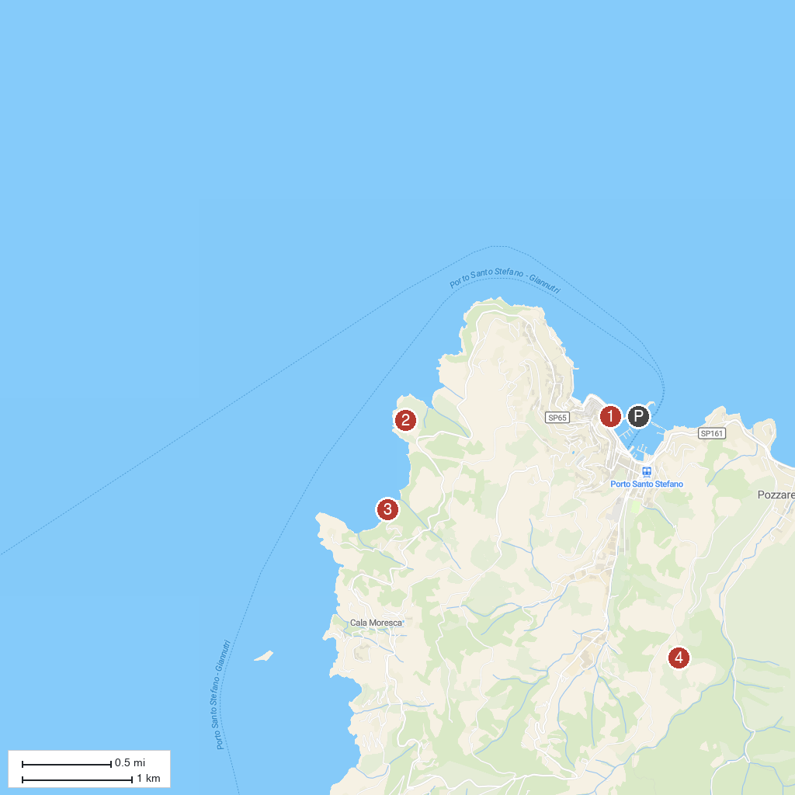
MAP KEY
1. Acquario Di Talamone | 4. Torre della Cacciarella
2. Roman Town of Cosa | 5. Cala Grande
3. Argentario Aquarium | 6. Torre Dell'Argentiera
P. Cruise port / terminal
Map © MapTiler © OpenStreetMap contributors · cruiseports.org

