Porto Santo Island, Madeira, Portugal
Forty-three kilometres northeast of Madeira and a world apart — Porto Santo is all golden sand, volcanic peaks, and unhurried Atlantic light. The whole island is smaller than Manhattan, which means you can cover the highlights on foot, by bike, or in a tuk-tuk before your ship calls you back.
⚓ Tender or dock (Porto de Abrigo) · 🕒 Typical call: 6-8 hrs · 💶 Euro (€) · 🗣️ Portuguese · 🏖️ Beach day
✍️ MY DAY IN PORT (FILL IN)
Ship / Date
In port | arrive ______ · all aboard ______
Booked excursion
Notes / meeting point
GETTING ASHORE
- Docking: Larger cruise ships usually tender; smaller/expedition vessels berth alongside at the Porto de Abrigo breakwater in Vila Baleira.
- Walk to centre: The commercial pier sits ~2 km from the town centre and main beach access — most cruisers take a shuttle, taxi, or short bike ride.
- Best For: Beach lovers, history buffs (Columbus connection), cycling, and anyone craving a crowd-free port.
- Don't Miss: The full 9 km beach walk, the Casa de Cristóvão Colombo museum, and a glass of local aguardente.
GETTING AROUND
- 🚕 Taxi: €5–€6 — Taxis from the port to Vila Baleira (city center) are about €5–€6 for the short ride. A 20% surcharge applies on weekend
TOP THINGS TO DO
- Porto Santo Golden Beach — The island's famous 9 km crescent of fine golden sand is the main event.
- Casa de Cristóvão Colombo (Columbus House Museum) — Christopher Columbus lived on Porto Santo in the 1470s when he was married to Filipa Moniz, whose father was the island's governor.
- Island Scooter or Bike Circuit — Porto Santo's compact size makes it ideal for a self-guided circuit.
- Pico do Castelo Hike — A rewarding walk or short drive to the island's most prominent peak (437 m), topped by the ruins of a 16th-century fortress built…
- Vila Baleira Town Walk — The island's only town is quiet and pleasant — whitewashed houses, the Igreja Nossa Senhora da Piedade (one of the oldest…
BEST WALKS
- Beach Promenade Walk: Easy • 2-9 km • flat sand — Start at the pier end of the beach and walk east along the full golden crescent.
- Town & Columbus Museum Loop: Easy • 1.5 km • flat — From the pier, walk to Largo do Pelourinho (the main square), visit the Columbus museum on Rua…
WEATHER · DAYLIGHT · MONEY
Month | High °F | Low °F | Rainy days
May | 69 | 63 | 7
Jul | 74 | 69 | 4
Sep | 76 | 71 | 7
Daylight: May 7:05AM–8:57PM · Jul 7:07AM–9:14PM · Sep 7:49AM–8:11PM
cruiseports.org/porto-santo-island-madeira · Confirm terminal & all-aboard time with your ship

Porto Santo Island, Madeira, Portugal — Port Map
Red = walkable sights · Amber = excursions farther out · P = cruise terminal
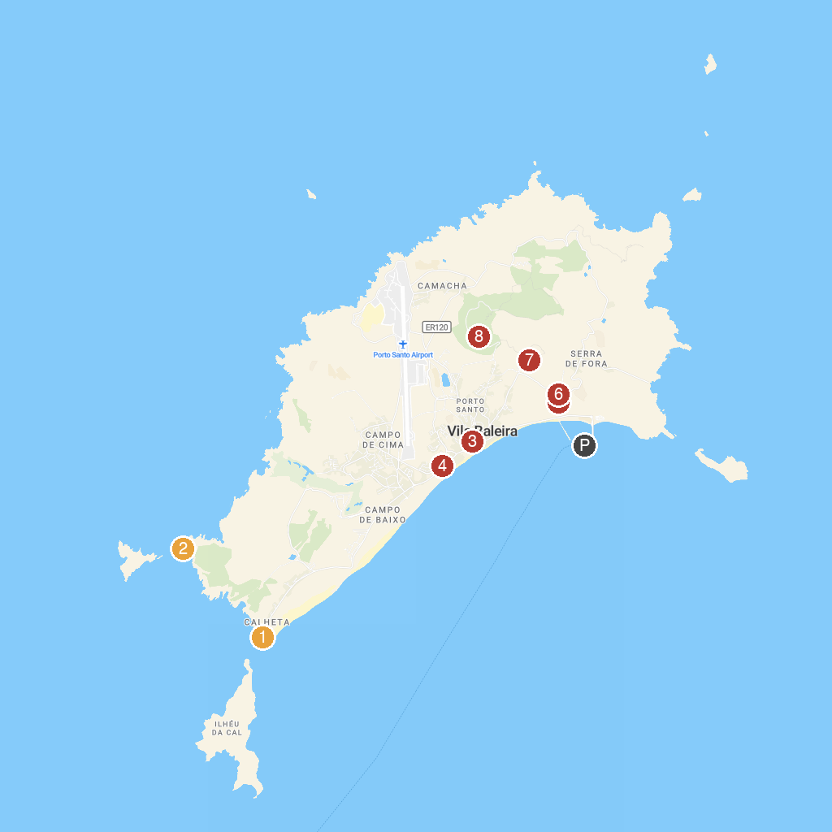
MAP KEY
1. Ponta da Calheta | 5. Miradouro da Portela no Porto Santo
2. Ponta da Canavieira | 6. Moinhos de Vento de Porto Santo
3. Casa de Cristóvão Colombo | 7. Capela de Nossa Senhora da Graça
4. Miradouro das Lombas | 8. Miradouro do Pico do Castelo
P. Cruise port / terminal
Map © MapTiler © OpenStreetMap contributors · cruiseports.org

