Leixões (Porto), Norte, Portugal
Portugal's second-largest port drops you at the doorstep of Porto — a UNESCO World Heritage city of port wine, azulejo-tiled churches, and dramatic iron bridges — with world-class surf beaches right outside the terminal gates.
⚓ Docked (pier) · 🕒 Typical call: 8-10 hrs · 💶 Euro (€) · 🗣️ Portuguese (English widely spoken)
✍️ MY DAY IN PORT (FILL IN)
Ship / Date
In port | arrive ______ · all aboard ______
Booked excursion
Notes / meeting point
GETTING ASHORE
- Docking: Always docked — two cruise quays (South & North terminals); no tendering
- Walk to center: ~10 min walk to Matosinhos beach & seafood street; Porto city center ~10 km (taxi/metro)
- Best For: History, port wine tastings, azulejo tile architecture, Atlantic beaches
- Don't Miss: Dom Luís I Bridge, São Bento Station tiles, port wine cellars in Vila Nova de Gaia
GETTING AROUND
- 🚕 Taxi: €10–€20 — Official taxis wait at the port exit. Journey to Porto city center takes roughly 15–20 minutes; confirm the meter is run
- 📱 Rideshare: ✅ Uber, Bolt
- 🚌 Hop-on hop-off: ✅ City Sightseeing Porto
TOP THINGS TO DO
- Porto City Highlights — Walk the Ribeira waterfront, cross the top deck of the Dom Luís I Bridge, and explore the cobbled lanes of this UNESCO World…
- Port Wine Cellar Tasting — Vila Nova de Gaia — The hillside cellars across the Douro from Porto hold centuries of vintage port.
- Douro Valley Wine Country — A full-day excursion up the terraced valley that produces port wine — stunning UNESCO-listed landscape of stacked schist…
- Guimarães — Birthplace of Portugal — Medieval walled city where Portugal was born in 1128.
- Matosinhos Seafood Lunch — Skip the tourist trail and walk 10 minutes to Rua Heróis de França — the legendary seafood street where chefs grill sardines and…
BEST WALKS
- Matosinhos Seafront Stroll: 1.5 km • Easy • 20 min — Walk straight from the terminal gate along the promenade past Matosinhos Beach to the famous…
- Porto Ribeira & Dom Luís I Bridge: 2 km loop • Moderate • 1-2 hrs — From São Bento Station, walk downhill through the medieval lanes to the Ribeira waterfront.
WEATHER · DAYLIGHT · MONEY
Month | High °F | Low °F | Rainy days
May | 69 | 55 | 9
Jul | 76 | 62 | 3
Sep | 74 | 61 | 7
Daylight: May 6:16AM–8:46PM · Jul 6:15AM–9:05PM · Sep 7:15AM–7:43PM
cruiseports.org/porto-leixoes · Confirm terminal & all-aboard time with your ship

Leixões (Porto), Norte, Portugal — Port Map
Red = walkable sights · Amber = excursions farther out · P = cruise terminal
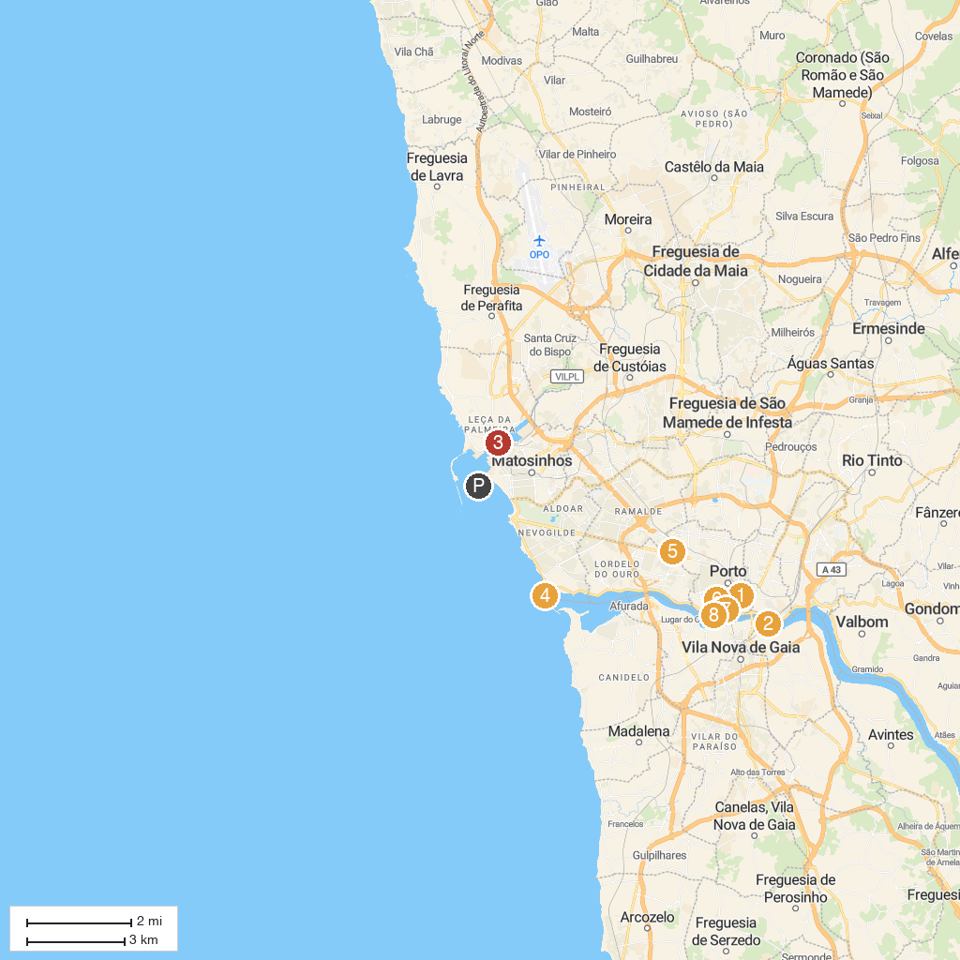
MAP KEY
1. Ageas Porto Coliseum | 5. Casa da Música
2. Ponte de São João | 6. Torre dos Clérigos
3. Ponte móvel de Leça | 7. Porto Cathedral
4. Felgueiras Lighthouse | 8. Palácio da Bolsa
P. Cruise port / terminal
Map © MapTiler © OpenStreetMap contributors · cruiseports.org

