Porto Belo, Santa Catarina, Brazil
A tranquil bay town on Brazil's Costa Esmeralda (Emerald Coast) with emerald-green waters, a car-free island just offshore, and some of southern Brazil's most beautiful beaches within easy reach.
⚓ Tender port · 🕒 Typical call: 6–8 hrs · 💵 Brazilian Real (BRL) · 🗣️ Portuguese · 🏖️ Beach destination
✍️ MY DAY IN PORT (FILL IN)
Ship / Date
In port | arrive ______ · all aboard ______
Booked excursion
Notes / meeting point
GETTING ASHORE
- Docking: Tender — ships anchor in bay, boats to yacht harbor
- Walk to center: 5 min from tender dock via free shuttle
- Best For: Beaches, snorkeling, island walks, floating bars
- Don't Miss: Ilha de Porto Belo island trail and Caixa d'Aço bay
GETTING AROUND
- 🚕 Taxi: BRL 20–60 — Metered taxis are available near the port. Fares within Porto Belo and to nearby beaches like Bombinhas typically run BR
- 📱 Rideshare: ✅ Uber
TOP THINGS TO DO
- Ilha de Porto Belo Island Tour — A serene island just a few hundred meters offshore, reached by water taxi.
- Floating Bars at Caixa d'Aço — Porto Belo's famous flutuantes — floating bars moored in the turquoise Caixa d'Aço cove — serve cold caipirinhas and grilled…
- Bombinhas Beaches Day Trip — Head 8 km east to the Bombinhas peninsula, home to Sepultura Beach — renowned as one of Brazil's best snorkeling spots — plus…
- Schooner Bay Circuit — Classic two-hour schooner cruise around Garoupas Bay stopping at snorkeling sites and natural pools.
- Porto Belo Town Walk & Church — The town center is compact and walkable.
BEST WALKS
- Waterfront to Town Center: 1 km · 15 min · Easy · Free — From the tender/yacht harbor, walk south along the waterfront promenade to Praça Central and the…
- Passarela Costão das Vieiras Walkway: 1.5 km · 25 min · Easy · Views — A scenic elevated walkway along the rocky coastline just north of town offering panoramic views…
WEATHER · DAYLIGHT · MONEY
Month | High °F | Low °F | Rainy days
May | 73 | 62 | 13
Jul | 69 | 57 | 8
Sep | 72 | 62 | 14
Daylight: May 6:47AM–5:33PM · Jul 7:02AM–5:37PM · Sep 6:11AM–6:07PM
cruiseports.org/porto-belo · Confirm terminal & all-aboard time with your ship

Porto Belo, Santa Catarina, Brazil — Port Map
Red = walkable sights · Amber = excursions farther out · P = cruise terminal
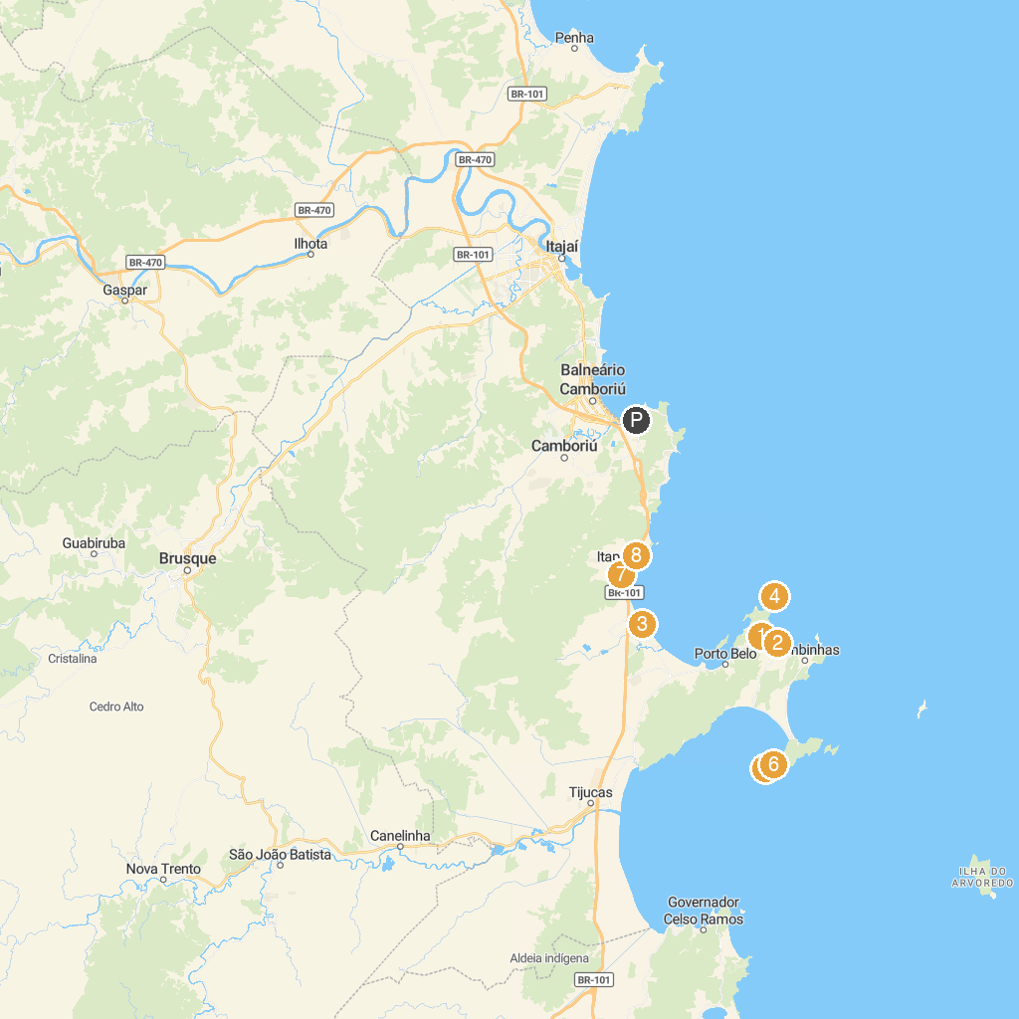
MAP KEY
1. Mirante de Bombas | 5. Praia do Cação
2. Praia de Bombas | 6. Tainha Beach
3. Divertimentos Náuticos Dodi | 7. Central Beach - Itapema
4. Ponta do Araçá | 8. Mirante do Encanto
P. Cruise port / terminal
Map © MapTiler © OpenStreetMap contributors · cruiseports.org

