Porto Alegre, Rio Grande do Sul, Brazil
Brazil's southern capital surprises cruisers with a vibrant riverfront, a stunning iron-and-glass public market, and a unique local ritual: applauding the sunset over the Guaíba together.
⚓ Pier (Guaíba River) · 🕒 Typical call: 8-9 hrs · 💵 Brazilian Real (BRL) · 🗣️ Portuguese
✍️ MY DAY IN PORT (FILL IN)
Ship / Date
In port | arrive ______ · all aboard ______
Booked excursion
Notes / meeting point
GETTING ASHORE
- Docking: Pier on the Guaíba River east bank; draft limitations apply, so some ships tender
- Walk to center: ~10–15 min on foot from the port area to Praça da Alfândega
- Best For: Culture, food markets, riverfront walks, day trips to wine country
- Don't Miss: Mercado Público Central and the Guaíba sunset applause tradition
GETTING AROUND
- 🚕 Taxi: R$30–50 (~$6–10 USD) — Taxis are available at the port. Metered fares to the city center typically run R$30–50 depending on destination and tim
- 📱 Rideshare: ✅ Uber, 99
- 🚌 Hop-on hop-off: ✅ Linha Turismo
TOP THINGS TO DO
- Historic Center Walking Tour — Explore Praça da Alfândega, the grand Mercado Público (1869), the Mario Quintana House of Culture, and tree-lined Rua dos…
- Guaíba River Boat Tour — Cruise the broad Guaíba — technically a lake formed by five rivers — past wooded islands and the city skyline.
- Mercado Público & Gastronomy — Porto Alegre's iron-and-glass public market (1869) houses over 100 stalls with fresh produce, local spices, cachaça, and…
- Usina do Gasômetro & MARGS — A former 1920s power plant converted into a cultural hub, and the Rio Grande do Sul Museum of Art on Praça da Alfândega — two…
- Day Trip to Gramado & Canela — Drive about 2 hours into the Serra Gaúcha to reach Gramado, a Bavaria-meets-Brazil mountain town famous for chocolate, fondue…
BEST WALKS
- Waterfront to Historic Core: 2.5 km · 45 min · Flat — Start at the Usina do Gasômetro on the river, walk north along Avenida Mauá past the port area to…
- Parque Redenção Stroll: 2 km loop · 40 min · Flat — Porto Alegre's beloved urban park features shaded paths, a lake, food kiosks, and a relaxed local…
WEATHER · DAYLIGHT · MONEY
Month | High °F | Low °F | Rainy days
May | 70 | 56 | 11
Jul | 67 | 51 | 10
Sep | 72 | 57 | 13
Daylight: May 7:03AM–5:39PM · Jul 7:19AM–5:42PM · Sep 6:23AM–6:17PM
cruiseports.org/porto-alegre · Confirm terminal & all-aboard time with your ship

Porto Alegre, Rio Grande do Sul, Brazil — Port Map
Red = walkable sights · Amber = excursions farther out · P = cruise terminal
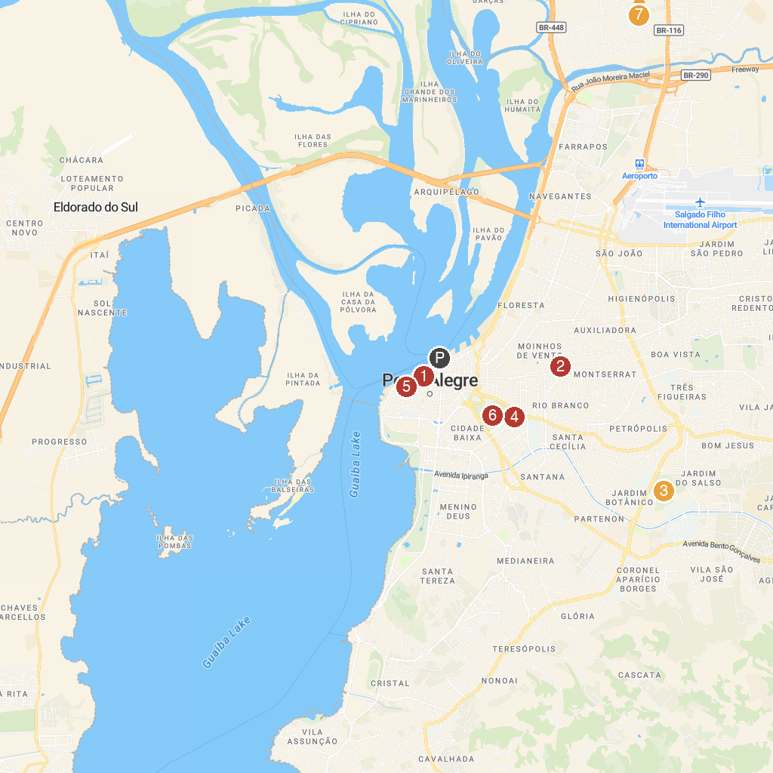
MAP KEY
1. Rio Grande do Sul Museum of Art | 5. Museu Militar do Comando Militar do Sul do Exército Brasileiro
2. Parque Moinhos de Vento (Parcão) | 6. Parque Redenção
3. Botanical Gardens of Porto Alegre | 7. GAG South Piazitos
4. Church of the Blessed Sacrament and St. Therese
P. Cruise port / terminal
Map © MapTiler © OpenStreetMap contributors · cruiseports.org

