Portland, Maine, USA
Maine's liveliest port city puts cobblestoned streets, craft breweries, and legendary lobster rolls within a 10-minute walk of the ship. Portland Head Light is a short drive away — one of the most photographed lighthouses in America.
⚓ Docked (pier) · 🕒 Typical call: 8-10 hrs · 💵 US Dollar (USD) · 🗣️ English · 🦞 Top food port
✍️ MY DAY IN PORT (FILL IN)
Ship / Date
In port | arrive ______ · all aboard ______
Booked excursion
Notes / meeting point
GETTING ASHORE
- Docking: Ocean Gateway Terminal (Pier 2) or Maine State Pier — both in the Old Port district, no tender required
- Walk to center: 5–10 min on foot to Old Port shops, restaurants, and waterfront
- Best For: Lighthouse sightseeing, fresh seafood, culinary walking tours, Casco Bay island cruises
- Don't Miss: Portland Head Light in Fort Williams Park — Maine's oldest lighthouse, 20 min by taxi or tour bus
GETTING AROUND
- 🚕 Taxi: $10–$15 — Terminal 2 is just ~2.5 miles from downtown Portland, so taxi rides are quick and affordable. Metered fares with a ~$3.5
- 📱 Rideshare: ✅ Uber, Lyft
- 🚌 Hop-on hop-off: ✅ Gray Line Pink Trolley
TOP THINGS TO DO
- Portland Head Light & Fort Williams Park — Maine's oldest lighthouse (1791) sits in Fort Williams Park in Cape Elizabeth — a 20-minute drive from the pier.
- Casco Bay Island Cruise — Hop aboard a Casco Bay Lines ferry or a scenic cruise to explore the bay's islands, spot harbor seals, and pass lighthouses…
- Old Port Culinary Walking Tour — Portland is consistently ranked among the best food cities in the US.
- Trolley City & Lighthouse Tour — Narrated trolley tours cover Portland's history, Victorian architecture, the Arts District, the Old Port, and make stops at…
- Freeport & L.L. Bean Day Trip — The town of Freeport, 20 miles north, is home to L.L.
BEST WALKS
- Old Port Loop: 1.5 miles · Easy · 45–60 min — The classic cruise-day walk.
- Eastern Promenade Trail: 2 miles one-way · Easy · 45-60 min — A paved trail along the bluffs above Casco Bay, starting near the Maine State Pier and stretching…
WEATHER · DAYLIGHT · MONEY
Month | High °F | Low °F | Rainy days
May | 68 | 49 | 10
Jul | 83 | 58 | 2
Sep | 75 | 55 | 8
Daylight: May 5:39AM–8:35PM · Jul 5:37AM–8:55PM · Sep 6:49AM–7:20PM
cruiseports.org/portland · Confirm terminal & all-aboard time with your ship

Portland, Maine, USA — Port Map
Red = walkable sights · Amber = excursions farther out · P = cruise terminal
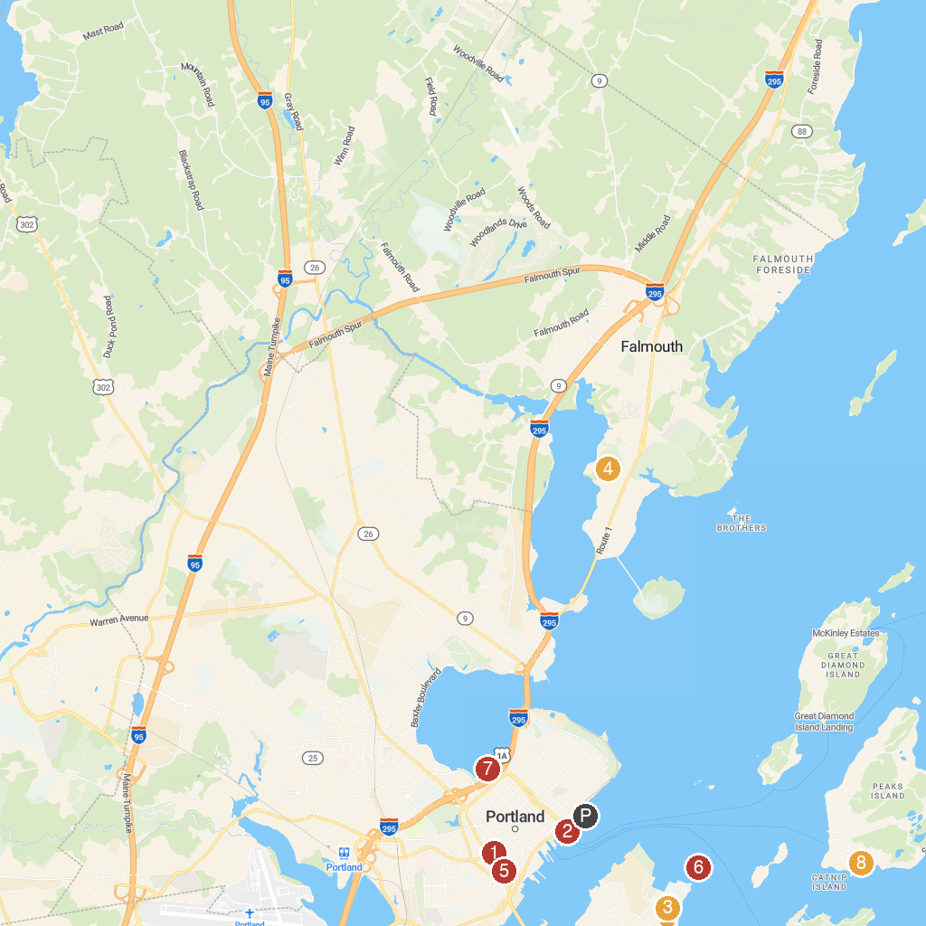
MAP KEY
1. Portland Museum of Art | 5. Victoria Mansion
2. Casco Bay Lines | 6. Spring Point Ledge Lighthouse
3. Crescent Beach State Park | 7. Back Cove Park
4. Maine Audubon | 8. Fifth Maine Museum
P. Cruise port / terminal
Map © MapTiler © OpenStreetMap contributors · cruiseports.org

